

Adding/Editing a Voter

- Select number ‘1’ ‘Voter File Maintenance’ from the ‘Main Menu’.
- Simply retrieve the voter you need to edit, or type in a new last name and first name to begin adding a new voter. Fill in the appropriate data on this screen and select ‘Save’ to save the voters information. The only fields that need to be filled in are lastname, firstname, and ward. Please note the ward field will only appear if you initially set wards up on the ‘Installation Maintenance’ screen.

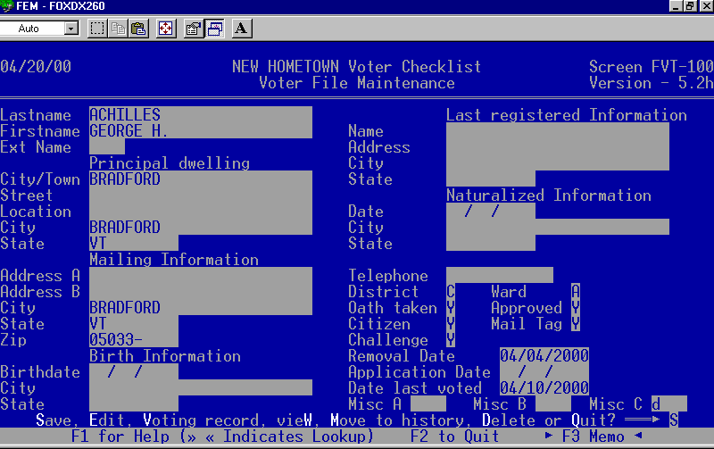
Only appears if the ‘Challenge’ field is flagged ‘Y’.
Action Bar
Save – saves a new record or any changes.
Edit – allows you go back through the record on the screen and make changes.
Voting record – enter absentee ballot or election information about voter.
View – only allows user to look at record. You can not make any changes to a voter when this option is selected.
Move to History – purges the selected voter from the main voter file to the history file. By doing this you have a record of everyone that has been on your checklist. (You can always move a voter back to the main voter file).
Delete – removes the voter from the main voter file permanently. You should only delete a voter if it is a complete mistake.
Quit – returns you to the ‘Main Menu’ without saving any changes.

Adding Elections

You may create as many elections as you want with this program. This will allow you to keep records of past voter checklist data. You can export checklist data to a diskette for specific elections for anyone who may make this request.

Creating Elections

- Select number ‘2’ ‘Enter Election Data’ from the ‘Main Menu’.
2. Next you must give the election a unique four-character code as seen below. If you want to edit an existing election simply type in the four-character code or press ‘F1’ to select the election to be edited.

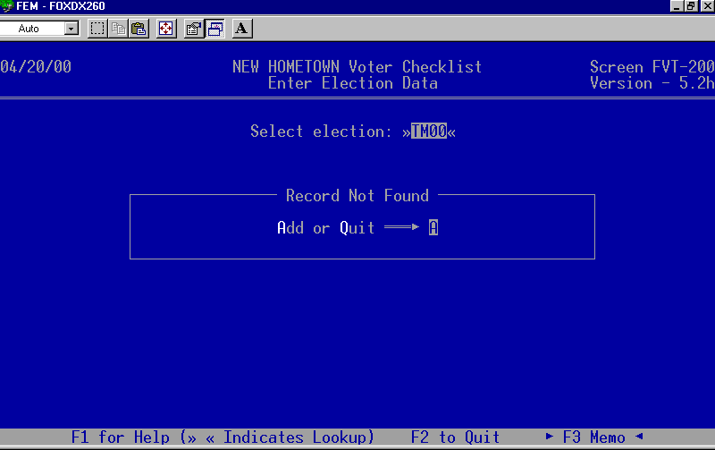
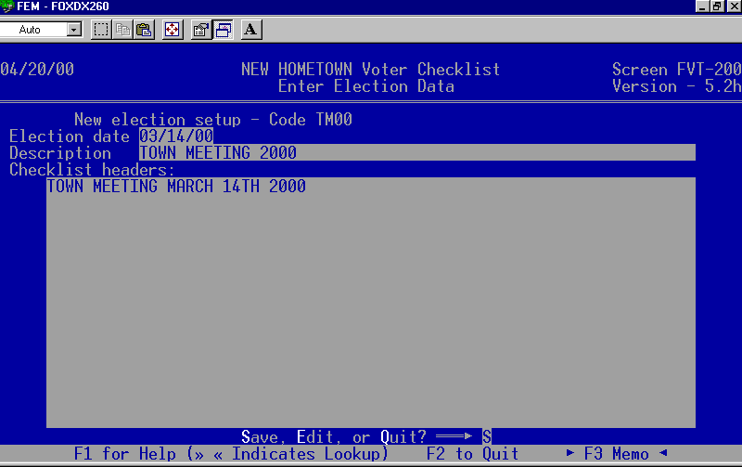
3. Press the ‘Enter’ key to continue adding a new election
4. Now fill in the date the election will be held, election description, and the heading you would like to appear on the top of the printed checklist.
5. Finally press the ‘PgDn’ key then the ‘Enter’ key to save your new election or changes. Once your elections are set up you can begin entering your voters election information.

RECORDING ABSENTEE BALLOT REQUESTS

AND

ELECTION RESULTS

There are two ways to record absentee ballot requests and election results.
- Voter File Maintenance (will update one voter at a time as seen below )
- Enter Election data (you can update many voters at one time as seen on the following page)

- Select number ‘1’ ‘Voter File Maintenance’ from the ‘Main Menu’.

Pull up the voter you would like to update.

Press the ‘PgDn’ key and select ‘Voter record’ from the ‘Action Bar’.

Type in the election code or press ‘F1’ and select the election to record the voter’s participation.

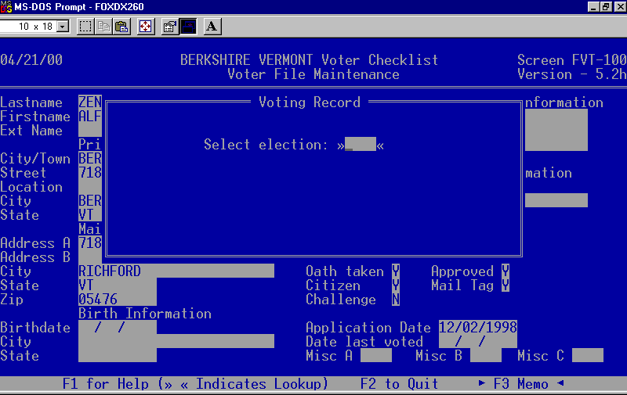
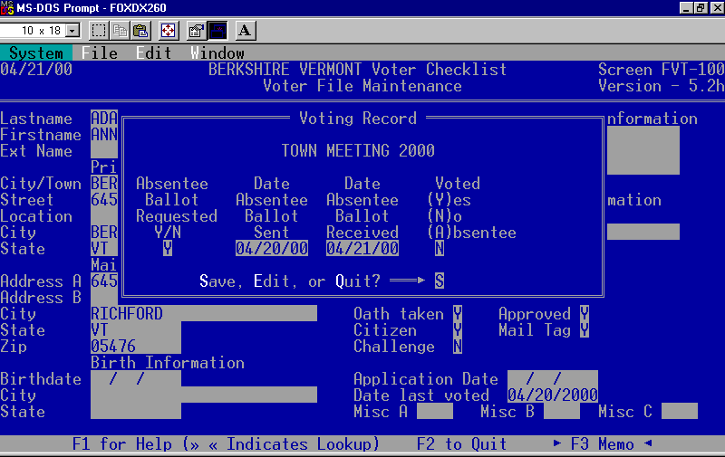
- Fill in the absentee fields if the voter has requested an absentee ballot. By entering this data you will be able to print a list of all voters that requested an absentee ballot for this election. You may also update a voter’s participation from this screen as well.
- Press the ‘Enter’ key to save your changes and return to the ‘Voter File Maintenance’ screen. You will be prompted again to save your changes. Simply press the ‘Enter’ key to save and continue to the next task.

ABSENTEE BALLOTS & ELECTIONS CONT.

2. Select number ‘2’ ‘Enter Election Data’ from the 'Main Menu'.
- Type in the election code or press ‘F1’ and select the election to record the voter’s participation.
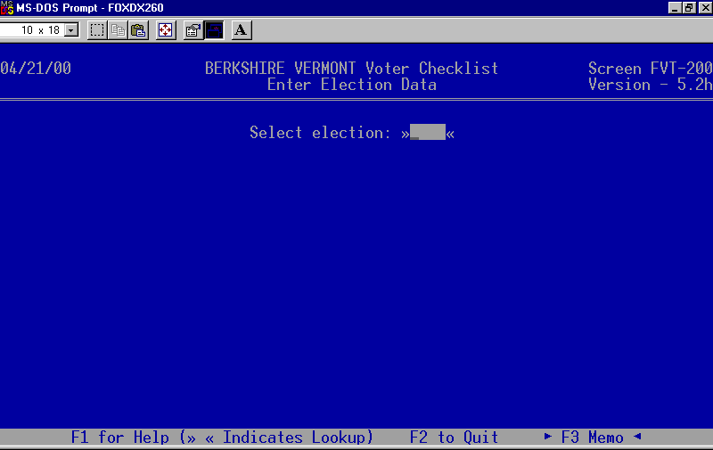
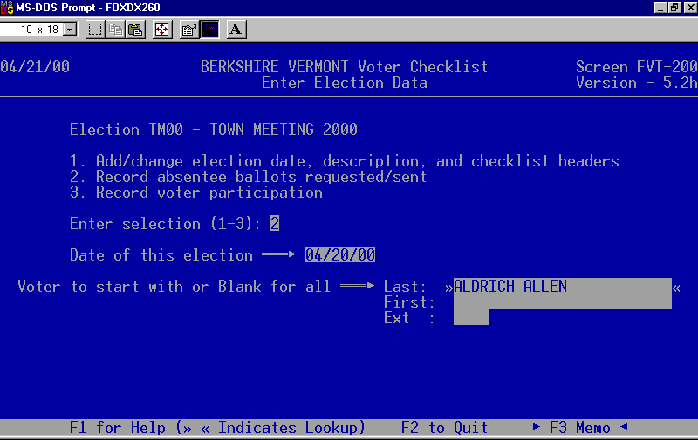
- Enter the date of the election then press the ‘Enter’ key.
- Next select the voter to update with absentee or election data.

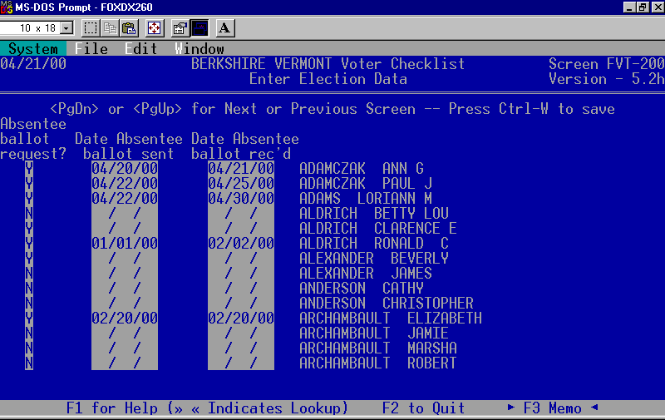

To record absentee ballot requests select ‘2’ from the menu below.

To record voter participation select number ‘3’ from the menu below.
F. Fill in the absentee data for the appropriate voters.
G. Finally press ‘CTRL+W’ to save your changes.

CHALLENGING VOTERS

- Select number ‘1’ ‘Voter File Maintenance’ from the ‘Main Menu’.
- Place a ‘Y’ in the ‘Challenge’ field.
- Next enter the date that the voter can be removed from the checklist. If you do not know the date at this time you may leave it blank and enter it later. If you neglect to enter removal dates, you will not be able to accurately purge your checklist by removal date.
- Save the record when you are finished.

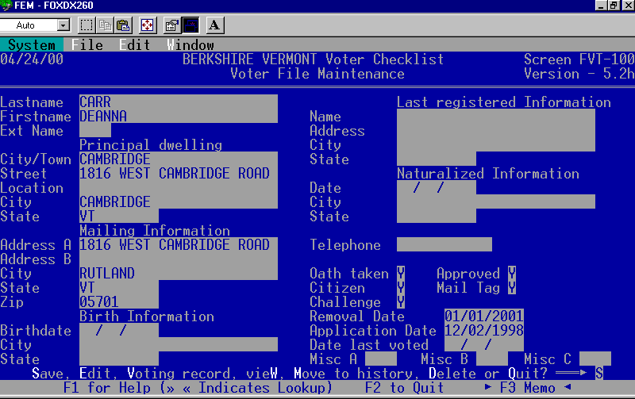

CHALLENGED VOTERS REPORT
Once you have all of the appropriate voters flagged ‘Y’ for challenged you can print a challenged voter report.
- Select ‘R’ ‘Reports’ from the ‘Main Menu’.
- Choose ‘8’ ‘Challenged Voters Report’. The report will list name, mailing address, and removal date as illustrated below.

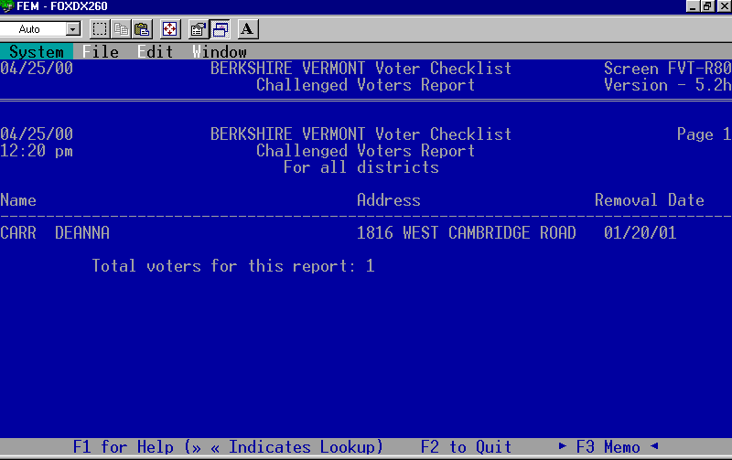

CHALLENGING VOTERS CONT.

Purging the Checklist

After you get approval to remove the challenged voters, you can remove them from the checklist all at once. You can remove challenged voters by removal date or using a FoxPro expression. FoxPro expressions allow you to select a group of voters to be removed from the checklist. For more information about FoxPro expressions refer to the FoxPro expression section included with this handout.

- Select number ‘5’ ‘Purge Voter Checklist’ from the ‘Main Menu’.
- To remove voters by ‘Removal Date’ or ‘Challenged flag’ select ‘C’ for ‘Challenged’. To remove by FoxPro expression select ‘F’.
- Enter the beginning ‘Removal Date’ and the ending ‘Removal Date’. If you leave both of these fields blank all of the voters that have the ‘Challenged’ field set to ‘Y’ will be moved from the current voter file to the history file.
- Next a message appears that informs you of the number of voters that will be purged. In this example only one voter will be removed. Enter the letter ‘Y’ to continue the purging process.

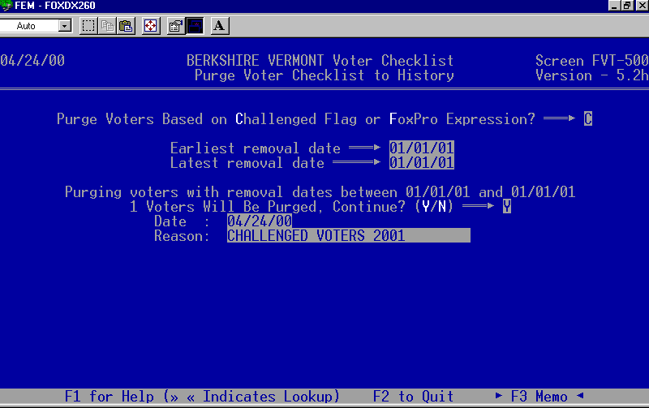
- Enter the date that the purge was done. The current date is the default.
- Type in a short description of why the voters were moved to the history file. This information will be displayed on each record moved to the history file at this time.

EXPORT VOTERS TO DISKETTE

The steps below explain how to export voter checklist data to a diskette.

- Select ‘R’ ‘Reports’ from the ‘Main Menu’.
- Then select ‘6’ ‘Export Voter Data’ from the ‘Reports Menu’.
- In the next two steps choose the voters you want to be exported. In this example we are only exporting the ‘Active’ and ‘Approved’ voters.
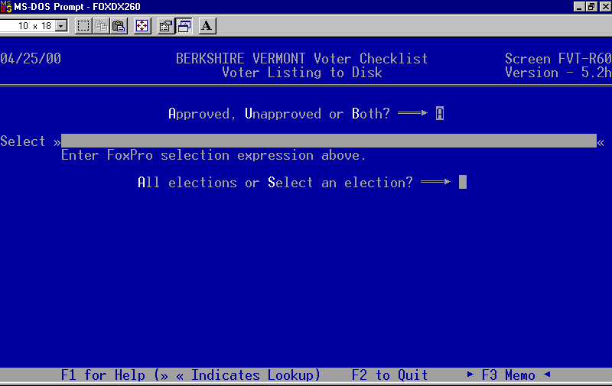
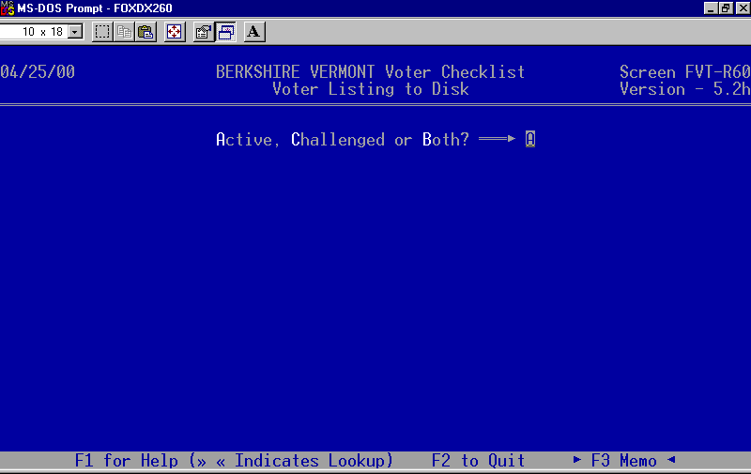
I
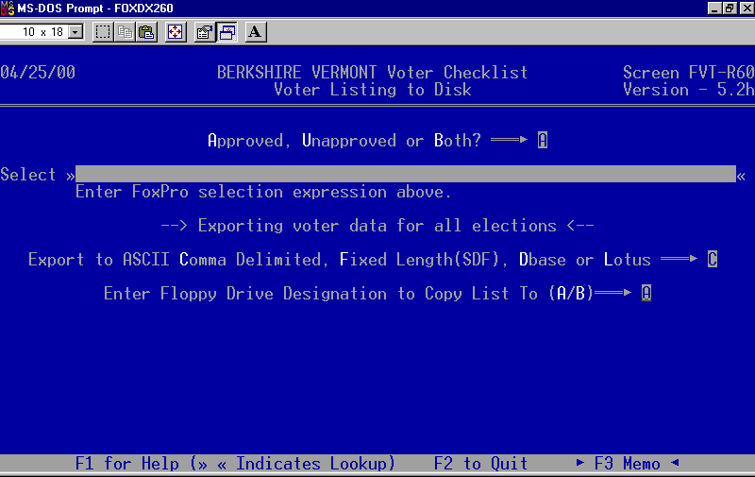
- Leave this field blank unless you want a specific group of voters exported. Refer to the FoxPro expression handout to learn how to use this ‘Select’ line.
- If you want to export all of your voters choose ‘A’. If you want to export all of the voters that voted in a specific election choose ‘S’ and select the election.
- Select the export file format you would like to use. The person making the request should be able to tell you what format they would like. If they do not specify select the default ‘ASCII Comma Delimited’, most programs can read this format.
- Type in the letter of the disk drive. On most computers the diskette drive is ‘A’. If you do not know what the drive letter is, refer to the handout labeled ‘Taking Control of Your Computer’.

EXPORTING VOTERS CONT.

- Below is a list of fields from the ‘Voter File Maintenance’ screen that can be exported. Simply go down the list of fields and mark them with a ‘Y’ to export, or a ‘N’ not to export the field. Last name, First name, Extension name, Mailing Address, and Mail Tag are the only fields being exported in this example.

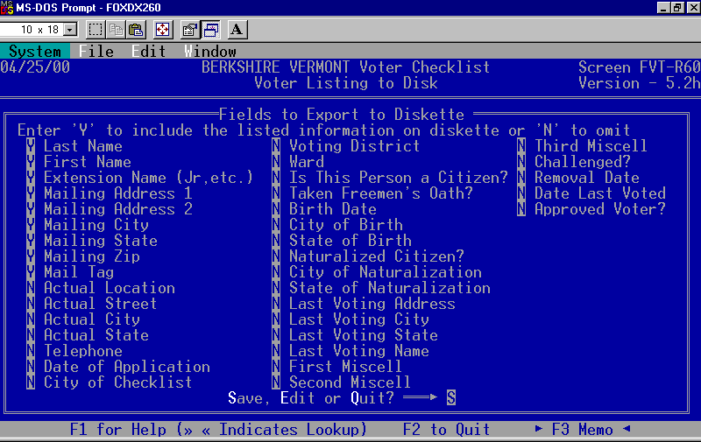
- Press the ‘Enter’ key to save your changes when you reach the bottom of this screen.
- Follow the prompts that appear on the screen. The computer will now export your data to the diskette.
- You will be asked if you would like to ‘Print’ or ‘Display’ the report below. The report informs the person that is receiving the exported data the file format, name of the file, fields you exported for them, and how many voters have been exported.
- After the report has been printed you will be informed the export is complete and to press any key to return to the ‘Reports Menu’. The export process is now complete.

