To record Absentee ballots follow the instructions below.

- From the Main Menu select ‘2’ Enter Election Data.

- Select the Election that you want to record your absentee requests. In this example we will select TM05 ‘Town Meeting 2005’ as seen in the picture below. Once you have selected the election to record the absentee ballots click on the Participation tab at the top of this screen.

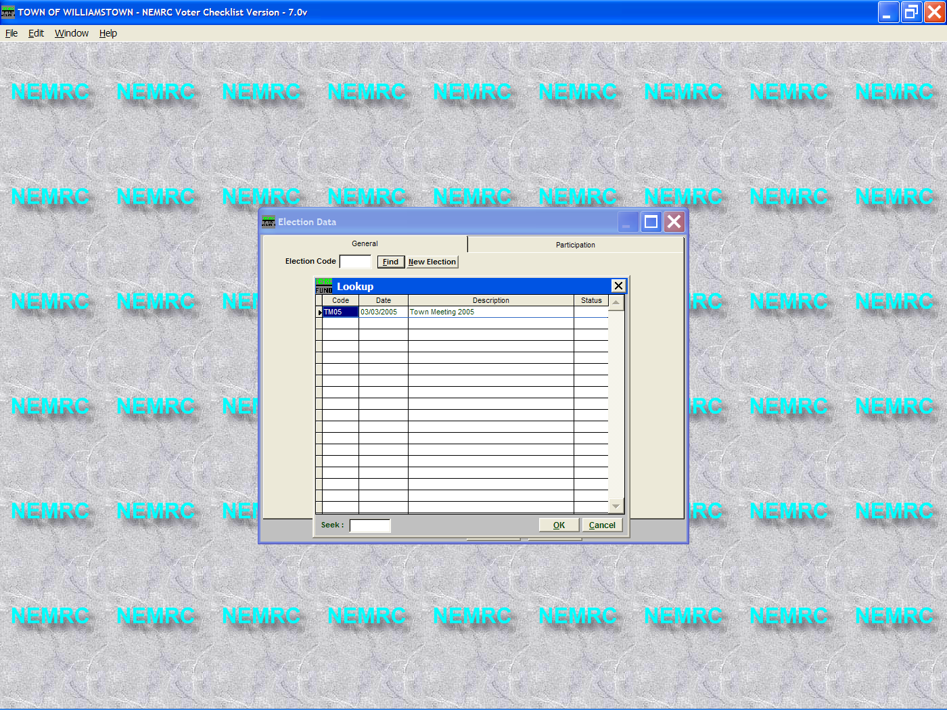

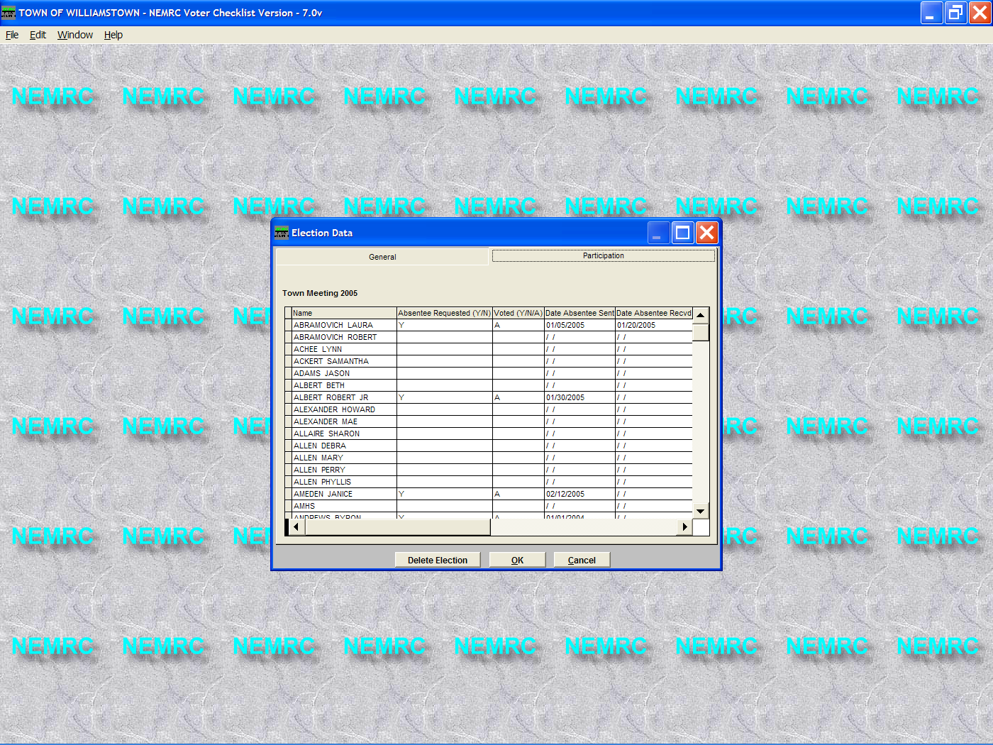

- Find the Voter on the list seen below that requested an absentee ballot and fill in the information accordingly. Enter ‘Y’ under the ‘Absentee Requested’ and an ‘A’ under ‘Voted’. Note: The date the ballot was sent and received is not required so the may be left empty. However if you leave them blank they will not appear on the absentee ballot report.
- Once you have finished recording your absentees simply press the ‘Ok’ button to save your changes.

- Next the window below will appear. At this time you do not want to update these voters with this election date as the last date that they had voted, simply because they have not voted yet. Once the election has been run and you return to this screen and update all of your voters as either voting ‘Y’ or not voting ‘N’ (Any voter that used their Absentee ballot to vote should remain an ‘A’ ones that did not use their ballots should be changed to ‘N’). Then you will want to update all the voters at that time. Note: it only updates the voters with a ‘Y’ or ‘A’ in the ‘Voted’ field.

