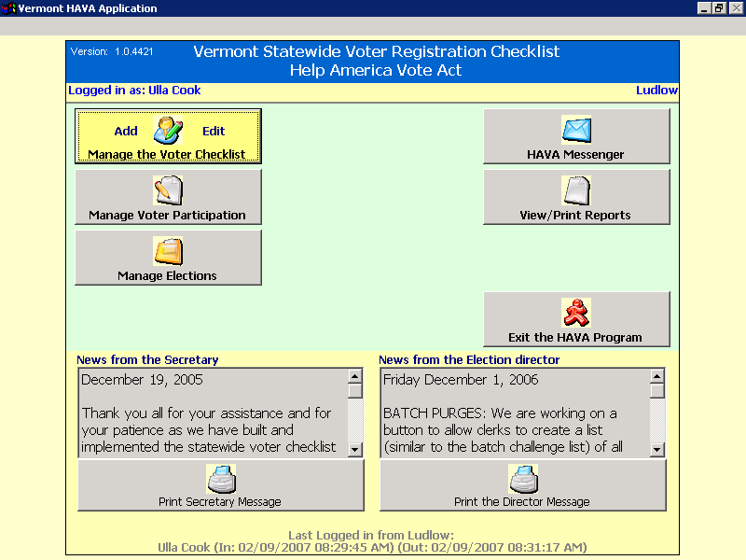
Log into HAVA and click on
‘View /Print Reports.

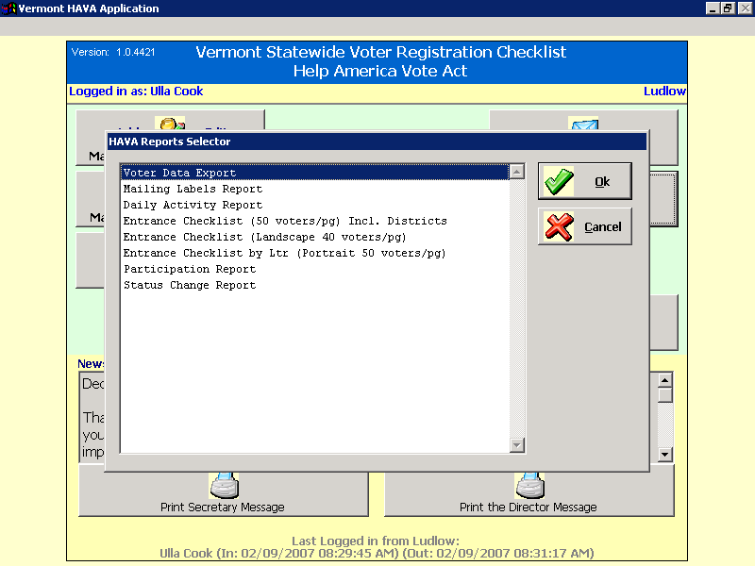

2. Select ‘Voter Data Export’
Then press ‘Ok’ Button.
Voter Data Export is the only report that will work with the NEMRC import process.

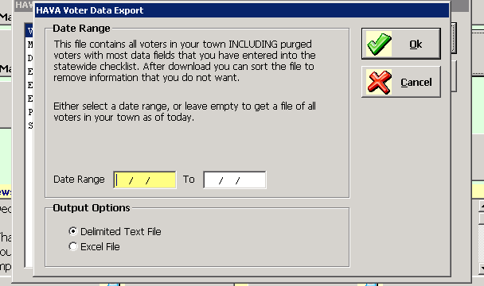
3. Accept the Default choices on this screen.
NO DATES
Delimited Text NOT Excel
4. Then press the ‘Ok’ button.

5. Next the program will display a window that says it is processing your request. When it is finished the program will ask if you want the file emailed to you. Select the ‘Yes’ button. Once you have received the email with the attachment, save the attachment to your computer.

It is up to you to know how to save attachments using your email software.

The attached file name will be ‘Townname_VoterDataExport_Currentdate_currenttime.txt
Here is an example.
LUDLOW_VoterDataExport_20060831_15_32_06.TXT

