The request to email files is becoming more popular and it will only continue to be requested more often. Whether it is a copy of your voter list, grand list, or even financials for the town report…the requests are coming in and you do have the tools to fulfill these requests. In the example that will follow, we will be using the Grand List Windows version. Its important to point out that all of our modules are similar in the way emailing a file can be achieved. It is also important to note that everyone has different types of email software so you need to learn how to attach a file in your software.

Using the Export Data option on the Reports Menu of the Grand List you will be in the Grand List to Disk Report Options. When you have selected all of the options that you want on the General tab then choose what fields you would like to include in your export file. Click the export button once you have made all of your choices.

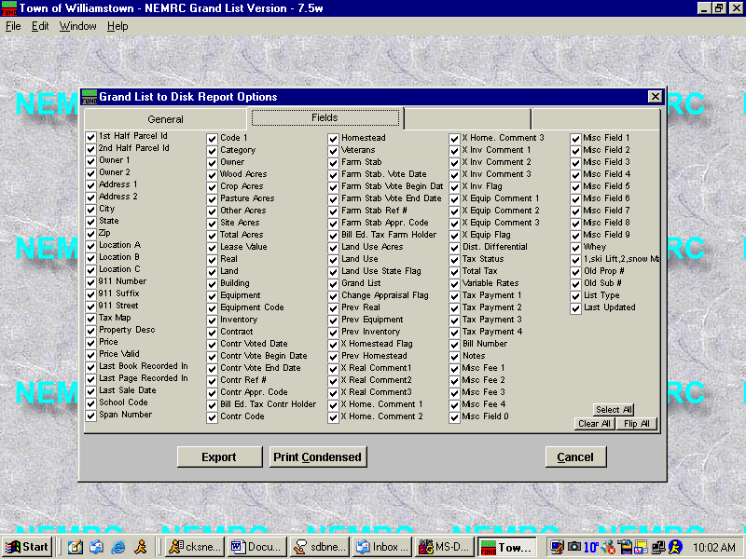
Once you have made your option selections you can click the export button

After clicking the export button you will get the message IF YOU WANT TO EXPORT THE GRAND LIST TO DISKETTE, PLEASE INSERT DISKETTE AT THIS TIME. THEN CLICK OK. Because we will be emailing this file you would not want to save it to a diskette, go ahead and click OK anyway. It will search for a diskette then give you an option to choose to save to another place.
Save file anywhere on your computer, you will need to remember where you saved it.
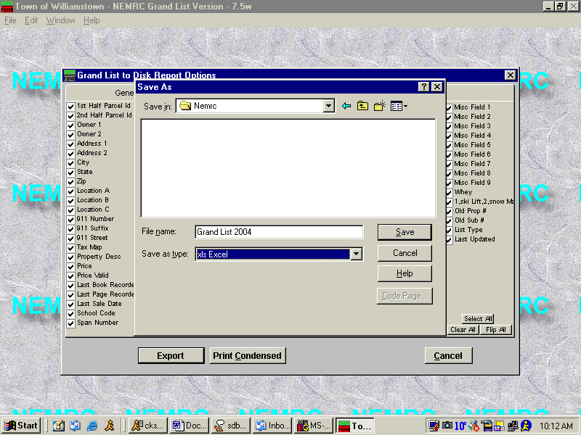
Name your file
The person requesting the file to be emailed should tell you what type of file they want it sent to them as.

Once you have named and saved the file you are done in the Nemrc program. Your next step would be to open your email software and create a new message to the person that you are sending this file to. After creating the message you will need to attach the file that you created when you were in the Grand List program. That is why it is important to know where it was saved because at this point you will be searching for that file to attach. Once the file is attached you will send the email and you are done. Most email programs are similar in their capabilities. We are using Outlook Express in this example.

After creating the email you will need to find the attach feature in your email program. This program is a paperclip with the word attach. Click the attach button.
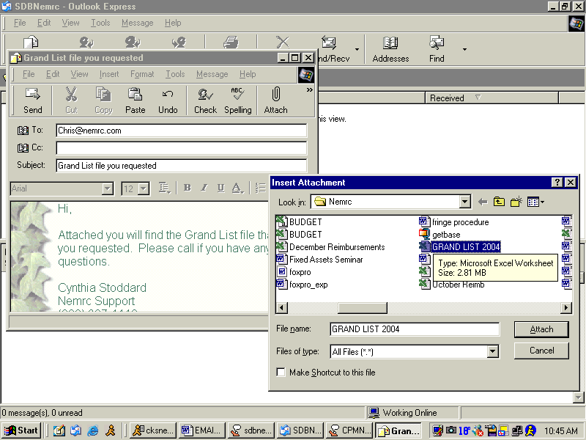
New mail is created, with email address of person requesting file.
Find the file, click attach. This will attach the file to you email, send and you are done.

