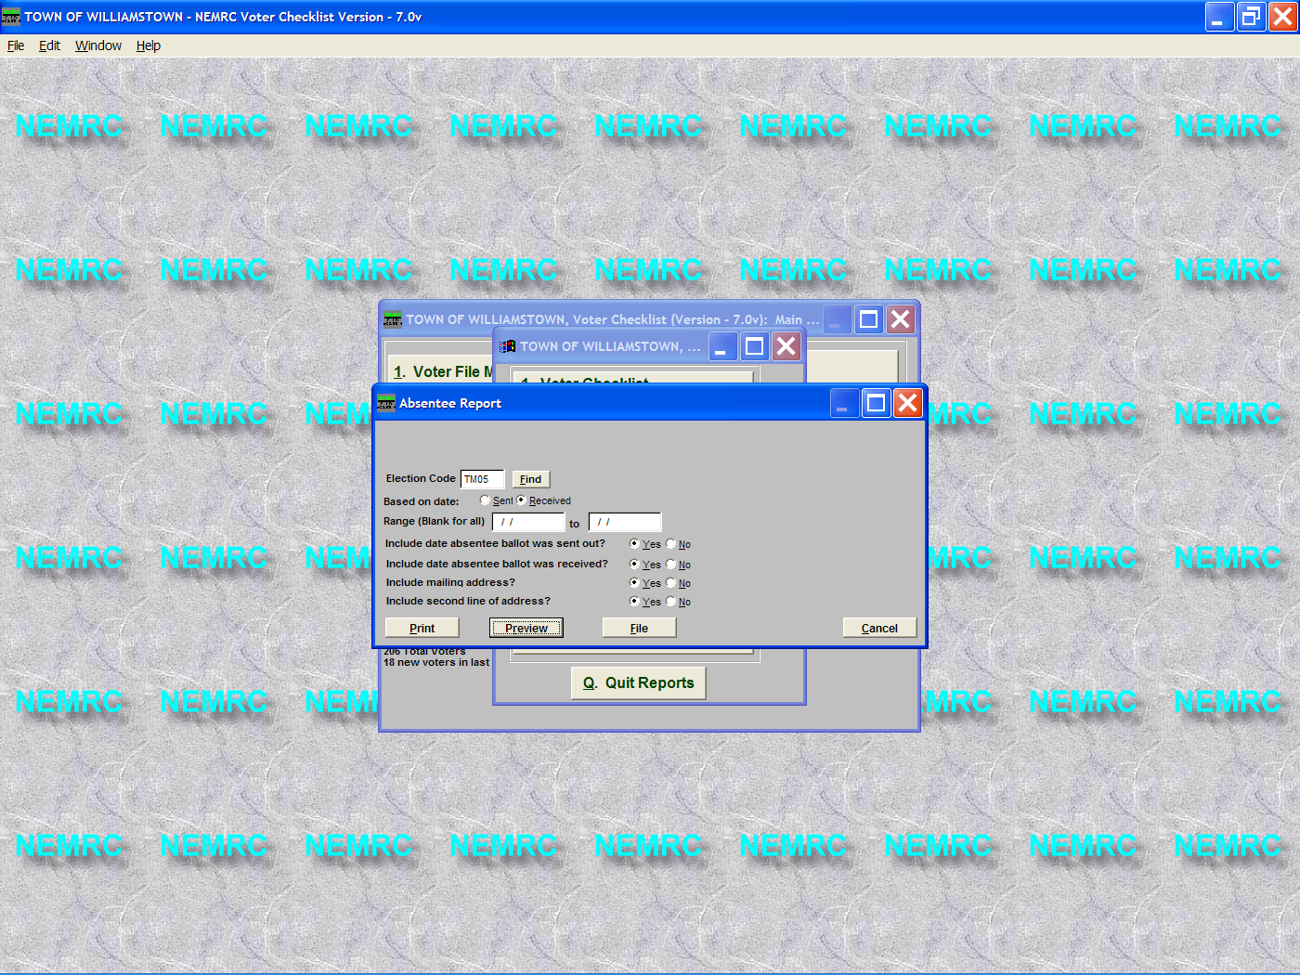
- From the Reports Menu select option ‘7’ Absentee Ballot Report.
- You must select the election that you want to use for this report. In this case we are using the ‘TM05 – Town Meeting 2005’ election.
- Select the appropriate options seen on the screen below and print your report.

- Below is the Absentee Ballot Report. This report may be posted the morning of your election as needed. As you can see it list the Voters name, address, and dates the absentee ballot was sent and received (Only if you bothered to enter that data when you were flagging your absentee ballots in ‘Election Participation’). This report also totals the number of absentee voters that have requested absentee ballots.

02/17/2005 TOWN OF WILLIAMSTOWN Voter Checklist Page 1
06:12 pm Absentee Ballot Requested Report
Election TM05 Town Meeting 2005

Name Mailing Address Absentee Sent Absentee Rec'd
------------------------------------------------------------------------------------------------------------------------------------
ABRAMOVICH LAURA 102 WILCOX RD ARLINGTON, VT 05250 01/05/2005 01/20/2005
ALBERT ROBERT JR 603 BALL MT RD ARLINGTON, VT 05250 01/30/2005
AMEDEN JANICE 144 OAK KNOLL RD ARLINGTON, VT 05250 02/12/2005
ANDREWS BYRON PO BOX 283 ARLINGTON, VT 05250-0283 01/01/2004
MADDALONI RICHARD 276 OAK KNOLL RD ARLINGTON, VT 05250 02/12/2005

Total voters requesting absentee ballots: 5

