Marriage & Civil Union Administration

Adding/Editing data

This program will print out a Marriage or Civil Union License form for you once you have entered all of the appropriate data. Please note you must use a laser or ink jet printer in order to print the license forms supplied to you by the Department of Vital Records.

The following steps guide you through entering Marriage data so you can print out a marriage license. Please take note that these steps can be used to print out a civil union license as well.
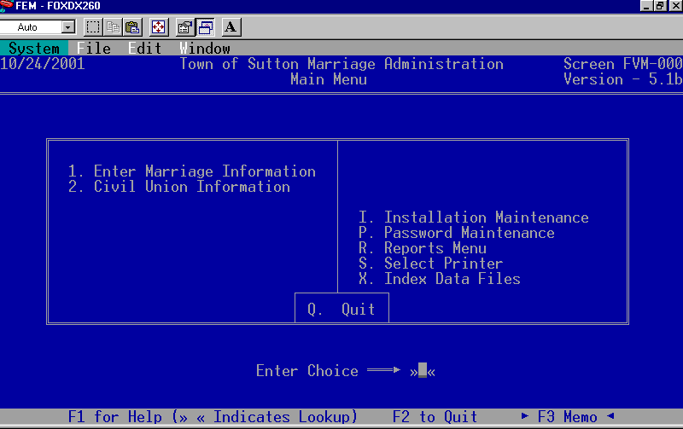
1. From the ‘Main Menu’ select which type of license you will be entering, Marriage or Civil Union.
- Enter the year the marriage will take place. You may leave this field empty but if you enter a date it will speed up the look up process. For example if the marriage will be performed in the year 2002 then enter 2002 in the space provided. If you are entering historical data enter the year the couple was married, 1920 for instance.

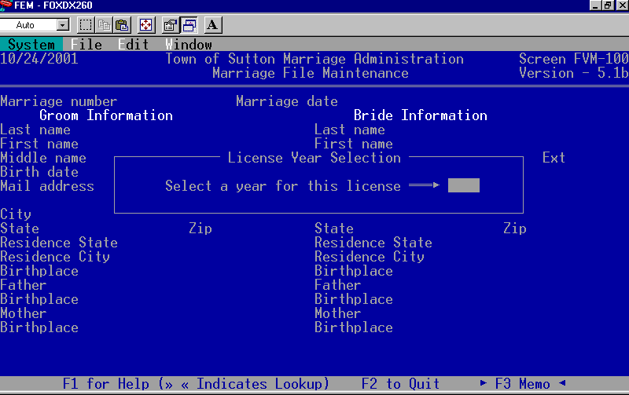
3. Enter a Marriage number or the Groom’s last name to begin adding a new record.
You do not have to enter a marriage number; however, by entering the number it can help you find records in the future. (Usually people enter the red number located on the license form).

4. Marriage date – enter the date of the ceremony here if you do not know the date of the marriage just use today’s date. This field does not print on the license form. When know the date the marriage took place you can pull up the record and enter the correct date. By entering the marriage date you can run reports for a specific marriage date range.

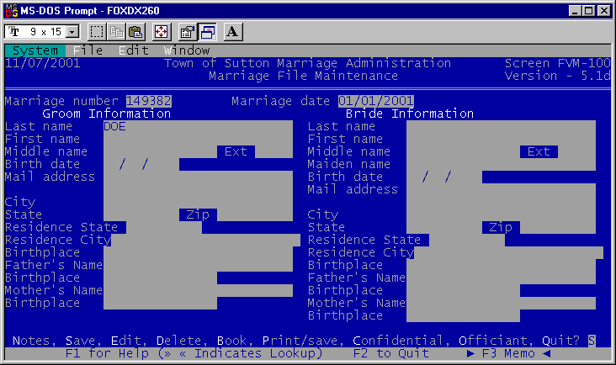

5. If you have any Confidential or Officiant information press the letter-highlighted and enter the data. Otherwise leave it blank.
6. Once all of the Groom/Bride data has been entered save the record. You may print the license form for this record by pressing ‘P’ for print/save. Or you may print the license from the reports menu it does not make a difference.

Printer Hint: Print may vary between using the paper tray and the single sheet feed.

