Reversing Cash Receipt on Deposit

Reversing cash receipts is used for checks that are returned. Select # 3 Adjusting Entries from the Main Menu. Then select # 5 Reversing Cash Receipt on Deposit. You must have the deposit number that the payment was assigned. You can get that information from the Detailed Transaction Report.

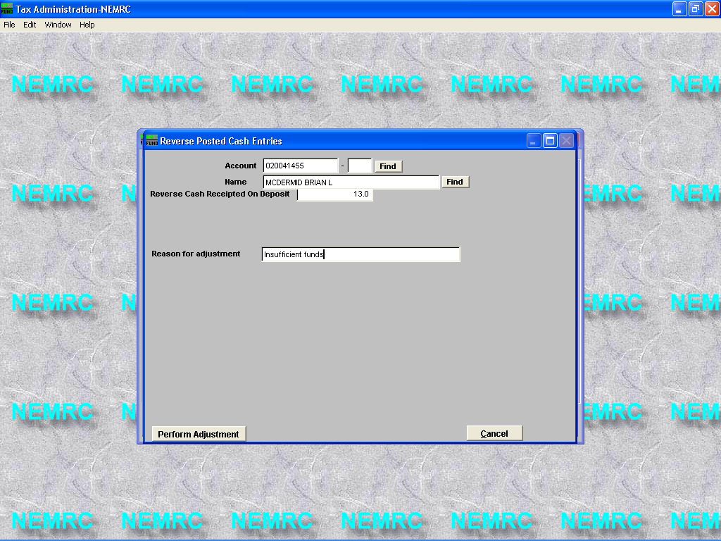

Select a parcel
Enter the deposit #

You must enter a reason for adjustment

Press the Perform Adjustment button

Print a new Detailed Transaction report to follow the transactions applied to this parcel.

11/06/02 Town of Rockingham Tax Administration Page 1
04:46 pm Detail Transactions Report CHRIS Parcel 020041455- All Tax Years Full Detail

Parcel Tax Year Name
Description Date Check # Deposit # G/L Batch# Remit Amount Balance
----------------------------------------------------------------------------------------------------------
020041455- 2002 MCDERMID BRIAN L
Bill Appl. To Prin. Pmt 1 11/05/02 1,311.17 1,311.17
Bill Appl. To Prin. Pmt 2 11/05/02 1,311.17 2,622.34
Rcpt. Appl. To Prin. Pmt 1 11/06/02 34125 13.0 -1,311.17 1,311.17
* Adj. Appl. To Prin. Pmt 1 11/10/02 Insufficient funds 1,311.17 2,622.34
----------
Parcel Balance 2,622.34

* 11/10/02 Reversal of payment made on 11/6/02 with check # 34125 due to “Insufficient Funds”.

