Delinquent Report/Notices

From the Main menu select ‘R’ Reports menu. Then select ‘5’ Delinquent Tax Report. This report will provide tax information on all parcels that show a balance after the last due date.

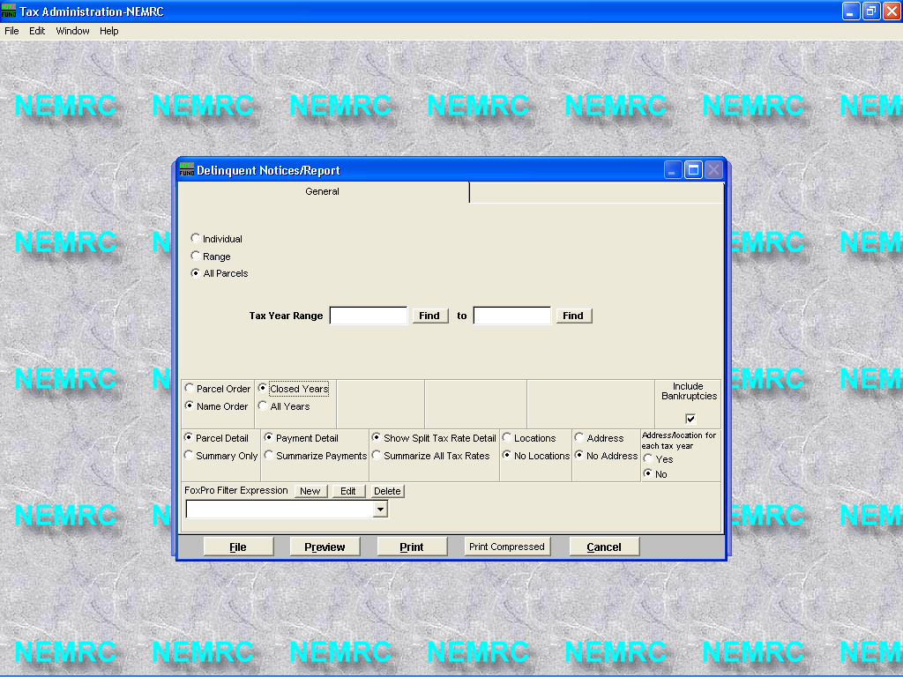

Payment Detail – shows what is owed on individual payments
Summarize Payments – adds all payments together.
If unchecked, Parcels flagged for bankruptcies will not appear on this report.

The Delinquent tax report displays amounts due for each payment, interest, penalty, other charges, and the total amount due. Page 2 shows summary of overdue amounts. It also breaks out total amounts due for individual payments, interest, penalty, and other charges.

01/16/2003 Town of Rockingham Tax Administration Page 1
11:15 am Delinquent Tax Report CHRIS For A Name Range

Parcel Name Tax Year Payment 1 Payment 2 Interest Penalty Other Total

234400024- SHELC GRACE 2002 1421.05 1421.05 56.84 227.36 0.00 3126.30

125050127-017 SHEPARD CHARLES & 2002 413.13 413.13 16.52 66.10 0.00 908.88

100420399- SHEPARD EVA E 2002 2478.78 2478.78 99.16 396.60 0.00 5453.32

100420374- SHEPARD JOHN O JR 2002 2997.39 2997.39 119.88 479.58 0.00 6594.24

125050127-001 SHERETTE JOYCE 2002 533.26 533.26 21.32 85.32 0.00 1173.16

233280012- SHERETTE ROGER D 2002 1095.82 1095.82 43.84 175.34 0.00 2410.82

01/16/2003 Town of Rockingham Tax Administration Page 2
11:15 am Delinquent Tax Report CHRIS For A Name Range

Tax Year Payment 1 Payment 2 Interest Penalty Other Total
-----------------------------------------------------------------------------------------------------------
2002 8939.43 8939.43 357.56 1430.30 0.00 19,666.72

Delinquent Report/Notices Cont.
From the Main menu select ‘R’ Reports menu. Then select ‘5’ Delinquent Tax Report. This report will provide tax information on all parcels that show a balance after the last due date.

There are 2 tabs on this window.

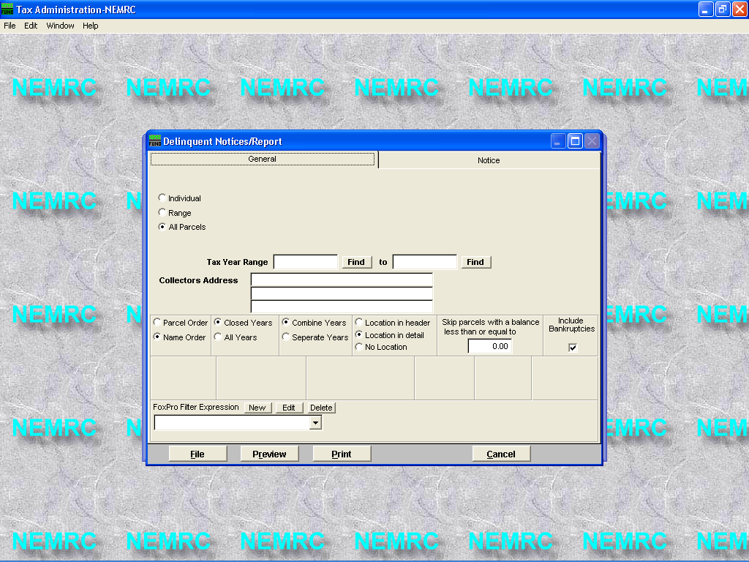
The General tab helps you select who you want to send a delinquent notice.

The Notice tab allows you to edit, add, and delete the delinquent notice.

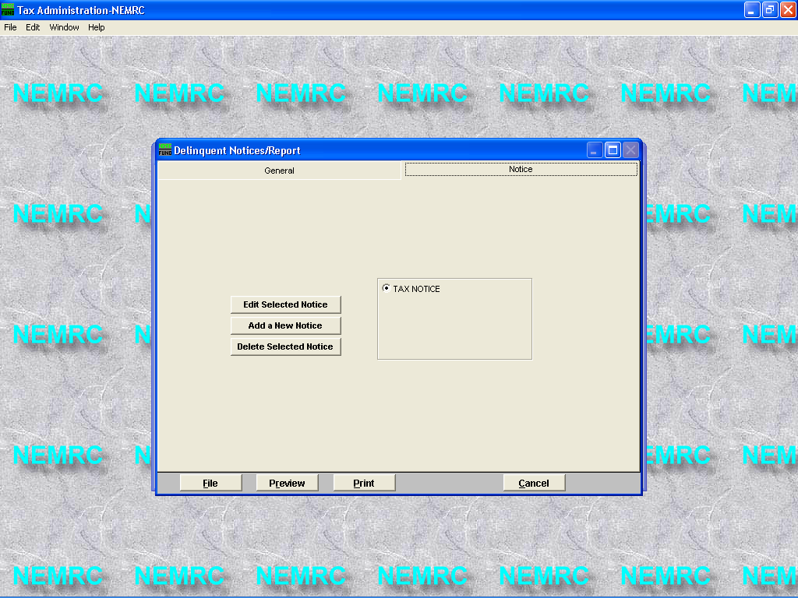
You can setup more than one delinquent tax notice simply by pressing the ‘Add a New Notice’. Then you can edit each notice as needed by using the ‘Edit Selected Notice’

Delinquent Report/Notices Cont.
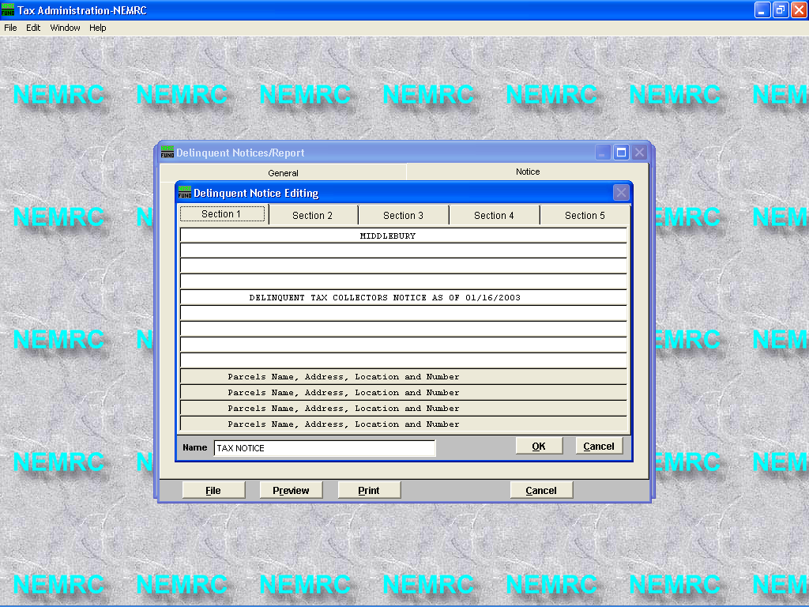
When you press the ‘Edit Selected Notice’ this screen is displayed. There are 5 tabs which have information that can be edited. Section 1 is the top of the delinquent notice and section 5 is the bottom of the notice. You may edit any area in white. Gray areas are used by the NEMRC programmers to display parcel ids, names, address, and amounts due. Below is a preview of a printed delinquent notice.

Press the ‘OK’ button to save any changes.

TOWN OF ROCKINGHAM

DELINQUENT TAX COLLECTORS NOTICE AS OF 01/16/2003

BENSON JANSON
12 SCHOOL ST
TOWNVILLE, VT 05101

PARCEL NUMBER : 234380012-

_ Taxes Assessed Against You _

Year Principal Interest Penalty Other Total Location
2002 2,256.10 45.12 180.48 0.00 2,481.70 BUILDINGS AND LOT .

TOTAL AMOUNT DUE 2,481.70

TAKE NOTICE
That taxes assessed against you as indicated hereon are placed in my
hands for collection with a Warrant attached, upon which I am commanded
to make a return.
I will receive taxes at my office in the Rockingham on
Monday through Friday, between the hours of 8:30 A.M. and 4:00 P.M.
If payment is made at that time summary action on my part will be
avoided. Otherwise I am commanded to distrain the goods and chattels,
until such taxes are paid. This is in accordance with the REQUIREMENTS
of Law and I have no alternative but to comply with it. Your own
compliance will avoid legal proceedings and additional expense.

Very respectfully,

............................Collector

Please Remit to :
DELINQUENT TAX COLLECTOR
55 Main St
Bellows Falls VT 05701

Please note that interest at 1.00% for the first 3 months and 1.00%
thereafter on any unpaid delinquent taxes. Checks are to be made payable
to Rockingham.

