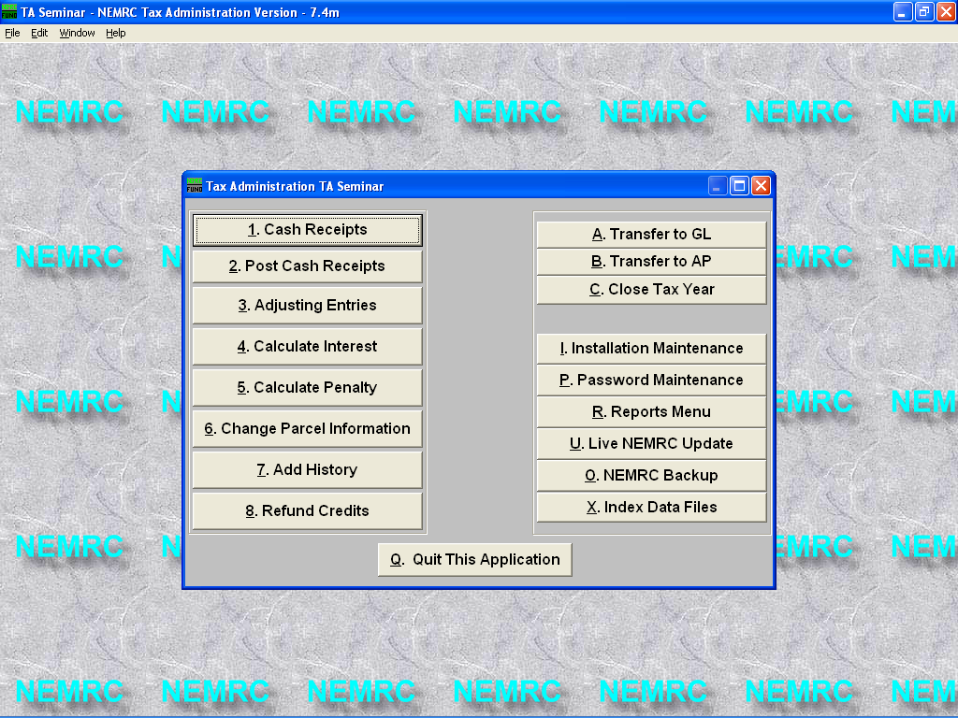
Executing this procedure

1. Select ‘R - Reports Menu’ on the Main Menu.

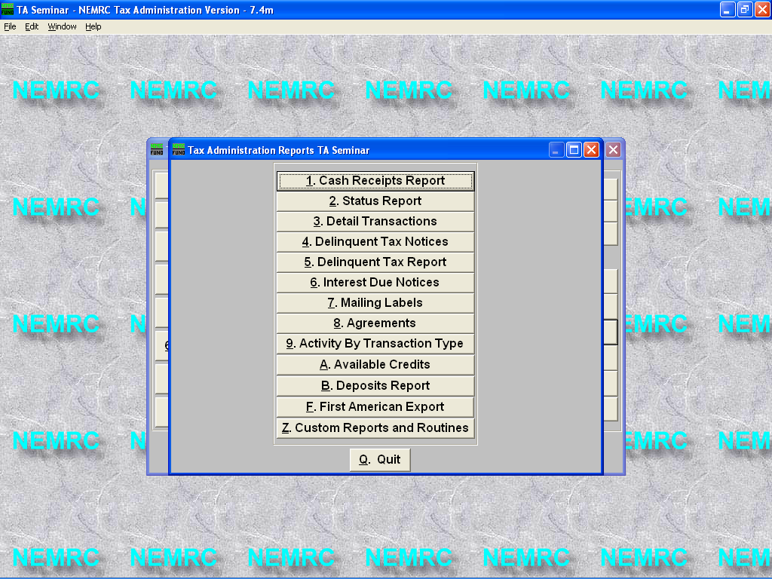
- From the Reports Menu Select ‘F - First American Export’

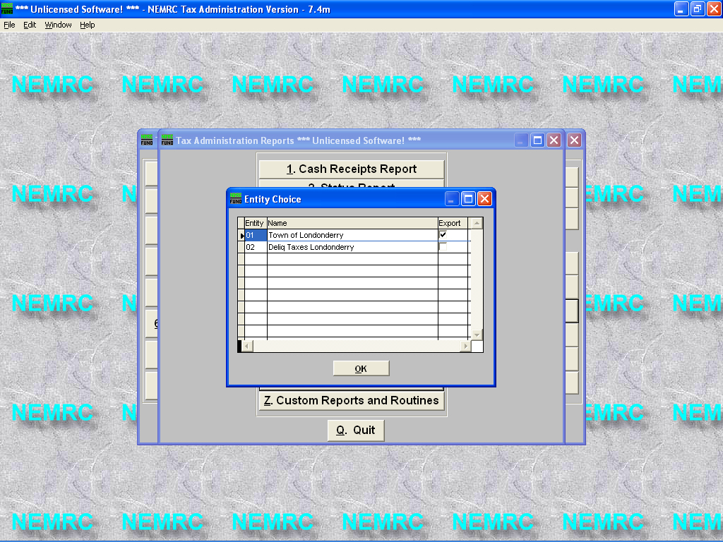
- Select the appropriate Tax administration entity to export. In this example Entity 01 Town of Londonderry is going to be exported. Note the check mark under the word export.
In most cases you will only have one entity to select.

4. Press the ‘OK’ button to continue after you have selected the appropriate entity to be exported.

5. Next you will see the message below alerting you to place a diskette in the disk drive at this time.



6. Once the diskette is in the disk drive press ‘OK’ to continue with the export process or press ‘Cancel’ to abort this procedure.

7. Once the data has been copied to the diskette this message will appear. Press the ‘OK’ button to return to the Reports Menu.

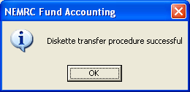

8. Eject the diskette and send it to First American Real Estate Tax Service via mail or email to: techteam.boston@firstam.com

- Below are a list of the fields that will be exported when the First American Export routine has been executed.
Data layout of NEMRC Escrow Export file (FIRSTAM.TXT)

Field Name Type Width Decimals Description

M_PROP Character 10 Parcel number
M_SUB Character 10 Subparcel number
M_YEAR Character 10 Tax year
M_BILLNUM Numeric 8 Bill number
M_NAME1 Character 40 Owner name
M_NAME2 Character 40 Co-owner name
M_PAYAMT1 Numeric 11 2 Payment 1
M_PAYAMT2 Numeric 11 2 Payment 2
M_PAYAMT3 Numeric 11 2 Payment 3
M_PAYAMT4 Numeric 11 2 Payment 4
M_ACCUMIN1 Numeric 9 2 Accumulated interest on payment 1
M_ACCUMIN2 Numeric 9 2 Accumulated interest on payment 2
M_ACCUMIN3 Numeric 9 2 Accumulated interest on payment 3
M_ACCUMIN4 Numeric 9 2 Accumulated interest on payment 4
M_ACCUMPE1 Numeric 9 2 Accumulated penalty on payment 1
M_ACCUMPE2 Numeric 9 2 Accumulated penalty on payment 2
M_ACCUMPE3 Numeric 9 2 Accumulated penalty on payment 3
M_ACCUMPE4 Numeric 9 2 Accumulated penalty on payment 4
M_ACCUMOTH Numeric 9 2 Accumulated other amount due
M_DISCTAK1 Numeric 9 2 Discount taken on payment 1
M_DISCTAK2 Numeric 9 2 Discount taken on payment 2
M_DISCTAK3 Numeric 9 2 Discount taken on payment 3
M_DISCTAK4 Numeric 9 2 Discount taken on payment 4
M_PAY1_DUE Numeric 11 2 Principal due payment 1
M_PAY2_DUE Numeric 11 2 Principal due payment 2
M_PAY3_DUE Numeric 11 2 Principal due payment 3
M_PAY4_DUE Numeric 11 2 Principal due payment 4
M_LASTCLC1 Date 8 Date of last interest calculation on payment 1
M_INT_DUE1 Numeric 9 2 Interest due on payment 1
M_LASTCLC2 Date 8 Date of last interest calculation on payment 2
M_INT_DUE2 Numeric 9 2 Interest due on payment 2
M_LASTCLC3 Date 8 Date of last interest calculation on payment 3
M_INT_DUE3 Numeric 9 2 Interest due on payment 3
M_LASTCLC4 Date 8 Date of last interest calculation on payment 4
M_INT_DUE4 Numeric 9 2 Interest due on payment 4
M_PEN_DUE1 Numeric 9 2 Penalty due on payment 1
M_PEN_DUE2 Numeric 9 2 Penalty due on payment 2
M_PEN_DUE3 Numeric 9 2 Penalty due on payment 3
M_PEN_DUE4 Numeric 9 2 Penalty due on payment 4
M_OTH_DUE Numeric 9 2 Other amount due
M_CREDITS Numeric 9 2 Amount of credit available
M_ADDR_A Character 30 First address line
M_ADDR_B Character 30 Second address line
M_CITY Character 30 City
M_STATE Character 2 State
M_ZIP Character 10 Zip
M_LOCA_A Character 30 Location of parcel
M_LOCA_B Character 30 Location of parcel
Field Name Type Width Decimals Description

M_LOCA_C Character 30 Location of parcel
M_HOMESTED Numeric 12 2 Homestead value
M_GRANDLST Numeric 12 2 Grand List value
M_ACRES Numeric 12 2 Acres in parcel
M_LAND Numeric 9 Value of land
M_BUILDING Numeric 9 Value of buildings
M_VETEXEMP Numeric 9 2 Veteran's exemption
M_REAL Numeric 9 2 Total real value
M_FARMSTAB Numeric 9 2 Farm stabilization exemption
M_LANDUSE Numeric 9 2 Land use value
M_TAXRATE Numeric 7 4 Total of tax rates billed
M_INTEXMPT Character 1 Exempt from interest (Y/N)
M_PENEXMPT Character 1 Exempt from penalty (Y/N)
M_TOTPRIN Numeric 11 2 Total principal due
M_TOTINT Numeric 9 2 Total interest due
M_TOTPEN Numeric 9 2 Total penalty due
M_TOTDUE Numeric 11 2 Total amount due
M_REPEAT Character 1 Does parcel number appear more than once in file (Y/N)

