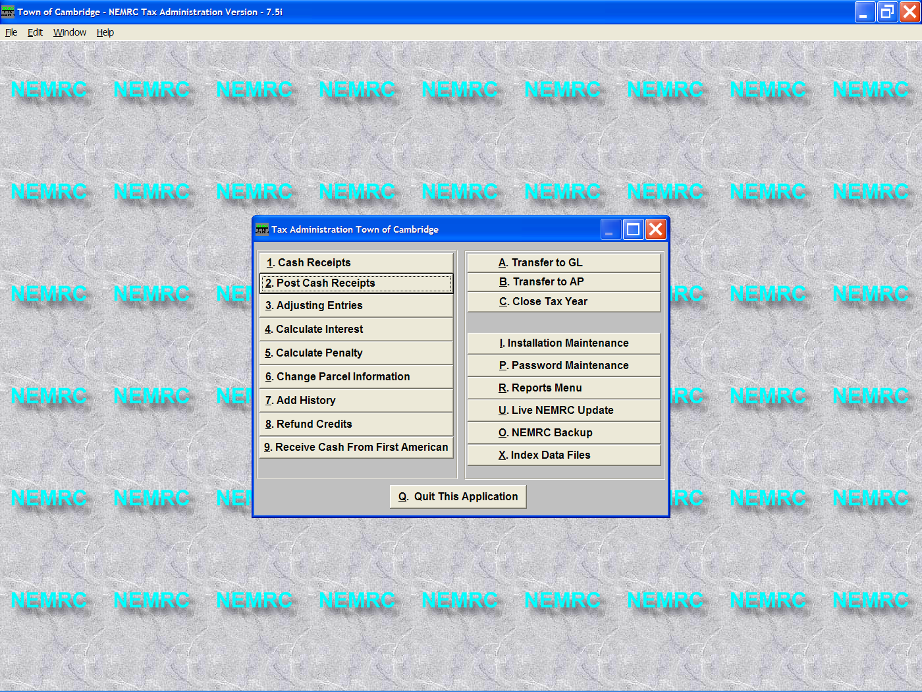
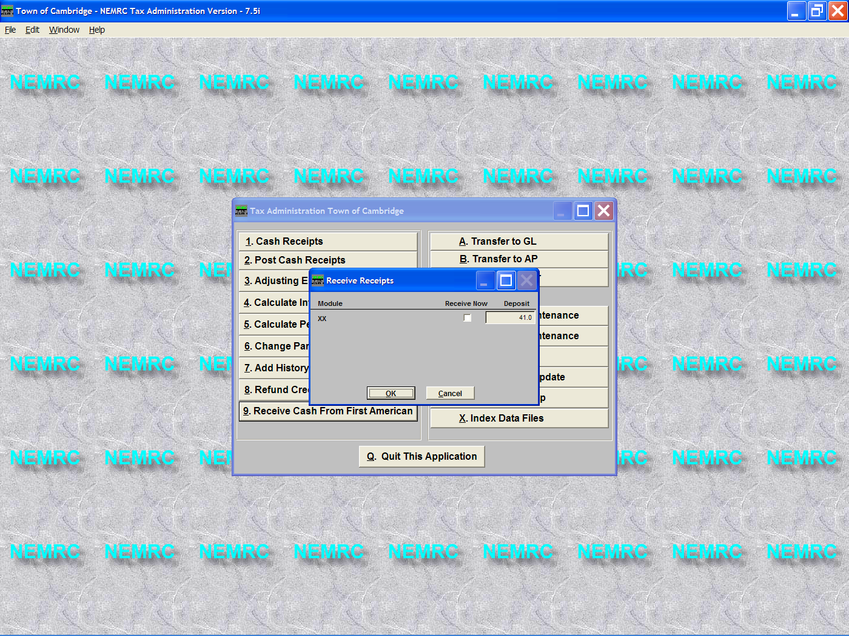
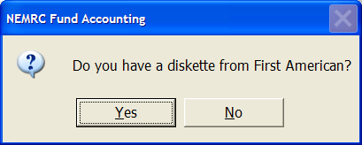
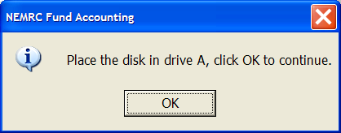
- Now place a check mark in the box under ‘Receive Now’ and enter the deposit # you would like these entries to be posted on.
NOTE: In most cases you will be accepting the default deposit #.
First American now has the ability to send you a file that will allow you to post receipts on parcels that they are making payments. This import routine will allow you to print reports to verify what parcels are being credited and the amount that is being applied.

1. Click the button on the ‘9’. Receive Cash from First American on the Main Menu
2. Click Yes on the window on the Left. Then insert the diskette that has the file that First American sent you and press OK.

4. Once the file has been imported you will have the option to review the data that was imported.
This is the same as the temporary cash receipts report that you normally use. Below is an example of how the report will appear.

11/14/04 Town of Cambridge Tax Administration Page 1
06:39 pm Transferred Cash Receipts Report
For Temp. Deposit 41.0, Detail, In Name Order

Parcel Year Name Date Deposit Check # Receipt Amount
------------------------------------------------------------------------------------------------------------------------------------
00275310-000 2004 86 HIGH STREET REALT 11/14/04 41.0 FIRSTAM 924.57
00265324-000 2004 ADAMS BARRY I 11/14/04 41.0 FIRSTAM 529.90
00245105-000 2004 ADAMS MELISSA A 11/14/04 41.0 FIRSTAM 752.93
00060247-000 2004 ALDRICH RANDALL S 11/14/04 41.0 FIRSTAM 772.71
00325603-200 2004 ALEXANDER DALE E 11/14/04 41.0 FIRSTAM 729.21

-------------------- Cash Receipts Report Summary ------------- 2 of 2
--------------------------------------------------------------------------------
2004 Principal Interest Penalty Other Credits Total
--------------------------------------------------------------------------------
Misc. 0.00 0.00 0.00 0.00 0.00 0.00
Payment 1 0.00 0.00 0.00 0.00 0.00 0.00
Payment 2 1074.00 0.00 0.00 0.00 0.00 1074.00
Payment 3 265397.57 0.00 0.00 0.00 0.00 265397.57
Payment 4 3410.29 0.00 0.00 0.00 0.00 3410.29
--------------------------------------------------------------------------------
Total 269881.86 0.00 0.00 0.00 0.00 269881.86
Total Cash: $0.00 Total Checks: $269,881.86
Total Principal Interest Penalty Other Credits Total

Misc 0.00 0.00 0.00 0.00 0.00 0.00
Payment 1 0.00 0.00 0.00 0.00 0.00 0.00
Payment 2 1074.00 0.00 0.00 0.00 0.00 1074.00
Payment 3 265397.57 0.00 0.00 0.00 0.00 265397.57
Payment 4 3410.29 0.00 0.00 0.00 0.00 3410.29
--------------------------------------------------------------------------------
Total 269881.86 0.00 0.00 0.00 0.00 269881.86
Total Cash Received: $0.00 Total Checks Received : $269,881.86
Total Current Years: $269,881.86 Total Previous Years: $0.00
Total of Receipts: $269,881.86

5. Post Cash Receipts. If everything on the report above is correct then simply Post Cash Receipts as you normally would to apply these receipts.

