- First print your ‘Available Credit’ report from the Reports menu.
- Next select ‘3 Adjusting Entries’ from the Main menu.
- Now choose ‘B Apply Credits in a Year’

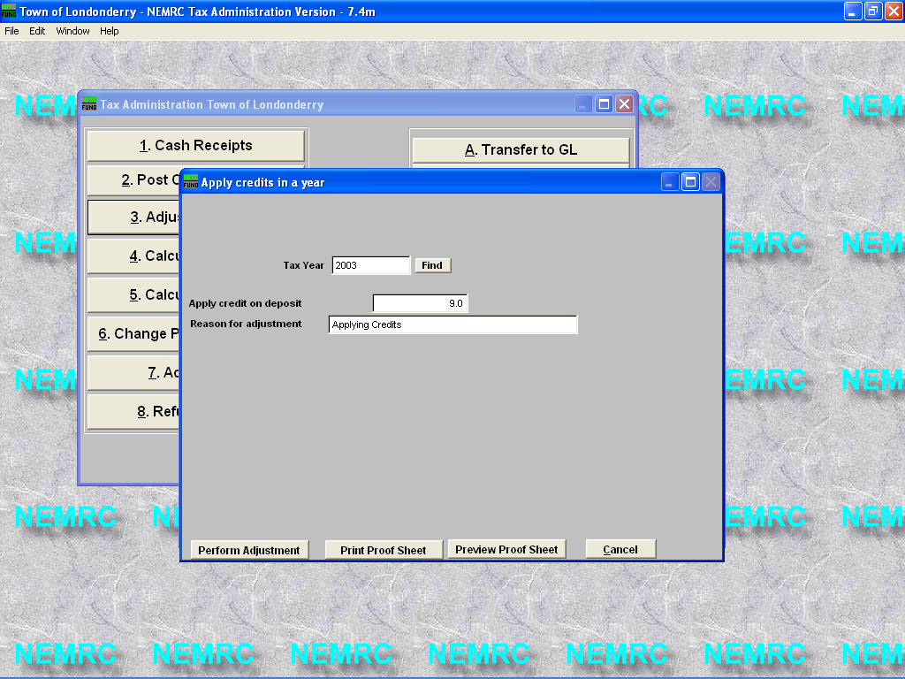
- Select the Tax year that contains the credits to be applied.

- Accept the default deposit number

- Enter a reason for applying the credits.

- Print a Proof sheet this will list all of the parcels that will be affected by this process.

- Press the Perform Adjustment button to execute this procedure.
- Remember to Select ‘2 Post Cash Receipts’ on the Main Menu to apply the transaction.

