Windows Land Records

Windows Land Record program is now available!

Features:

- Unlimited number of Grantors and Grantees
- Remembers the last page number you recorded.
- Preview on all reports
- Update software via internet
- On line backup feature
- Grantee may be left empty
- Informs you of number of cards being printed
- CTRL + D / CTRL + T enters current date / time

Adding Land Records
Enter unlimited Number of Grantors & Grantees

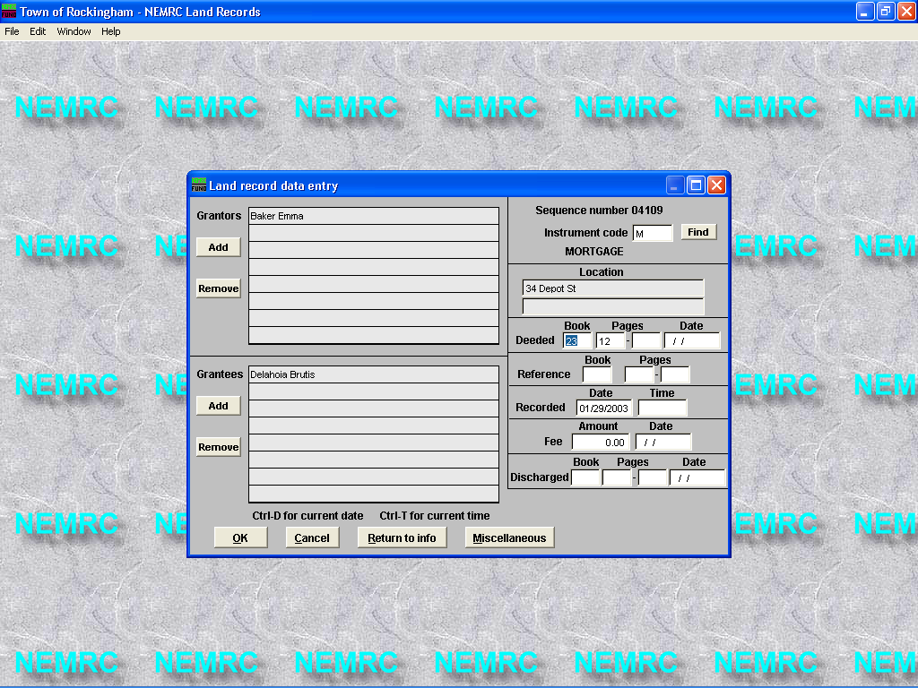
Click “Add” button to begin entering grantors & Grantees

Inserts next page to be recorded automatically

Recorded date defaults to current date.

Insert current dates & times by using hot keys.
All dates & Book/pages show on one screen.

Index card printing

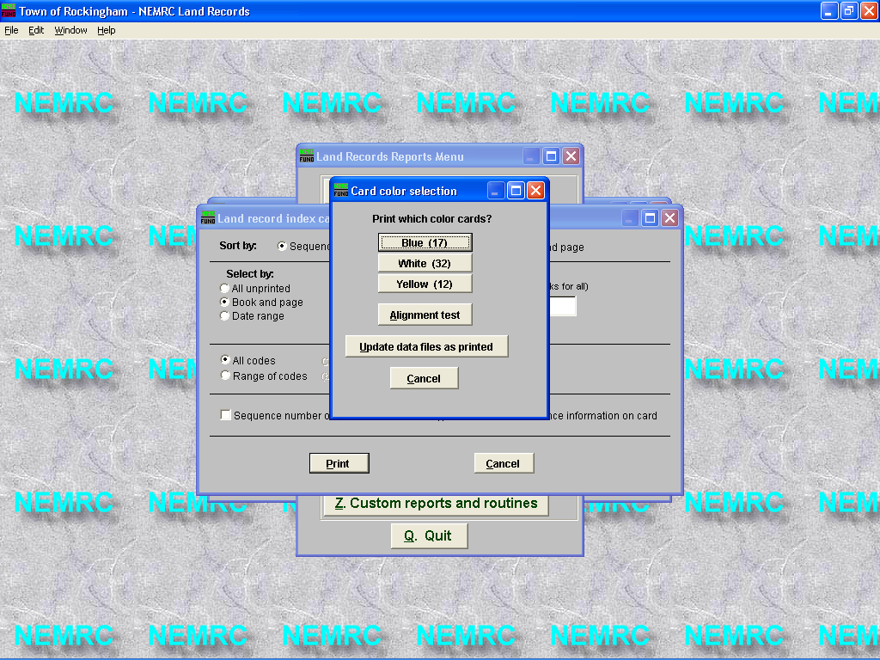
Displays # of cards to be printed.
Marks instruments as printed.

