Figuring out what your tax rate or amount to be raised should be. This document will also show you how to compute your Local agreement rate if applicable. Below are instructions on how you use this feature

1. Print the 411 from the ‘Reports’ menu option ‘4’. This report has all of the grand list figures you need to help you figure out your tax rates.

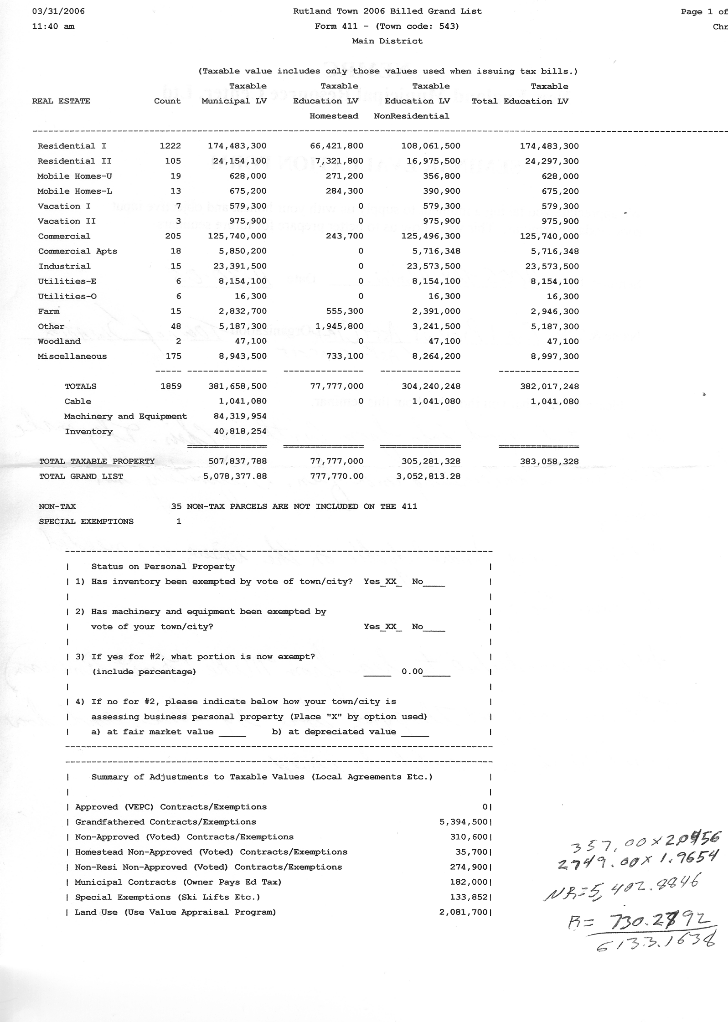

If you have Non Approved contracts in your grand list you must show a ‘Local Agreement’ tax rate on your tax bill. This is to make up the education money that will not be raised due to these contracts. Page 4 of this document will explain how to compute the Local Agreement tax rate.

2. Click on the ‘Calculate Taxes’ button on the ‘Main Menu’

The process on this page shows you how to figure out your amounts to be raised.

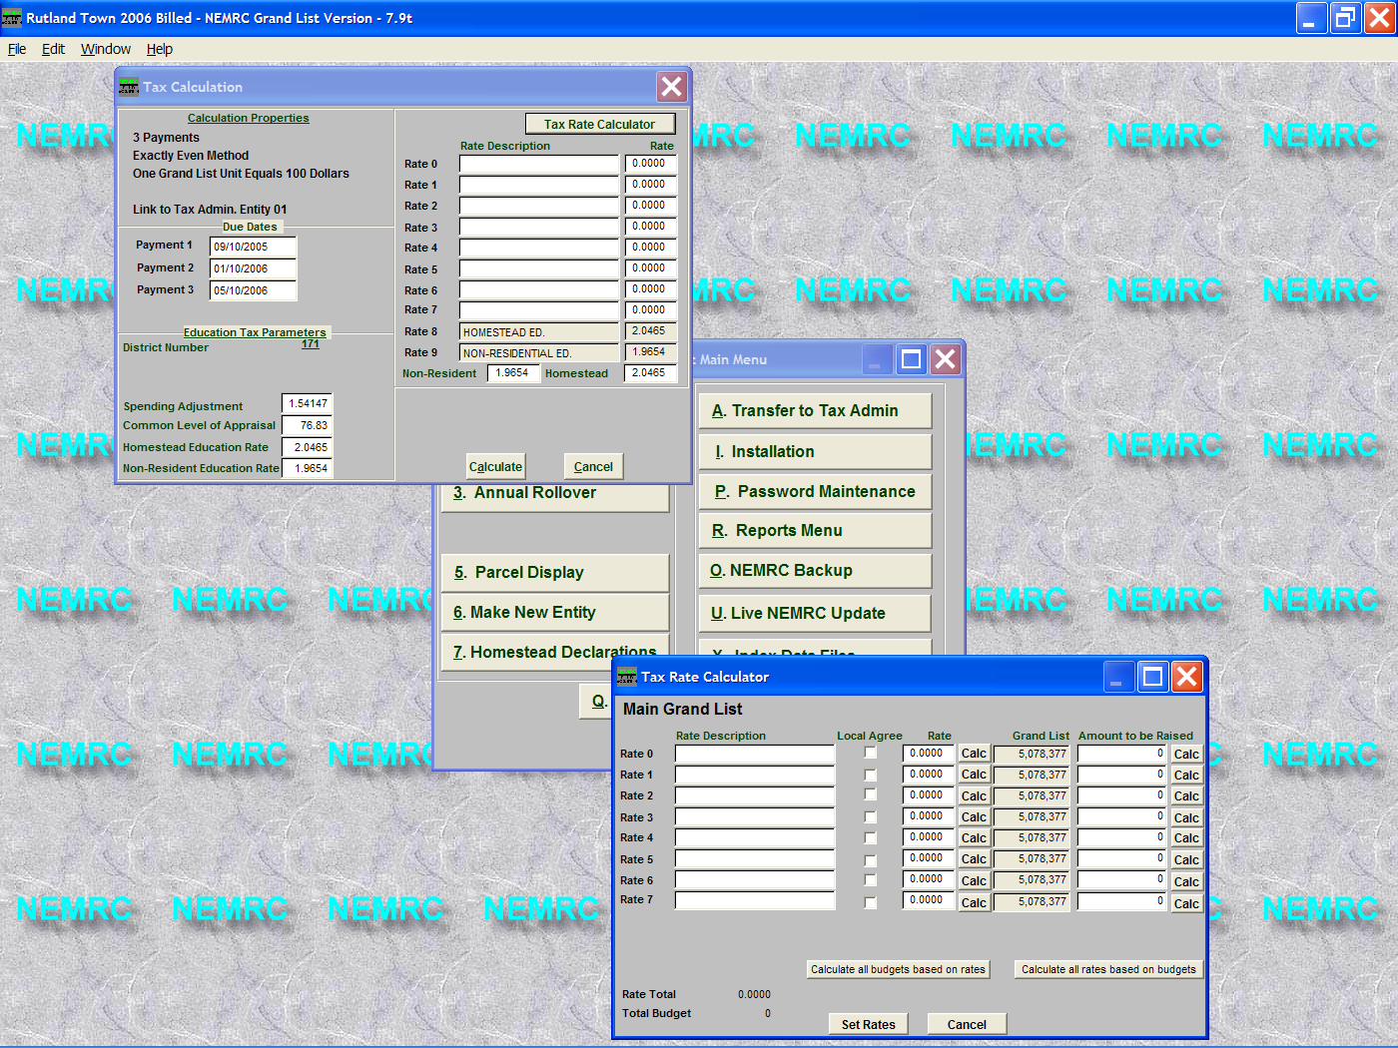
Enter the tax due dates
The ‘Tax Rate Calculator’ will assist you with computing your tax rates and show you the amount to be raised.

The window below will appear.

Enter the Education tax rate information as provided by the Tax Department.

A. Type the tax rate name.

B. Type in the tax rate if it has been provided for you.

C. Press this ‘Calc’ button and the program will fill in the ‘Amount to be raised’. By multiplying the (taxrate x grand list figure shown).
Make sure you are raising enough money before your print your tax bills…

D. This button will calculate all of the ‘Amounts to be raised’ for all of the tax rates entered.

E. Once all the rates are correct press the ‘Set Rates’ button. This will automatically place your tax rate names and rates on the ‘Tax Calculations’ screen seen above in this picture. Advance to step F on the next page.

Calculating rates by entering the Amount to be Raised

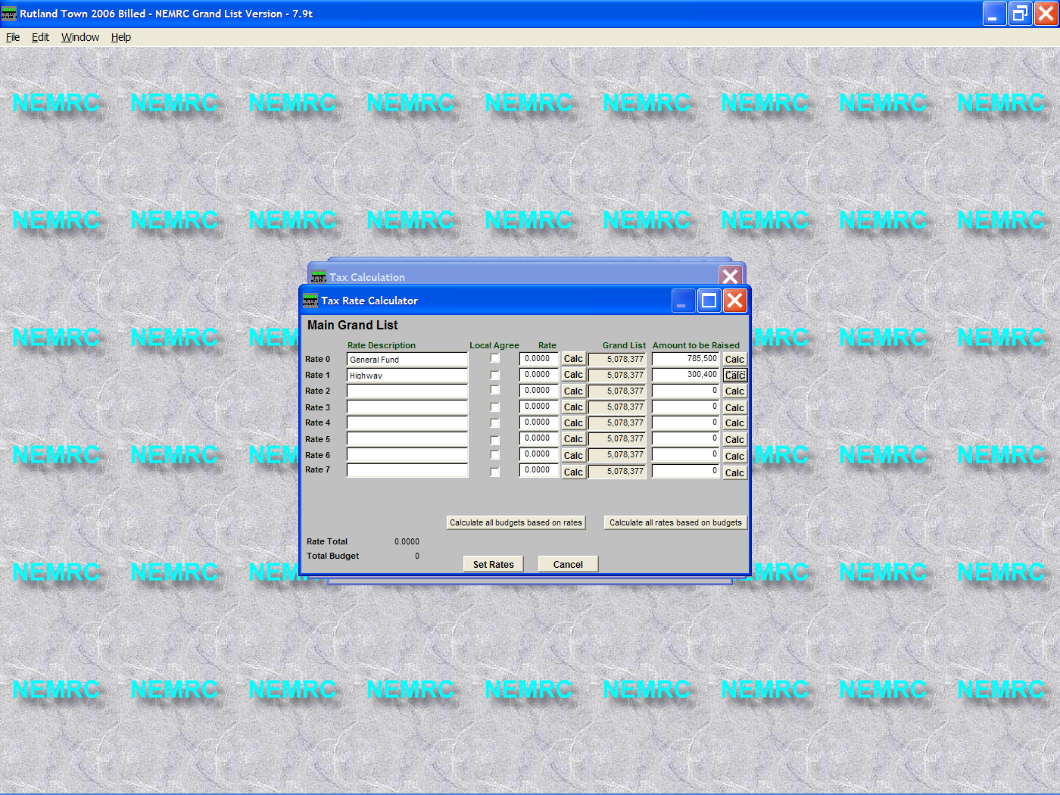

A. If you know the amount you need to raise in taxes type it in the space provided. (Leave the Rate box empty)
B. Pressing this ‘Calc’ button will automatically compute your tax rate by dividing the amount to be raised by the grand list.
(Amount to be raised / Grand List)

C. You can calculate all of your tax rates at once with this button once you have entered all of your tax rate names and amounts to be raised.

D. Once all the rates are correct press the ‘Set Rates’ button. This will automatically place your tax rate names and rates on the ‘Tax Calculations’ screen seen below

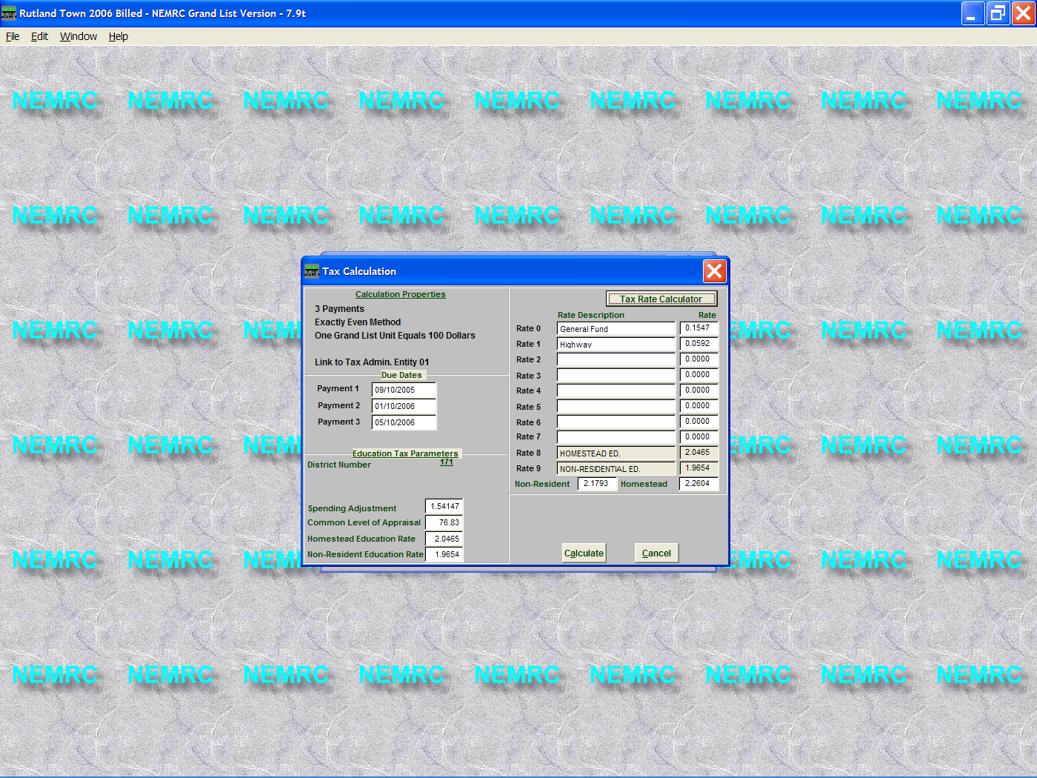

F. Now review the rates and names to make sure they are correct.

G. Press the Calculate button to calculate these rates for all taxable parcels.

You can calculate taxes as many times as you like until you actually print the tax bills.

H. Now go to the ‘Reports’ menu and select ‘5 Tax Book’ with no detail. This will confirm that you are raising enough money.

Calculating your Local Agreement tax rate.
Cities and Towns will have a Local Agreement rate when they have entered into a contract with an organization to exempt that organization from property taxes. These are known as Voted exemptions that have not been grandfathered and should not be confused with parcels that are tax exempt by statute. For example, Churches, Schools, Municipal buildings etc…
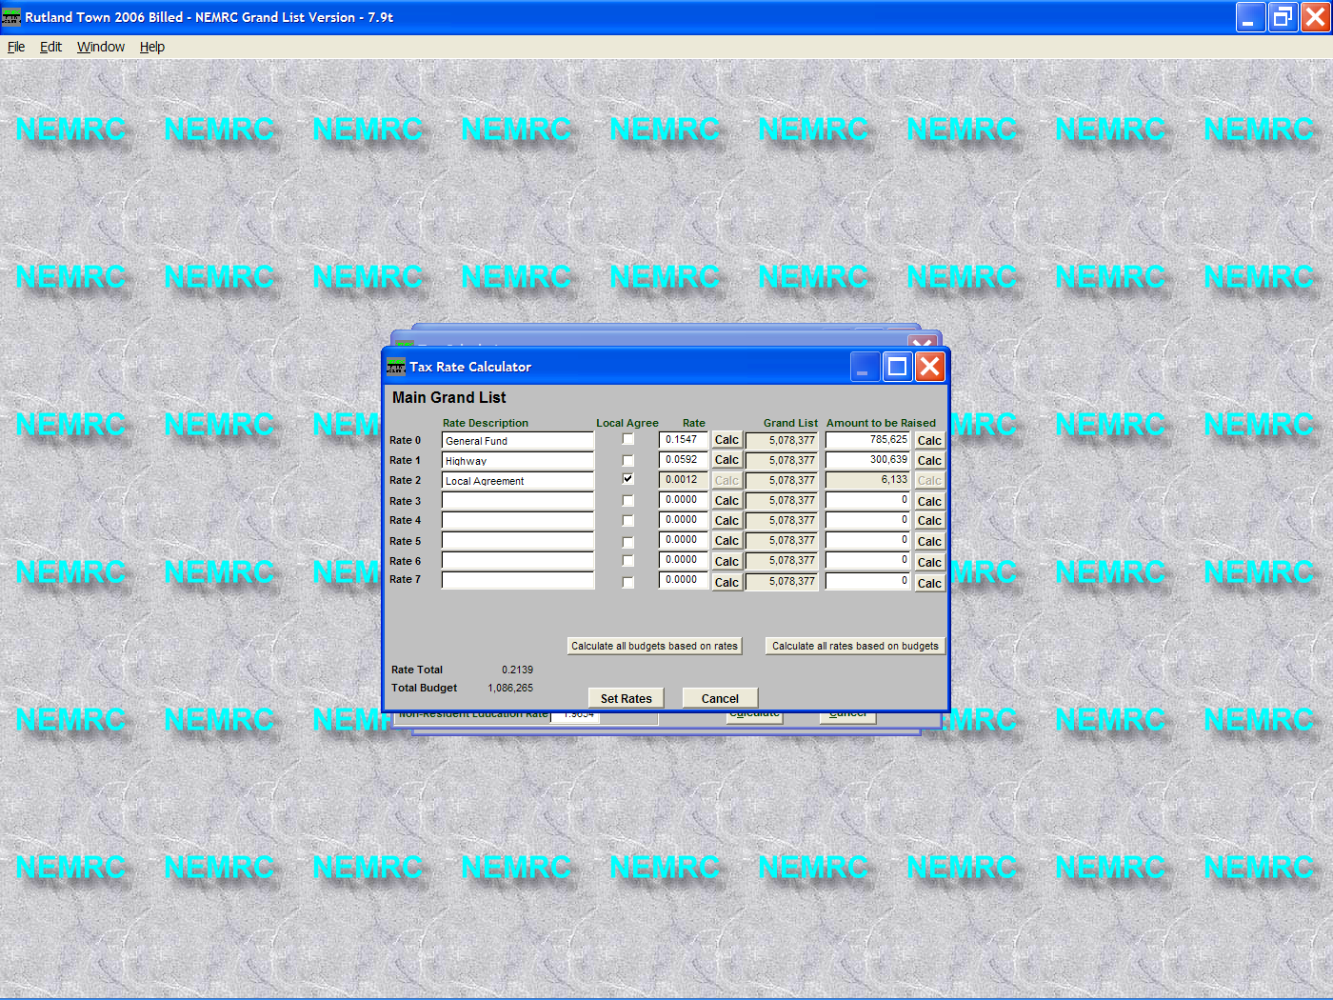
The Local Agreement rate is figured out by using this formula.
Take the amount of the ‘Homestead Non-Approved (Voted) Contracts/Exemptions’ and the Non-Resi Non-Approved (Voted) Contracts/Exemptions From the 411 on page 1 of this document and multiply them by .01. Then multiply them by the ‘Homestead Education’ and ‘ Non Residential Education’ tax rate provided to you by the Tax Department.

In this example
‘Homestead Non – Approved (Voted) Contracts/Exemptions’: 35,700 x .01 = 357.00
‘Non-Resi Non-Approved (Voted) Contracts/Exemptions’: 274,000 x .01 = 2,740.00

Multiply the Homestead non approved value by the Homestead Education Rate.
This is the amount of money these parcels would have contributed to the ‘Homestead Education’ tax rate if they did not have a contract on them.

357.00 x 2.0465 = 730.60

Next Multiply the Non – Resi Non approved value by the Non Residential Education tax rate. This is the amount of money these parcels would have contributed to the ‘Non Residential Education’ tax rate if they did not have a contract on them.

2,740.00 x 1.9654 = 5,385.20

Then add the 730.60 + 5,385.20 = 6,115.80. This is the total amount of education money that the City/Town will need to make up and send for education money. Also know as the short fall.

Finally take the total 6,115.80 / by the Municipal Grand List the result is your tax rate.

6,115.80 / 5,078,377 = 0.0012 The result is the Local Agreement Tax rate.
If you check the “Local Agreement’ check box your Local Agreement tax rate will be calculated automatically.

