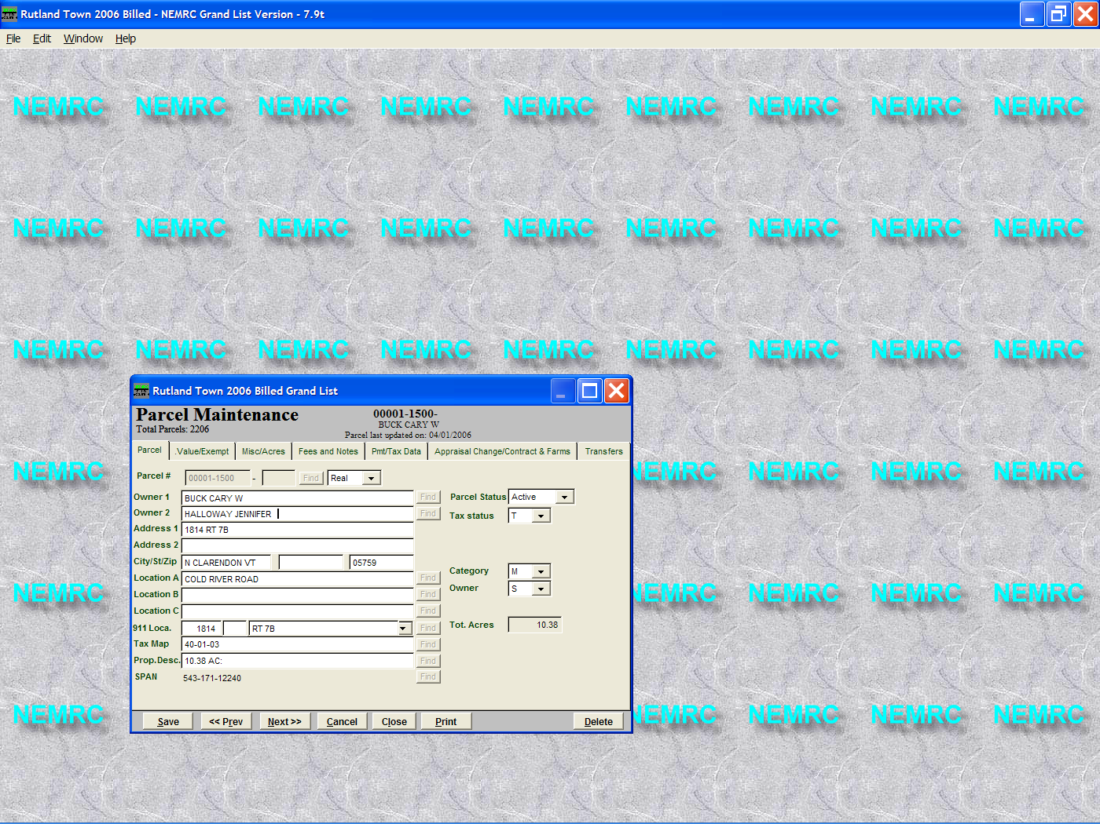
Whenever you make a change to an ‘As Billed’ Grand list a message appears that asks ‘Send changes to current grand list?’ This was created to reduce the amount of double entry that the end users would have to do.

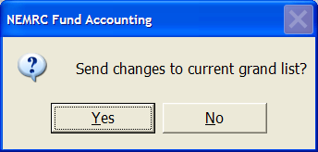

When you select ‘Yes’ it will update the entire record in the current grand list.
For Example: If this parcel was flagged for a change of appraisal in 2005 and you have already cleared your change of appraisal flags in the current grand list this parcel would show up as being flagged again in the current grand list..

