Result of Grievance
Once the Change of Appraisal hearings are over you may print a 'Result of Grievance' letter for the appropriate parcels. This is done on the ‘Parcel Maintenance’ ‘Appraisal Change / Contracts and Farms’ tab. As seen in the picture below.

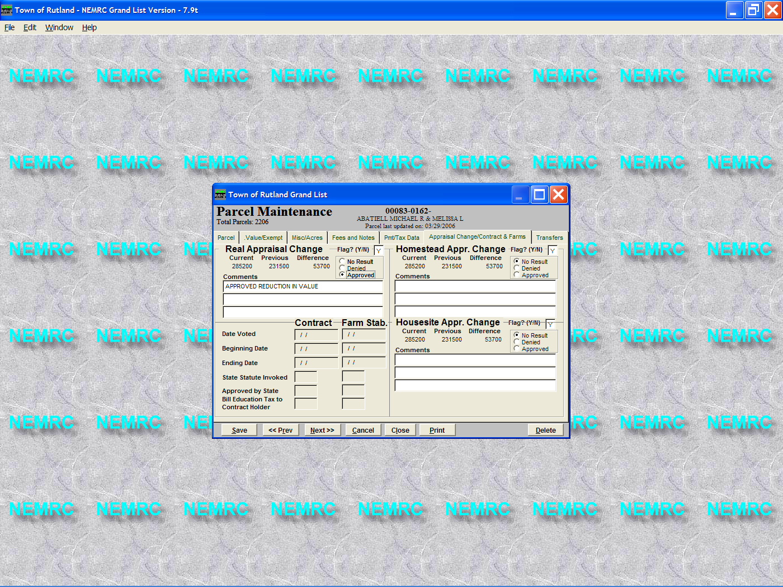
.

3. Enter your remarks in the corresponding comment areas.
In this example we only approved the Real value changes and only have a remark in the Real value comments section.
1. You will notice that there are 3 separate Grievance flags and 3 separate Results of Grievance radio buttons. They are circled below. 1 for Real value changes, 1 for Homestead changes, and 1 for Housesite changes. You must make a selection in each area in order for that value to be present on the result of grievance notice.
2. DO NOT REMOVE your original grievance flag….
4. Only do this step if you are linked to the Microsolve Cama software. This routine will move all of your current values to the previous value fields for those records that were flagged as ‘Approved’ for a result of grievance. Now you can import your revised cama values for the appropriate parcels.
A. On the main menu select the ‘Annual Rollover’ button
B. Check the box under ‘Perform on Results of Grievance Approved ONLY’
C. Check the box under ‘Perform Now’
LEAVE ALL OTHER CHECK BOXES BLANK AT THIS TIME.
D. Press the ‘Ok’ button

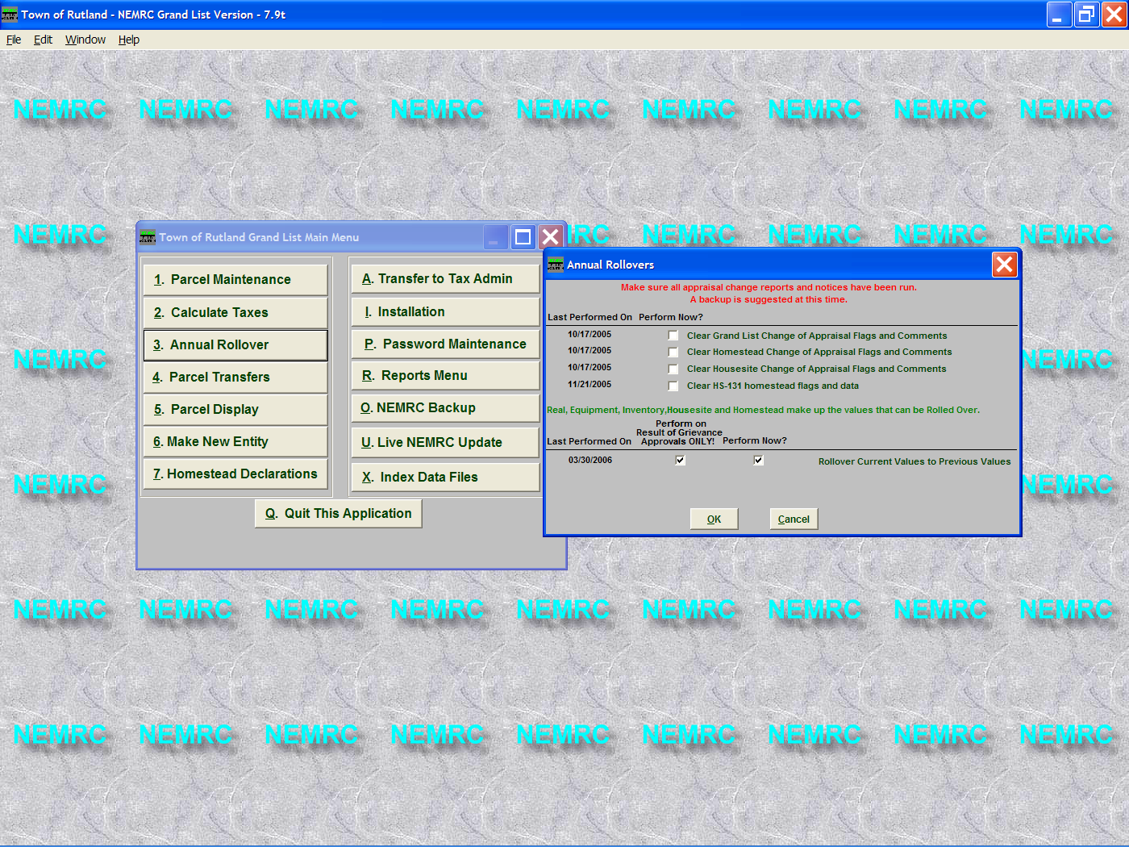

5 Now go to the 'Grievance Process' report option on the 'Reports' menu and click on the 'Grievance' tab. Select the 'Result of Grievance' option as seen below. Then begin printing your Result of Grievance notices.

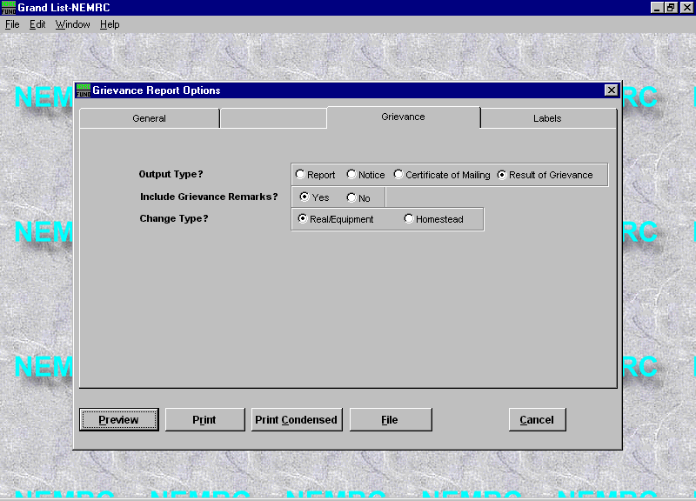
6. Below is a sample of the ‘Result of Grievance’ letter. When folded properly the name and address will fit in a standard number 10 envelope.
