You may move all non – value grand list data from one Entity to another. Or move the non value data from one computer’s grand list to another computer’s grand list. Many Listers do this process when they are going through a reappraisal. For instance, a reappraisal may not be scheduled to be complete for 2 or more years. The Listers still have to maintain a grand list for those years until the new reappraisal grand list is finished. Instead of making name and address changes to a current grand list and the reappraisal grand list you may maintain one grand list then import all of the non value data to the reappraisal grand list all at one time. Below are the steps that will guide you through the process.

1. Exporting non value data. Enter the grand list entity that has the current non value data you want to move.
2. On the Report menu select (‘I’ Assessor/Lister Actions)

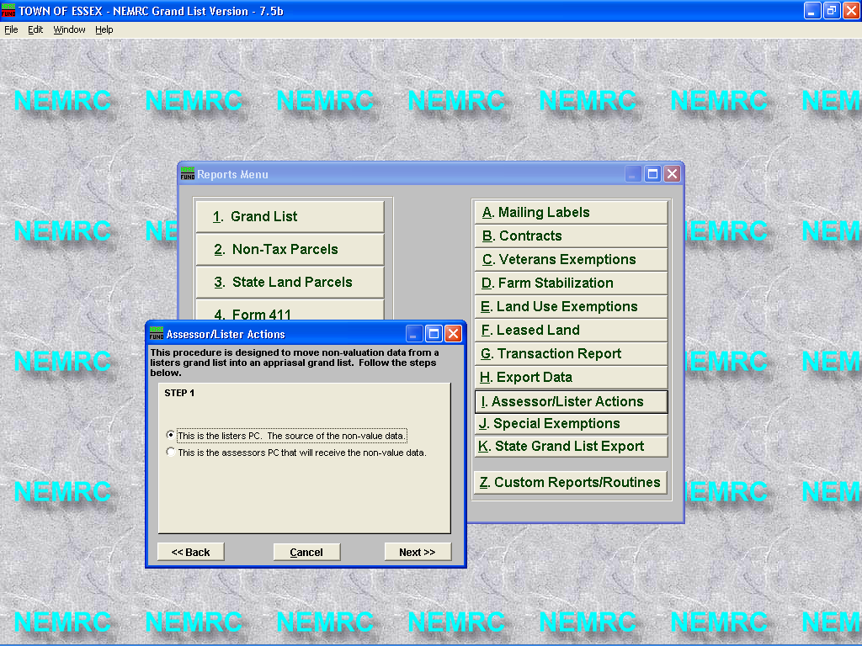

3. Select the top option – The source of the non value data. Then Click the ‘Next’ button.

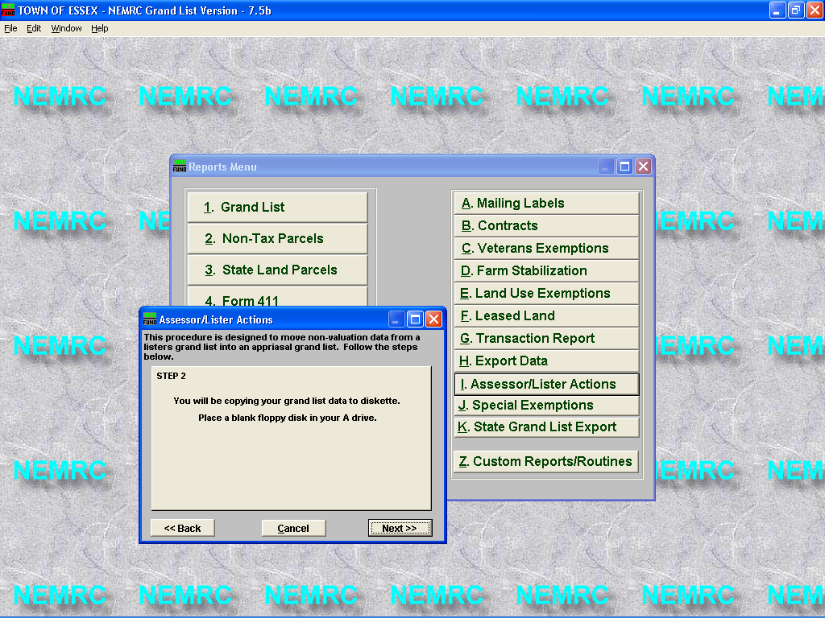

4. Data will be copied to a diskette. Insert a diskette into drive A: and click the ‘Next’ button

5. Once data is copied to the diskette click the ‘Ok’ button on these 2 windows. Eject the disk and take it to the computer that needs the updated information.

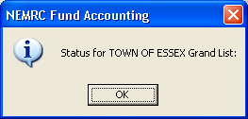

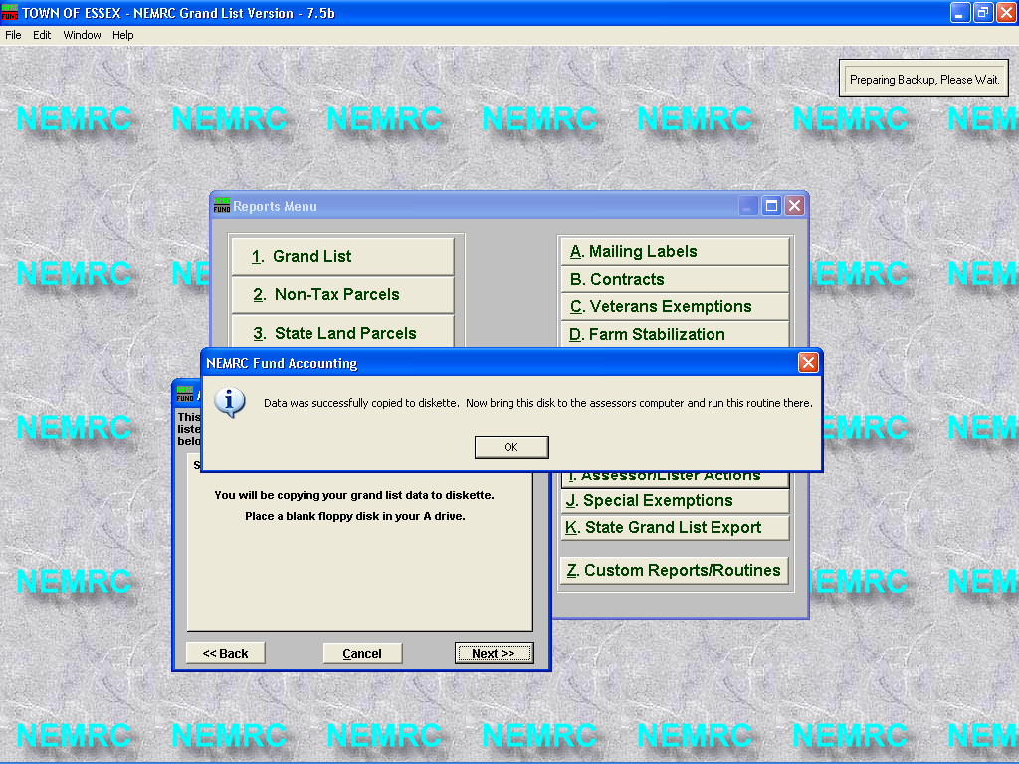

Importing the non value data to another Grand list entity. If the grand list to receive the non value data is on the same computer then exit the grand list that the non value data was extracted.
Open the grand list that will receive the non value data. In this example we will be importing the data to Entity # 3 Essex Reappraisal 2006.
Once the proper grand list has been accessed go to the report menu and select (‘I’ Assessor/Lister Actions)

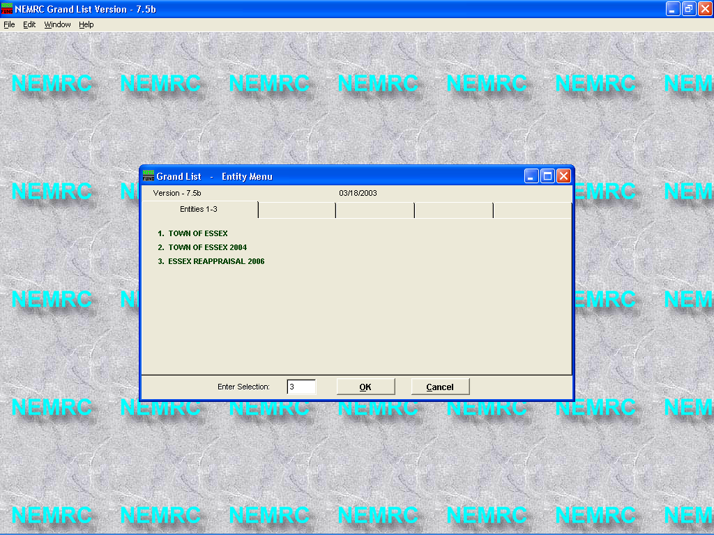

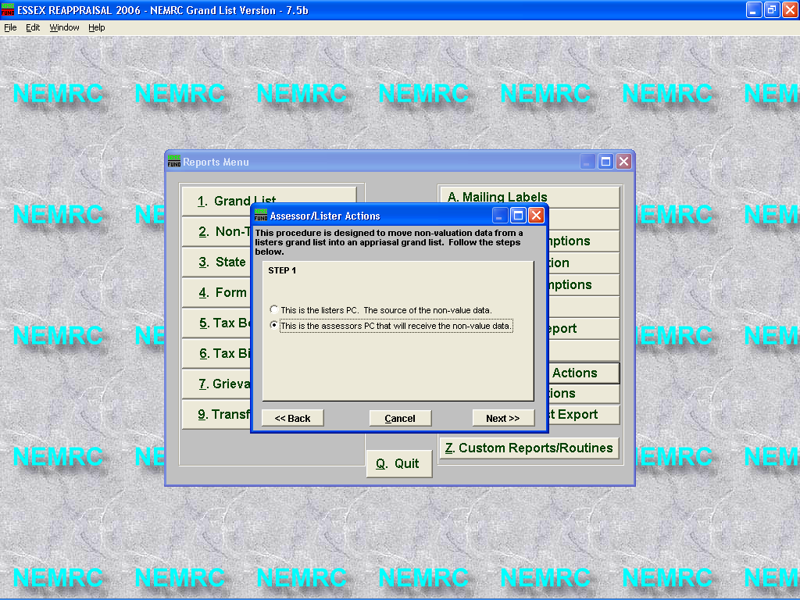
10. Select the second option as seen below. This is the pc that will receive the non value data. Then click the ‘Next’ button.

11. Place the diskette with the non value data in drive A.
12. Enter the Entity number of the grand list from which the non value data was extracted. In this example the Entity number was # 1. If you refer to the entity screen on the previous page you will see Entity #1 is the Town of Essex. In this example that is our working grand list. Then Press the ‘Next’ button.

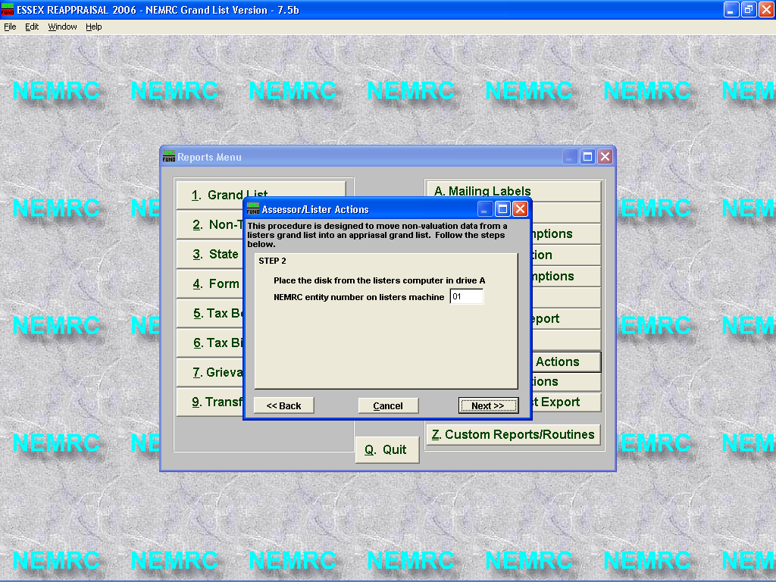

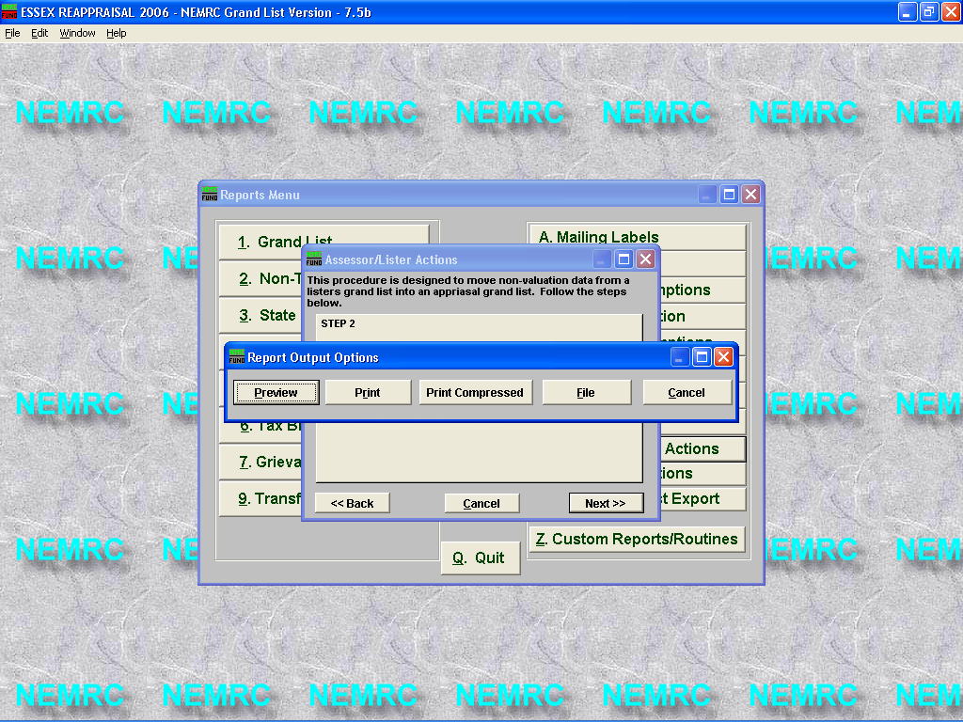
13. Report options appear, this report will display any parcel that has been added to the ‘Assessors’ grand list and parcels that have been removed from the Listers grand list. It is up you to verify why these parcels have been added or deleted. In the example below the parcel 0002.999 is a # that does not exist in the Listers grand list. Parcels 0001 & 0005 exist in the Listers grand list but do not exist in the ‘Assessors’ grand list.

03/18/2003 ESSEX REAPPRAISAL 2006 Grand List Page 1
09:05 pm Exceptions Report

Parcel ID Name Problem
----------------------------------------------------------------------------- 0002.999 SMITH TIM In Assessors Grand List NOT in Listers Grand List

0001. RODRIGUEZ, NANCY M In Listers Grand List NOT in Assessors Grand List

0005. SHERMAN, DUANE M In Listers Grand List NOT in Assessors Grand List

