You may move all of your grand list data from one Entity to another. Or move all data from one computer’s grand list to another computer’s grand list. Many Listers do this process when they are going through a reappraisal. For instance, a reappraisal may not be scheduled to be complete for 2 or more years. The Listers still have to maintain a grand list for those years until the new reappraisal grand list is finished. Instead of making changes to a current grand list and the reappraisal grand list you may maintain one grand list then import all of the data to the reappraisal grand list all at one time. Below are the steps that will guide you through the process.
BACK UP YOUR DATA BEFORE YOU RUN THIS ROUTINE.

1. Exporting data - Enter the grand list entity that has the current data you want to move.
2. On the ‘Reports’ menu select ‘I’ Assessor/Lister Actions

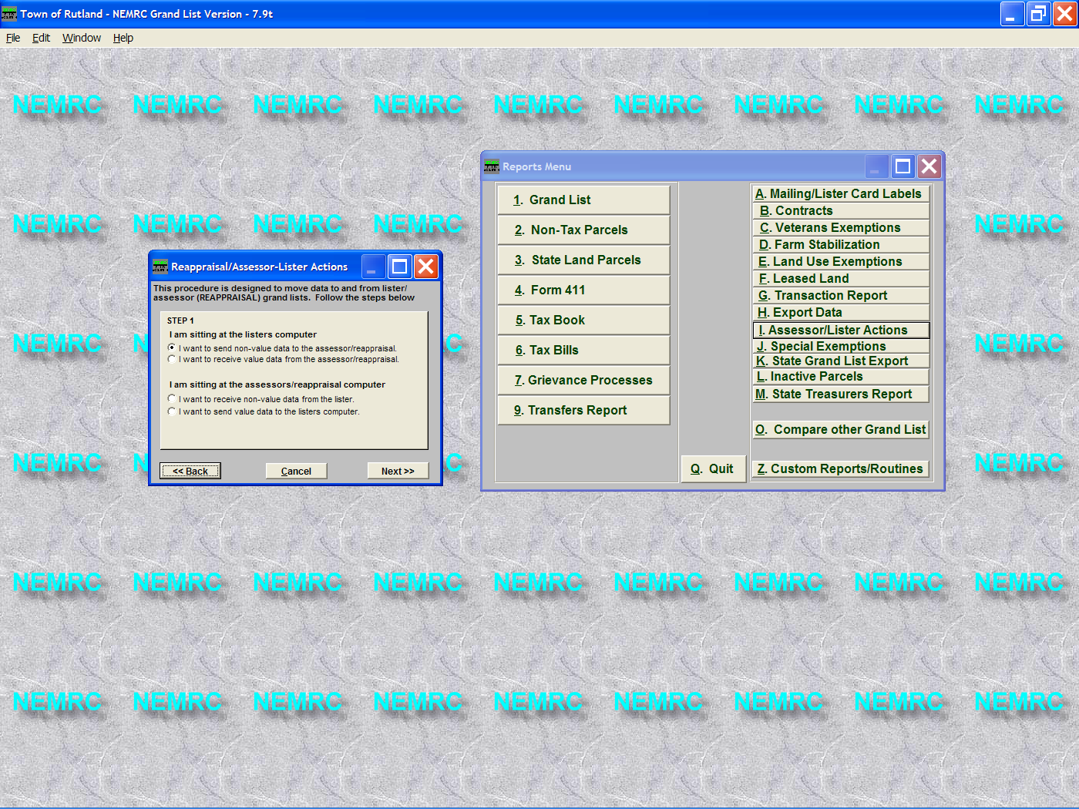

3. Select the top option – ‘I want to send Non Value data’ The source of the data. Then Click the ‘Next’ button.

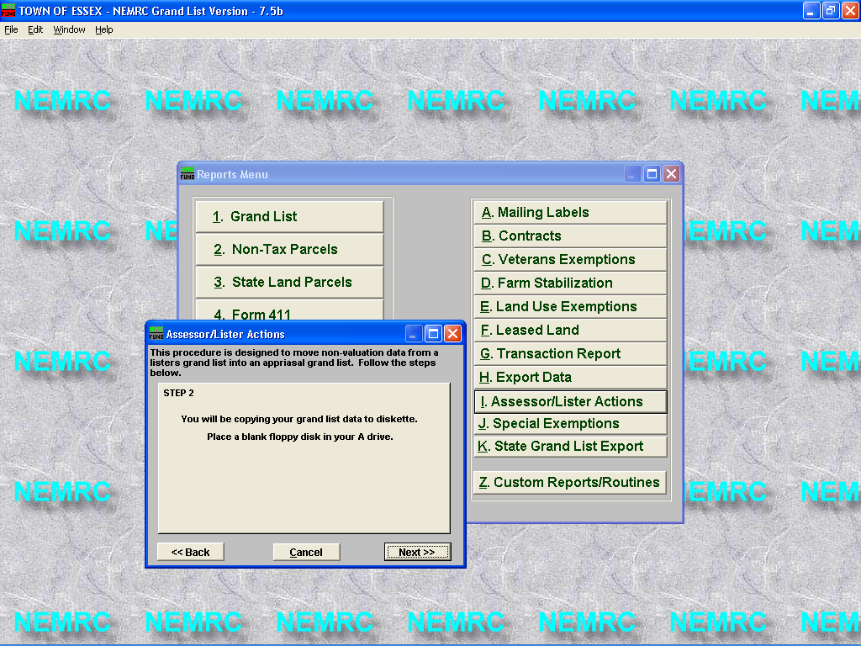
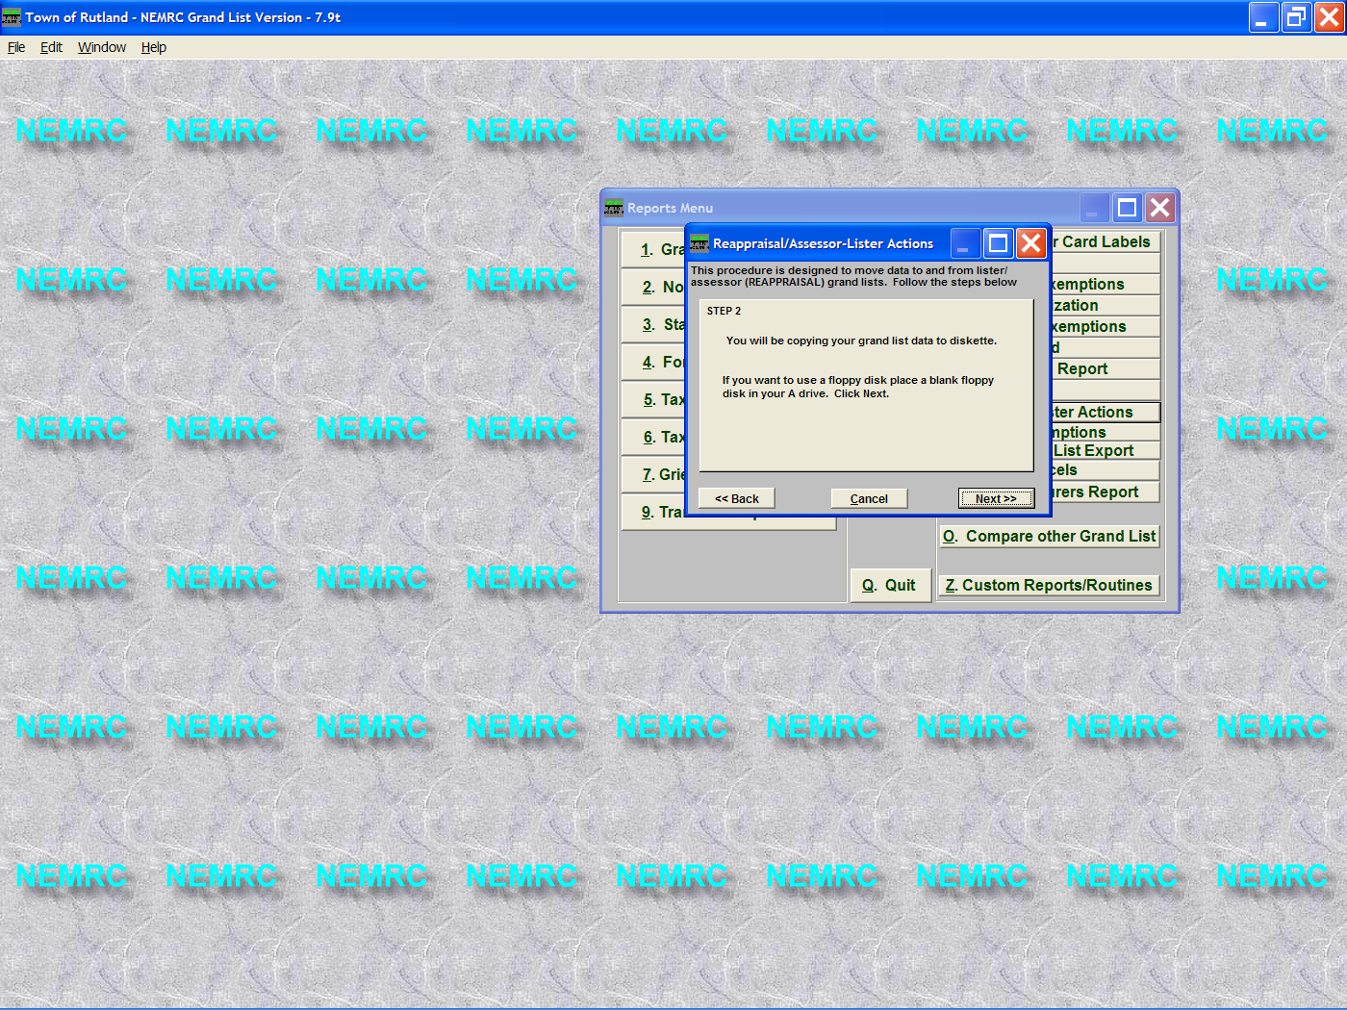

4. Data can be copied to a diskette. Insert a diskette into drive A: and click the ‘Next’ button.
If the grand list you want to update is located on the same computer then you may proceed without a diskette. The program will save the appropriate file to your NEMRC directory.

5. Once the data is copied to the diskette or the NEMRC directory click the ‘Ok’ button on the confirmation window. Eject the disk and take it to the computer that needs the updated information. (If you had to use a diskette).

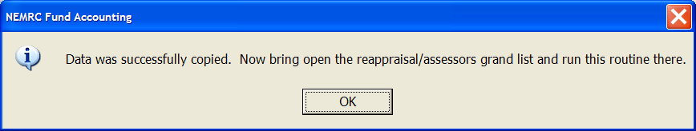

Importing the data to another Grand list entity. If the grand list to receive the data is on the same computer then exit the grand list that the data was extracted.
Open the grand list that will receive the data. In this example we will be importing the data to Entity # 60 Rutland Town 2006 Reappraisal 2006.
Once the proper grand list has been accessed go to the ‘Reports’ menu and select ‘I’ Assessor/Lister Actions.

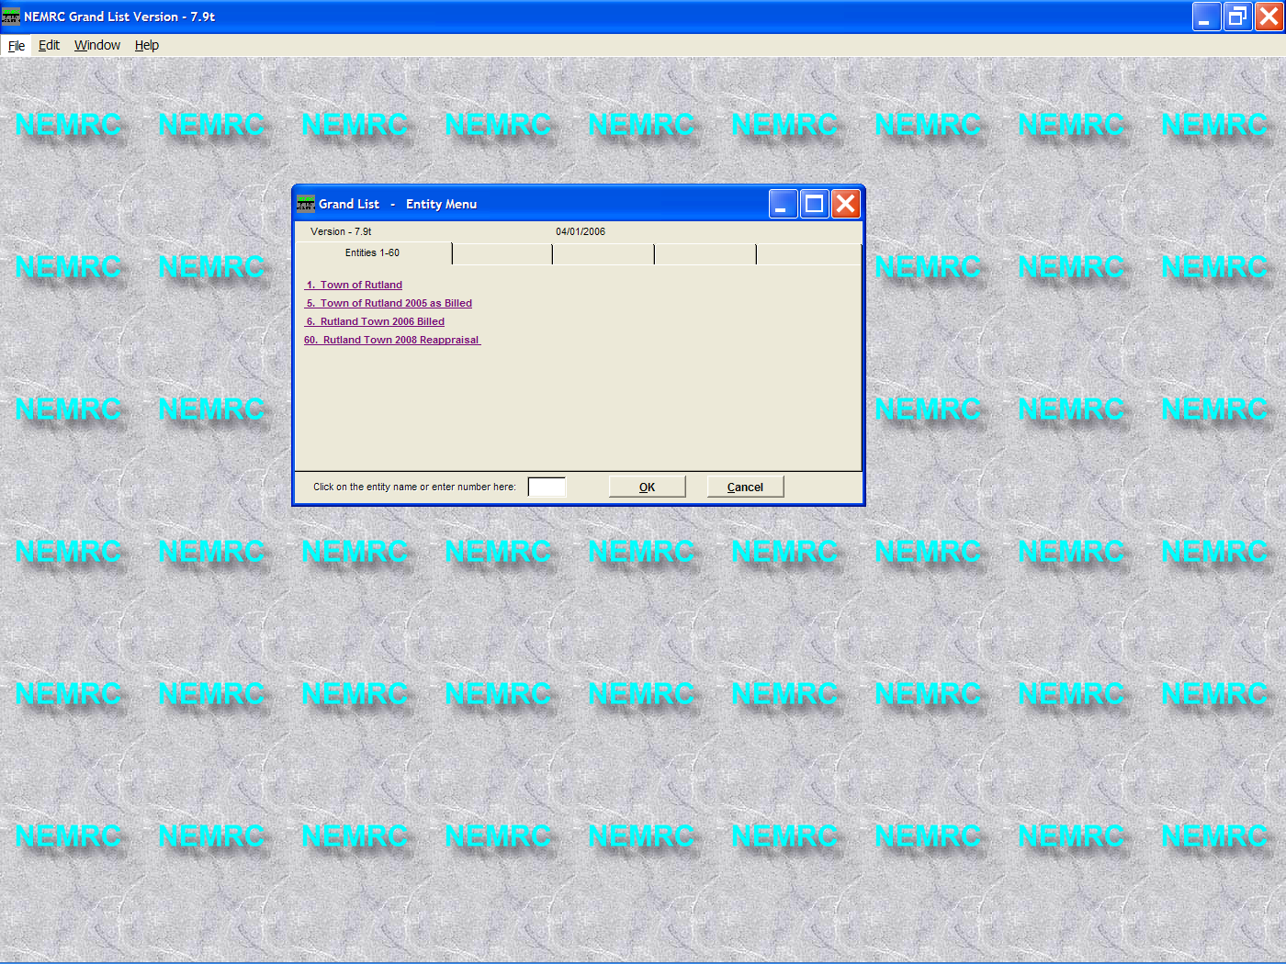

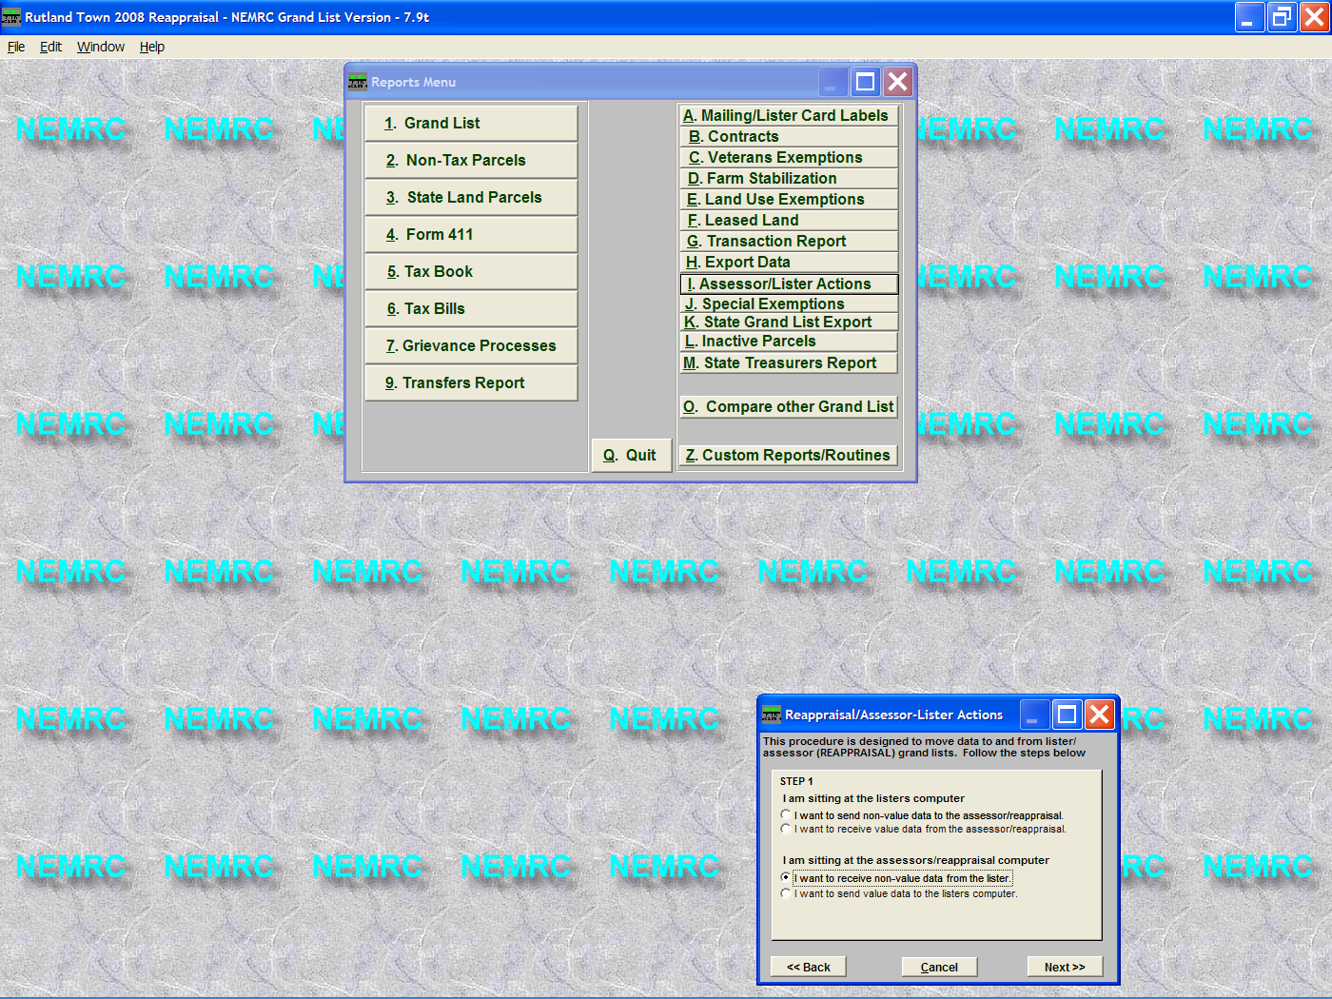

10. Select the radio button under ‘This is the pc that will receive the non value data’. Select the type of data you are trying to import ‘Non value’ or Value data. (In this handout we are moving ‘Non value’ data from our current grand list.)
11. Click the ‘Next’ button.

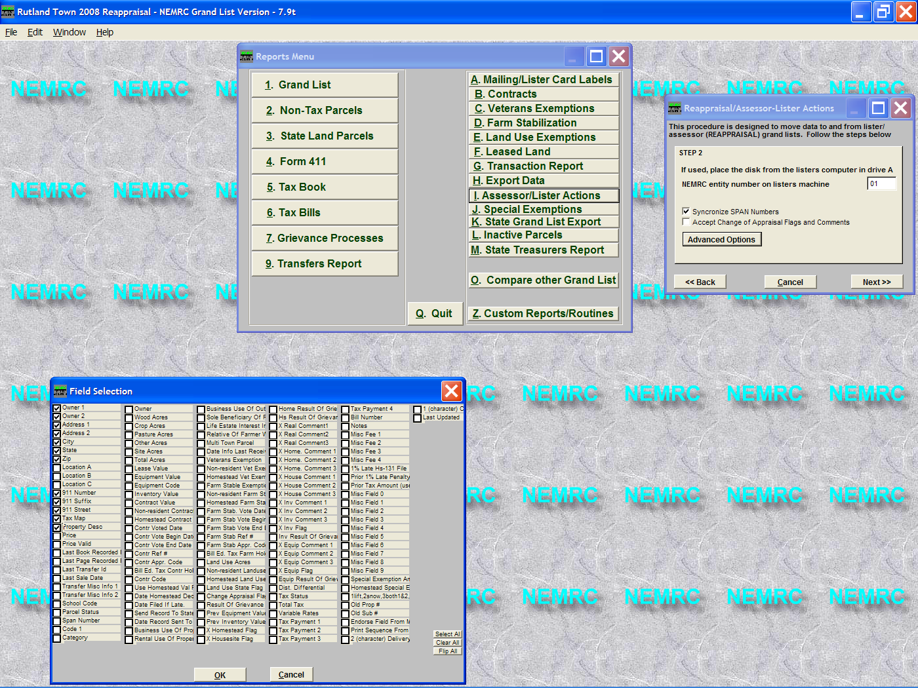

14. Synchronize Span #’s – When a reappraisal takes more than 1 year to complete the span #’s on parcels that the Assessors added might not be the same as the ones in your current working grand list. It is VERY important that you synchronize them before you use the reappraisal grand list. Failure to do so could result in taxpayers having incorrect span numbers to file.
15. ‘Accept Change of Appraisal Flags and Comments’ – If you check this box it will move all of your change of appraisal flags from your export data into the grand list you are currently working in. In this example we exported from entity #01 and are importing that data into entity 60 the reappraisal grand list.

12. Place the diskette with the non value data in drive A. If you did not use a diskette skip to step 13.
13. Enter the Entity number of the grand list from which the data was extracted. In this example the Entity number was # 01. If you refer to the entity screen on the previous page you will see Entity # 01 is the Rutland Town. In this example that is our working grand list.

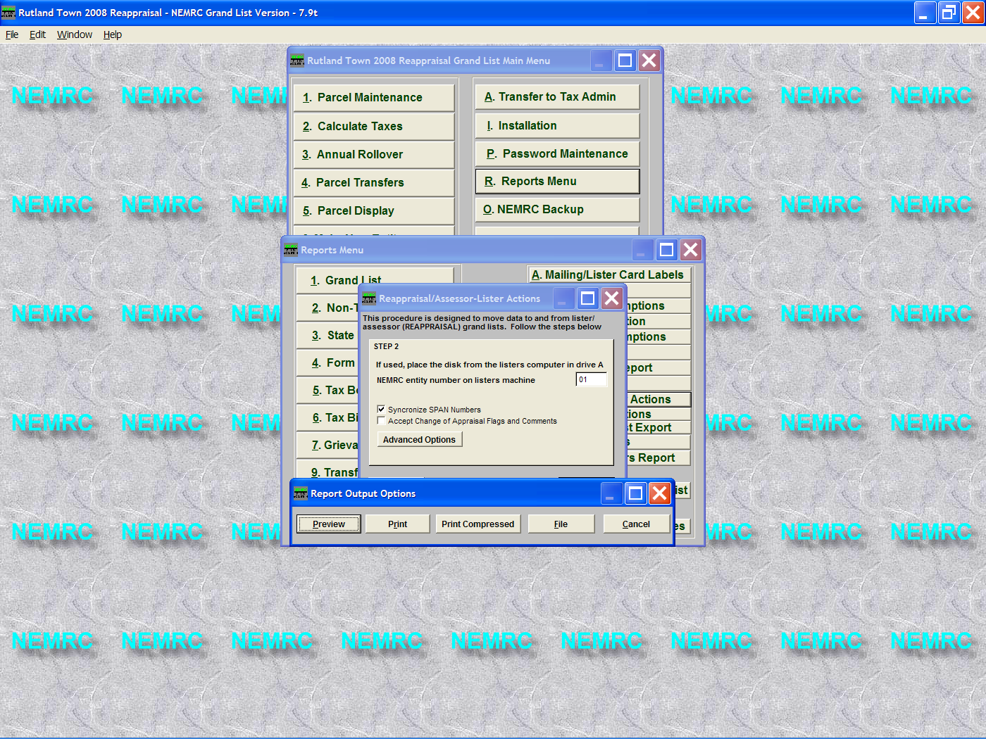
16. ‘Advanced Options’ – This allows you to select which fields to import. Click the ‘Ok’ button when you have finished making your selections on this screen.
17. Click the ‘Next’ button on the screen above to continue.

13. Report options appear, this report will display any parcel that has been added to the ‘Assessors’ grand list and parcels that have been removed from the Listers grand list. It is up you to verify why these parcels have been added or deleted. In the example below the parcel 00055-9899 is a # that does not exist in the Listers grand list. Parcels 00450-0001 & 000520-14100 exist in the Listers grand list but do not exist in the ‘Assessors’ grand list.

03/18/2003 ESSEX REAPPRAISAL 2006 Grand List Page 1
09:05 pm Exceptions Report

Parcel ID Name Problem
----------------------------------------------------------------------------- 00055-9899 SMITH TIM In Assessors Grand List NOT in Listers Grand List

00450-0001 JONES, NANCY M In Listers Grand List NOT in Assessors Grand List

000520-14100 SHERMAN, DUANE M In Listers Grand List NOT in Assessors Grand List

