Once you have downloaded the latest HS – 131 file from the State’s server you have the option to run a range of detailed reports based on any individual HS – 131 file that you have downloaded. To access these reports follow these instructions.
On the Main Menu select option ‘7 Homestead Declarations’ next click on the button labeled ‘Print Homestead EXCEPTIONS report’. You may also find it helpful to run the ‘Print other Homestead reports’ as well.

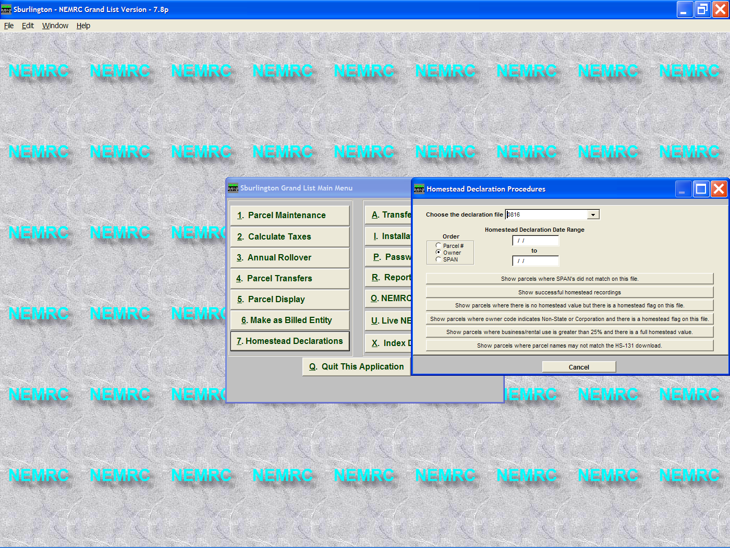

- Select the HS – 131 file you want to run a report for. Note that all of the files you download will be listed in the drop down list.
- Select the order in which you want yuor report to print in.
- You may limit the number of parcels on the report by entering a range of Homestead Declaration dates.. This will allow you cross check parcels if desired in smaller chunks.
- Select a report that you want to run by clicking on one of the buttons seen here.

Available Exceptions Reports

- Show parcels where SPAN # did not match – This report looks at the parcels in the download file and shows you any parcel where the span # did not match any parcel in your grand list.

- Show successful homestead recordings – Display of all parcels that were in the download file that had a span # that matched a parcel in your grand list.

- Show parcels where there is not homestead value but there is a homestead flag on this file – This report allows you to see any parcel that has been flagged for a homestead but does not have a homestead value. You may review the parcel and add a homestead / housesite if needed. (It is important to have this information correct before printing tax bills).

- Show parcels where owner code indicates Non-State owner or Corporation and there is a homestead flag on the file – This report provides you information that may need to be modified if the property has sold or you may want to flag this parcel for the state to review when you do your Lister Responses to the State.

- Show parcels where business/rental use is greater than 25% and there is a full homestead value – Again providing you with an opportunity to review this parcel and examine the values that have been allocated to the homestead and housesite.

- Show parcels where parcel names may not match the HS – 131 download – A good cross check to make sure the name in the download file matches your grand list. This will help you check for incorrect span #’s that people field by accident.

