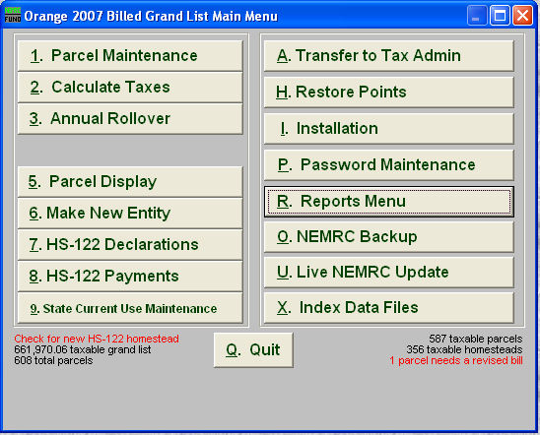
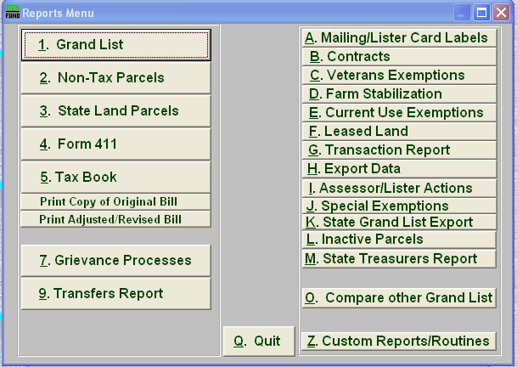
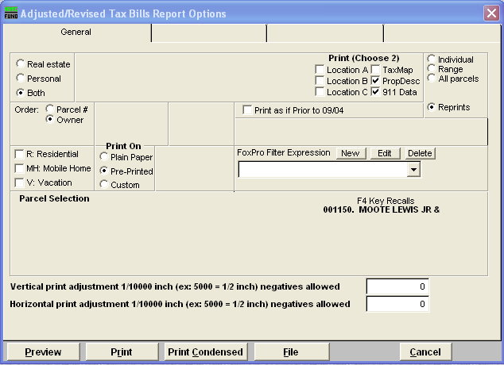
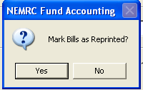
1. Left click on the red letters to see a report of parcels that need a revised bill.
2. On the ‘Reports’ Menu select
‘Print Adjusted / Revised Bill’
3. Check the ‘Reprints’ Radio button. Then Click the ‘Print’ button. Then it will remove the Red ‘Revised Bill’ alert on the ‘Main Menu’ seen in step one.
4. Click ‘Yes’ to remove the Red ‘Revised Bill’ alert on the ‘Main Menu’ seen in step one.

