First American Grand List Export

1. Select the “current” grand list from the entity menu. In most cases this is entity #1.
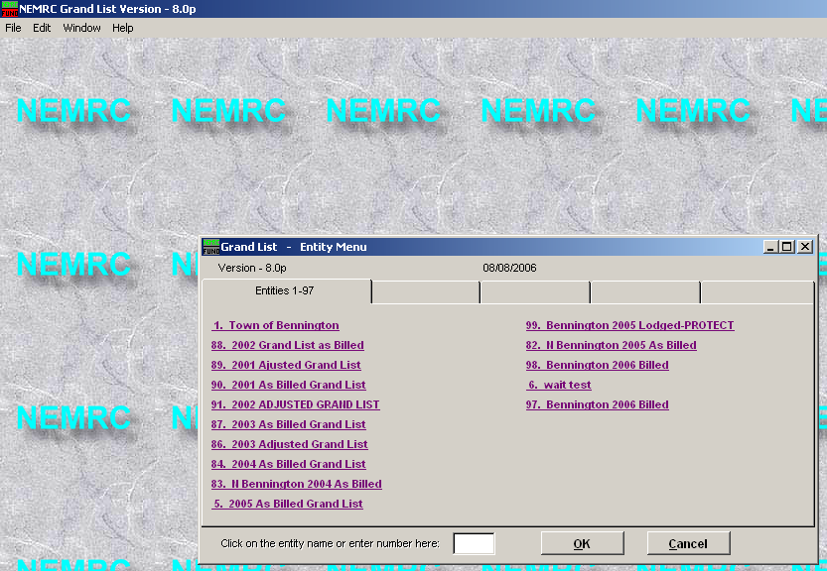
2. Select the reports menu.
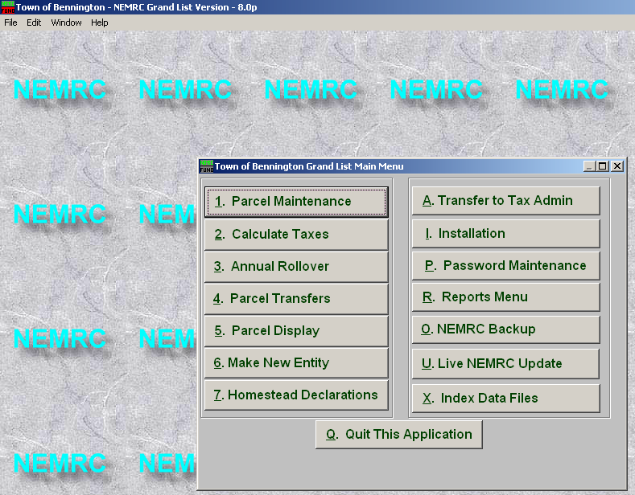
3. Select Z. Custom reports and Routines.
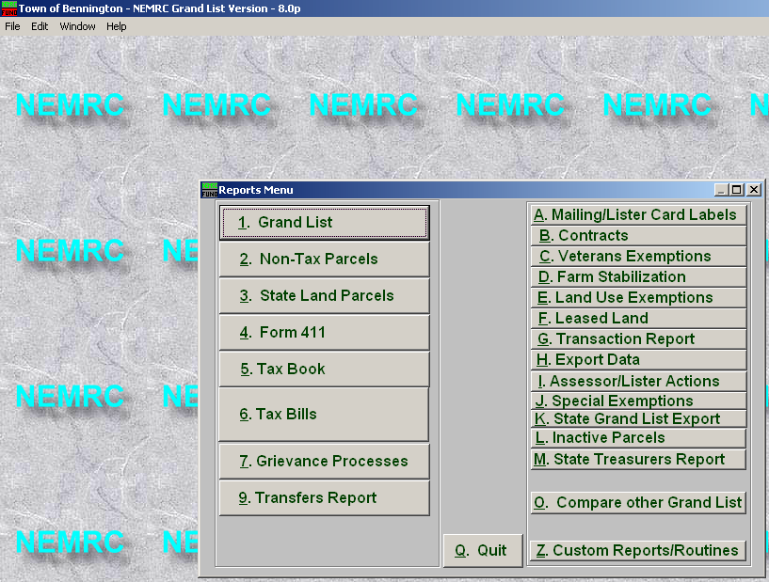

4. Select “First American Export” then click Run.
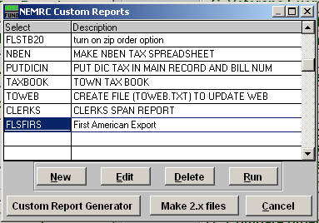
5. Click send via internet.
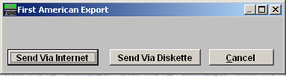

6. Transfer in progress meter.
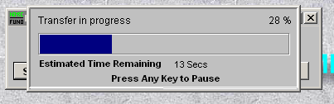

TROUBLESHOOTING

If you get the message below you are not using the entity that is the “Current” grand list, you may be using as “As-Billed” or “As-Lodged” grand list. Return to the entity menu and select the grand list you need. In some towns cases, the current grand list can be found on the listers computer only and not on the treasurers, please keep this in mind when doing or instructing on transfers.
