This new feature will allow the user to change a parcel id without deleting the parcel entirely. However you will need an access code to enable you to complete the parcel id change. The access code can be obtained from PVR or NEMRC.
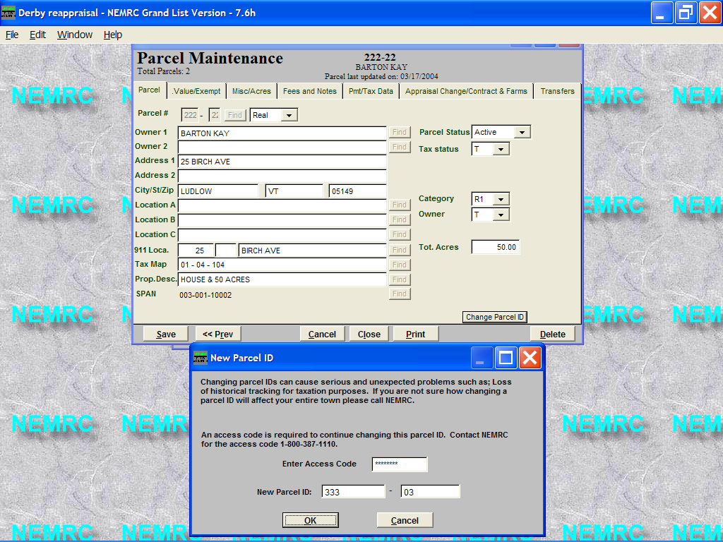
- Pull up the parcel that you need to change the parcel id.
- Click on the button in the lower right corner labeled ‘Change Parcel ID’.

- Next enter the access code. You will need to obtain the access code from PVR or NEMRC.
- Once the access code is entered you will be able to type in the new parcel id. You will not be able to duplicate an existing parcel id.
- Press the ‘Ok’ button to save your change.

