A 911 street drop down list has been created. This will help you clean up your street names as needed. The program will build the drop down list using your existing 911 street information. Then you may go through the list and correct any inconsistencies that you find. The following guide walks you through this process.

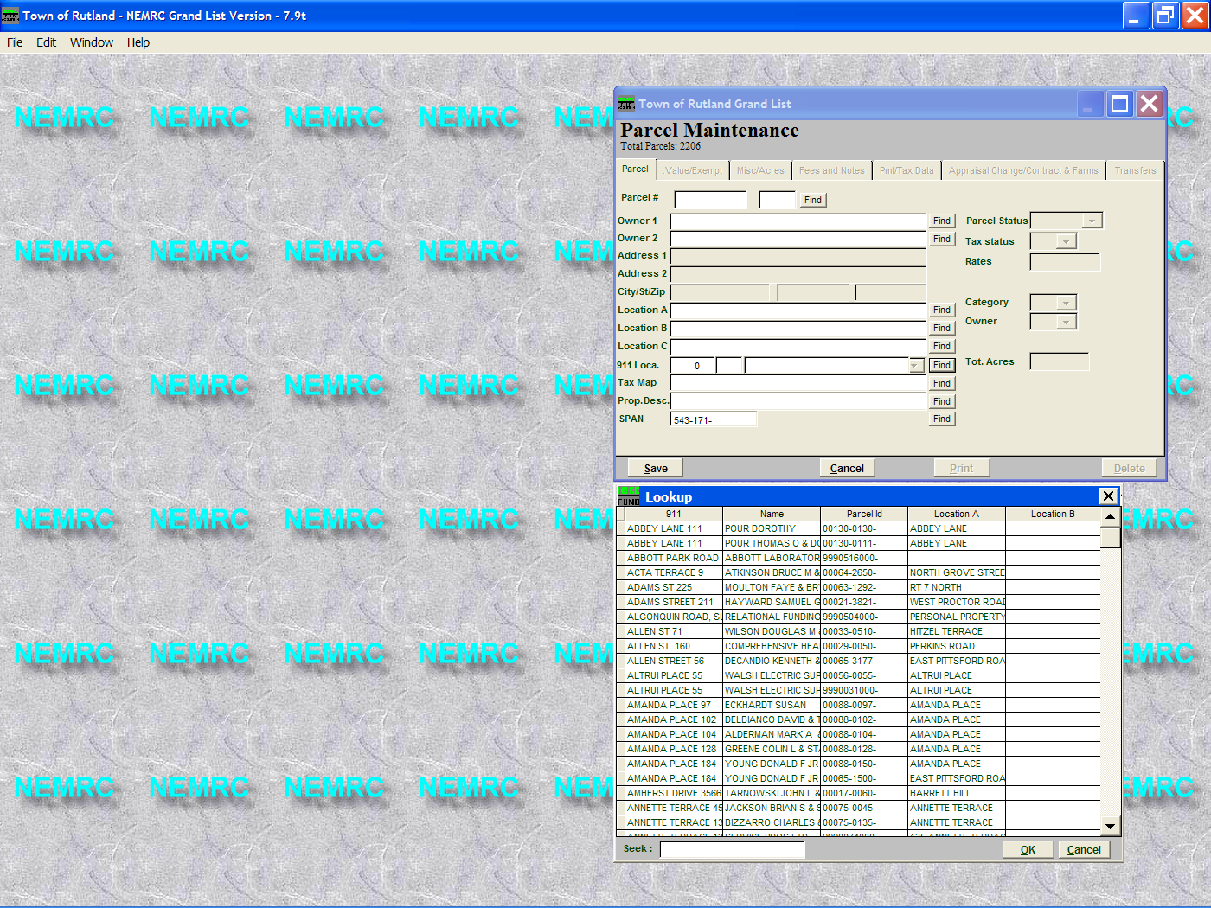

1. Click the Find button next to 911 field. This will sort all of your 911 locations alphabetically.

2. Scroll through the list and find any street that is not spelled correctly or is inconsistent. Decide if you are going to use punctuations along with abbreviations or if you will spell out the words Street, Road, and Lane etc.

3. Double click the record that needs to be corrected. In this example we will select the record where the word ‘Street’ is spelled out. Then the one with the period after the ‘St.’
Allen St
Allen St.
Allen Street

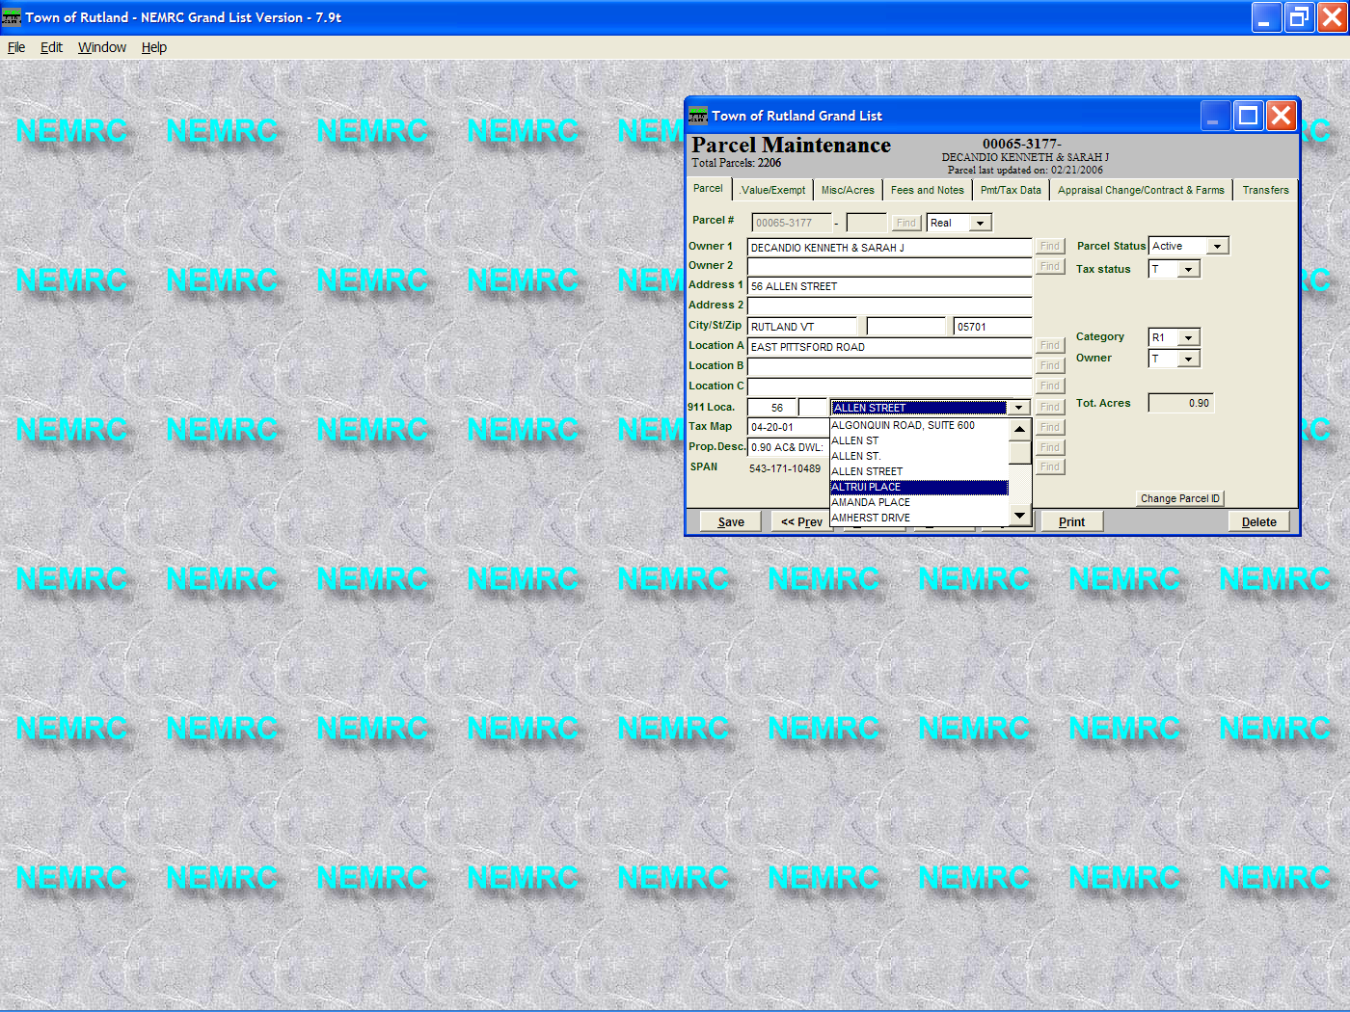

4. Once the record is on the ‘Parcel Maint’ screen click the drop down and choose the correct street name spelling.

5. After all of the incorrect spellings have been removed from the program they will be removed from the drop down list after you exit the software and come back in again.

