Agenda

9:00 – 9:30 Registration and Coffee

9:30 – 10:30 Parcel Transfers and Subdivisions

10:30 – 10:45 Quick Break

10:45 – 11:15 Covenant Restricted Housing

11:15 – 12:00 Change of Appraisal Process

12:00 – 1:00 Lunch

1:00 – 2:00 Current Use – Best Practices

2:00 – 2:30 Cloud Computing vs Local PC / Network

2:30 – 3:00 How to incorporate PDF Files to keep track of your Grand list

3:00 – 3:30 State Payments on parcels without Homestead Dec

NEMR.CTnmafer/Split 8112/2016 Page 1of 7

The Parcel Transfers/Split Process
Keep Track of Your Transactions.

To begin entering yom property transactions,click onthe Parcel Transfer button on the Main Menu. After the Transfer File Maintenance screen is displayed use this handout or the insll'uctions on the screen to guide you throughthis process.

Ifthis is aparcelttamfer you will bebrought to the Parcel Maintenance screen. Enter inthe new owner information, and then click on the Ok button to return to this saeen. Now proceed to step E.
I
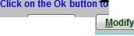
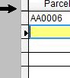
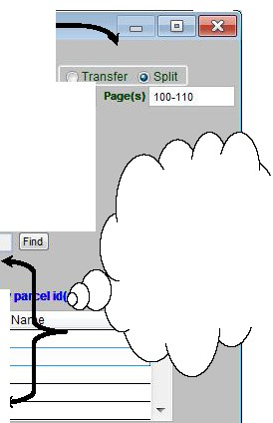
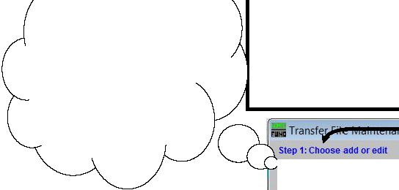

A) When entering new Transfers/Splits leave the 'Add' button checked as
seen below.Next select the tnmsacti.ontype (Trand'er or Split).
> Transfer isused when entire pazcel isbeing sold.
> Split isused for sub-divisions (when only apiece of aparcel is
being sold.)
Input the transaction information about the pan;el inthe available fields.

Add Edd
Step 2: Select Transfer or Split, then enterthe transactioninformation below.

Sale/close date Transfer ID
Valid/ nval d Price Reason
B) Fimlthe pan:el1hatyou wam to
split or tnnsfer.
0112212013 lDate recordedJ 0210512013 ILR Book
- I Sale Pricel 80,000.00 lf,f Valid

This Step iionly used when
SpU:tdng Parcell!

C) Enter the New Parcel Id in the next available space below the original Parcel id.
MiscellaneousInfo 1 10AC SUBDIVISION MiscellaneousInfo 2
Step 3:Select the parcel thatis being split or transferred.
Parcel# AA - 0022_ IFind I
0Wner1 DEMPSI JULIUS
To Parcel(s)

Step 4:Arrow down or clckon the next available Illeand enter the new pa
ID
 |  | 0029 | DEMPSIJULIUS

This section onlycliaplaya onthe screen
when you clioose tb Split Pllftel option.

D) Ifyou are doing aparcel split click on the modify button to
H reP!:!im'lml"'°!lll ·k on the parcel id above, then clck on the'Modify' button to enter the parceldata.
save your changes.To edit a parcel click on the Modify button.

advance to abhmk Parcel Maintenance screen. Fill inthe data and click on 1heOk button to returnto this screen.
Note:Use the modify button to return to the Parcel Mainten11nce screen if needed. This works for both
Pl Splits and Transfcn.
ave
I !;ancel I

E)After you have returned from the Pareel Maintenance screen. click onthis Save

Dealing with Contiguous Parcels
Contiguous parcels -are defined as parcels that touch each other and the ownership is in the same name.
When this happens both parcels must be combined together and taxed as one parcel. The instruction on this page shows you how to cmTectly use the 'Contiguous Parcel, field located on the Parcel Maintenance screen.

Here is a tax map where the owner of the parcel onthe left is going
to sell IOac of landto theproperty owner of the parcel on the right.
So the lOac subdivision of land willbecome contiguous with parcel AA0007.0029 on the right. Below isthe procedme to follow.
Create the new subdivided parcel
Then Inactivate the new parcel and combine the acreageto the parent parcel 'AA0007.0029' in this example.
Reduce the acreage of the original parcel
'AA0006.0029' in this example.

..Step 1:Choose add or edC@Add 0Ed• >

_ •Transfer File Mainten.a..n,c.e _
Onthe 'Main Menu' select '4.
Parcel Transfers'
Select •Add' and 'Split' as seen on this window.
Enter all of the Transfer
Infinmati.on
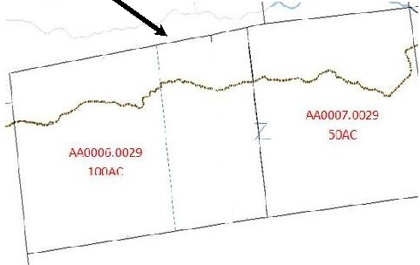

l CJ IJllllLii!l1 1

Step 2: Select Transfer or Split,then enter the transactioninformation be¢llt"'!Transfer @ Spliip
Sale/close date 01 /2212013 Date recordedI0210512013 LR Book Page(s)J 100-110 I
TransferID 2012-001 Sale Price I 80,000.00 n./l Valid
Val d/ nval d Price Reason
t-- -1
MiscellaneousInfo 1 10AC SUBDIVISION
1-- -1
MiscellaneousInfo 2 '-- --'
Step 3:Select the parcel thatis being split or transferred.

II
Parcel# | AA0006 | 0029
0Wner1 To Parcel(s) | DEMPSIJULIUS

Step4:Arrow down or click on the next available line and enter the new parcel id(s).

 | Parcel | ID | Name
 | M0006 | 0029 | DEMPSIJULIUS | J
 | M0006 | 0291 | LAUNDRY ALFREDANDWILMA

....
Step 5:Arrow down or click on the parcel id above,then cl ck on the 'Modify'button to enter the parcel data. Cl ck on the Ok button to save your changes.To edit a parcel click on the Modify button.
I ave I !f Md. 1.Y] I l;.ancel I

- Ml l,lUYY l l I""\.;) UlllC::U VI Ol lU L.l;)L

AA0006-0291
Parcel Maintenance
LAU?>. R' Y ALFRED AND \\11.MA

Total Parcels: I
hrctl wt -apditt4on; I

Enter the new owner and parcel
Parcel# - Fnd [i! eal J:] INACTIVE PARCEL

information aswell asthe acreage on the
new subdivided parcel.

Inactivate this parcelbecause it will be taxed
with theparcelit is contiguous with.

Owner 1 LAUNDRY ALFREDAND WLMA
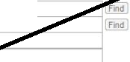

Owner 2 '
Address :7 ANDY AVENUE

City/ St/Zip ' ANYTOWN J Ivr _ }§sss

Parcel Status[ltnactive ]
rs

Tax status

Contiguous Paree!Informadon
Ent.er the main parcel id that this parcel is contiguous with as seenhere. You will see the owner, status and acres of that parcel appear.
Location A (Frid Category E:::GJ
Location B----------------< Owner EGJ
""·'1!!11.1.1_!lll'l! iiiiiiiiiiiiiiiiiiiiiiiiiiiiiiiiiiiiiiiiiiiiiiiiiiii;;:: F d
911 Loca. J..--s-rJ--[ir[A-ND_Y_A_VE -=,_....,==--".-.-.'I Tot. Acres [ 10.00 ]
Tax Map lf!il!'."'• Cont guo Information-
------ - Parcel # AA0007 J 0029 [
Prop.Oesc LAND F d -----'
SPAN --------------- Owner1 LAUNDRYALFREDAl'IO
Parcel Status Active
Tot Acres 60.00
I

Click the Save button to save your changes
andreturn to the Parcel Transfer whldow.
I Save I
ICancel J l Ctose J [ Print J
Delete rp

 | Parcel
 | AA0006 | 0029 | DEMPSIJULIUS
 | AA0006 | 0291 | LAUNDRY ALFRED ANDWILMA


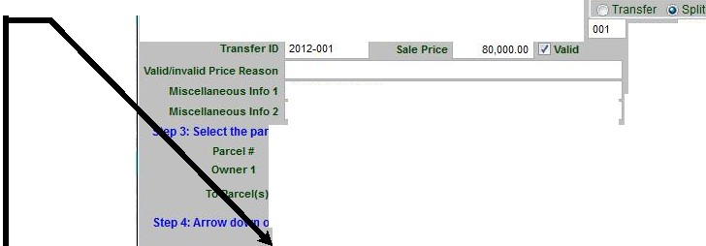

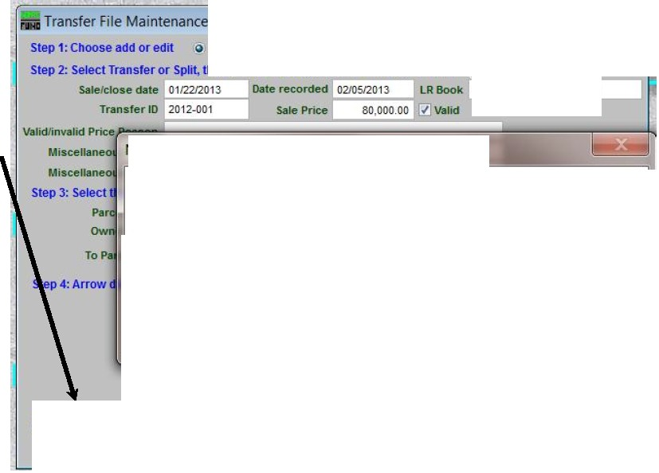
Step 1:Choose add or edit Add Edit
Highlight the original parcel and click on the Modify button. Reduce the total acreage for this parcel and save that change. Inthis example the original parcel was 100 acres and they sub divided 10 acres off of that Therefore this parcel now contains 90 acres. You will have to adjust the acreage inyour appraisal program manually and generate a new value for this parcel as well.
Click the Save button when you return. to the transfer screen.
IiiTransfer File Maintenance
Step 1:Choose add or edit Q AddEdit
Step 2: Select Transferor Sp it,then enter the transactton nfonnation below.
Sale/closedate 01 12212013
Date recoi-ded 02/GS/2013
LR BookPage(s) 100-110
Miscellaneous Info 1i11} AC SUBOMSION
--1
3: SekKt the parcel thatis being splitor transferred.
AA0006
DEMPSJ JULPJS
- 0029
or clck on the next avai able tine and enterthenew parcelKl(s).
ID
Name
A
Step5:Arrow down orcltek on the parcel Mi above,then cltek on the 'Modify' button toentertheparceldata.
lick on the Ok button to save your changes.Toedit a parcel click on the Modify button.
Once you finish editing your parcels, click on the Save button to save those changes.
The program recognizes that the new parcel is contiguous with another parcel.
Click the Yes button to edit that parcel and add 10 acres and Save that change. Remember you will have to change thethat parcel accordingly inyour appraisal software.
Step 2: Select Transfer or Split,then enter the transactioninformation below. Transfer Split
001 Page(s) 100-110

NEMRC Fund Accounting

During the transfer youindicated parcelAA0006-0291 is
I contiguous with AA0007 -0029 do you want to do maintenance
on that parcel now?

-- -v_e_s ....J. 1...... _N_o

Step5:Arrow down or clck on the parcel Idabove,then cick onthe 'Modify' button to enterthe parcel data. C ick on the Ok buttonto saveyour changes- To edit a parcelcilck on the Modify button.
[::S:ii ]j Modify l [ !;_ancel

  - Transfer Fi e Maintenance
Step 1:Choose add or edit Add Edit

Step2:Select Transfer or Split, then enter the transactioninformation below.
Transfer Splt

Sale/close date 0112212013
Date recorded
001
Page(s) 100-110

TransferID l- 2_0_1_2-_0_01

......

S_a1e P_riceL...
so..;,_.oo_o_.o_o.c./=v-a_1_id
....,

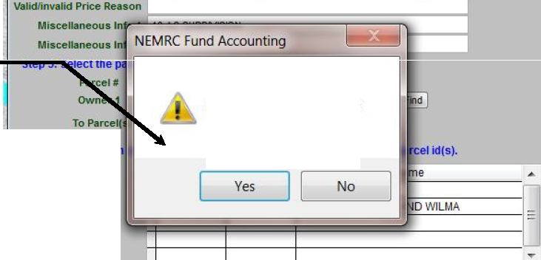


Record Another Transfer?
When you returnto the Transfer screen select Save and decide whether or not to record another transfer.

Step 4:Arrow dow

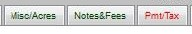
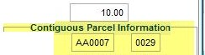

NEMR.C Transfar/ lit 8/12/2016 Page 4of 7
iiAnytown As Billed Grand List

Parcel Maintenance
TotalParoels:3611

Parcel Value/Exempt
AA0006-02!11
LAUNDRY ALFRED AND WILl\·!A
Parcel wt updated on:0210512013
Chg Appr. Contract$ Farm

Parcel# - IReal GI
0Wner1
1L-AU-N-DRY A L FR ED AN D W I LM ---------
1--------------------
7ANDY AVENUE
ANYTOWN 05555
6 ANDY AVE ...
LAND

0Wner 2
Address 1
Address 2

ICity/ St/Zip

INACTIVE PARCEL
Ifind I Parcel Status!Inactive GJ
1
11Find J Tax status I T GI

Category
...

Location A !Find )
location B ! Find J owner
Location C ! Find J

'911 oca.
IFind ) Tot.Acres

Tax Map ! Find J

Parcel #

Prop..Oesc
SPAN

639-201-140;9
! Find J
!Find I Ovvner 1 LAUNDRY ALFREDAND
Parcel Status Active
I Change Parcel IO I Tot. Acres 60.00

Save J I «Prev J I Next» I I Cancel 1 1 Cjose 1 1 Print Delete leJ

NEMRC Transfer/Split 8/12/2016 Page 5 of 7

Parcel Transfer/Split Cont.
Review Data Entry with Transfer Report.

Once you have entered some of your property transactions, you can run the Parcel Transfer report to help you track the parcels that have been entered into the computer. From the Reports Menu select the Transfer Report button. The Transfer Report Options window will come into view. This report is driven by the Date to Record Transfer field located on the Transfer File Maintenance window (refer to the illustration on the previous page). Therefore, you could run this report daily, weekly, or monthly depending on how many transactions you have to deal with. Enter a handful of transfers, then run this report on a small
date range. Next, compare the report against the property transfer cards to ensure that there were no data entry errors. Ifyou do find discrepancies between the property cards and the transfer report you can correct the
error immediately. Below is an illustration of the Transfer Report Options window. Simply enter a date range and select Detail or Summary. After you have made your selections you can click on the Print button.

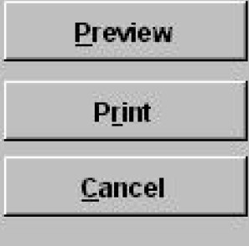
eport 0ptions


Below is an example of a Detailed Transaction Report for one parcel.

Transfer Date Range (Blankfor All)
Io3ilJ112002I to lo3f3112002I
(:, Report Summary

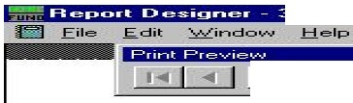
tt+11"¥1"tfW4- ·- w
j, 00% !El I
·'WI '!ti¥!
-I
------ - --- ---- - ------ - - ------ - --- ----------- -------- - ----- ------- - - --
s...q . .., '
.. o:s ,.::L../2002 a.,,-.r..to"' OSTO:L005 -:L
::L:LO ,ooo .oo
:r:J'...T JS L .:n:>.
=:r::r...-r :ttxc::au:::r...r: :tt
250"" Cz.:r...r!ND00'.I< :E>D
L cn<l">.TJ'.LL.r: V'T 0'5e"5:::L -<> ..02
"'"' ..... -c A.-.:> H:<:f<TS>= i'G:i= --co ""
R..:I aK T SXDJ:!: OPPOS XT.C PATOX R:c
R.2T
OSTO:L00"5- :L
I
---------------------------------...---------------------------------+--------------------------------
......--------------------------------
::> _ 5 AC: AND KOU's: /f =
R.:l """"T S'J:D C<PPQS' J: PA"X'O>J:MJ:
--- - - -- - --I
QS°X'O>:l.Q Q"'-1
""-2
T
I °X'O>
-- -- -- -- --- -- -- --- -- -- -- --- -- -- -- +-- -- -- --- -- -- -- --- -- -- -- --- -- -- -+- -- -- -- --- -- -- -- --- -- -- --- -- -- -- +-- -- -- -- ----- -- --- -- ---- --- -- -- -

NEMRCTnnsfe:r/Split 8/12'2016
Editing Parcel Transfers I Splits
Pqe,of7


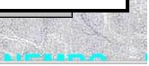

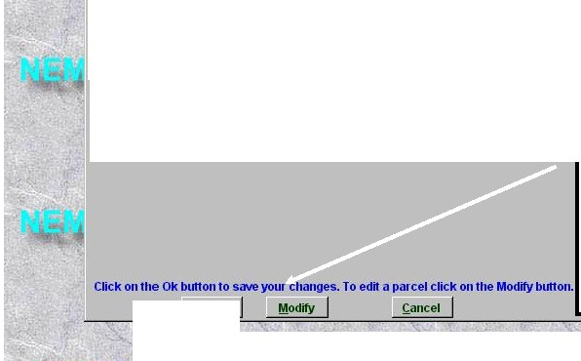

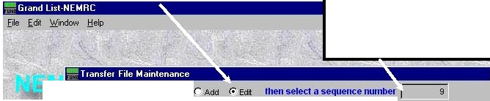
1)Select 'Ed!t' u seen below to editapioperty
I
1• traJls&r that you pmouly entered.

2)Enter the &eq11C11cenumber of the
1rallllfer below. The SequenceNumber

nmst
be obtained:&mn1he 'Parul

Mainfellall' Tnuf'er' Tab l1l'the
'Property Tnmrer' report at lllit time. - x
Theillustndions on1he page will showyou whereyou can :!indthe IMIQ1leDl:G 'llUDlbcmL

Step 1:Choose add or edn
Step 2:Select Transfer or Spin,thenenter the tran sact oninformat onbelow.
r== = = =---oJ Date to Reco1·d Transfer 03118/2002 Land Record Book
- Cl x

I21s I Page E:JI

!!! Transfer Parcel TransferID
Q1 SplilParcel MiscellaneousInfo 1
"== = =--

....
234
Sale Price
110,000 Valid

MiscellaneousInfo 2
Tr------;;;11
Step 3:Select the parcelthatis being spinor tra n iiSf.emra:"....................................
Parcel# JosT01005 ffllim l
iJl;!@:l | l;ii: | i::i;i:i

Owner 1 Jr-;;; === ==
'1j

To Parcel(s) OST01005-1
TAYLOR JAMES

QK
r

3) &litany of the fields onthis ilCI'lleJ1 dmtmight be incomct orpresa 1he 'ModlfJ'button to comet anypaP:el infmmation that might need tobeanreclt:d.

Prea11he'Ok' buttonto
18VO your c:hanps.

!o:!!:!!!::E::=!!!!!::!::!!====="'I 4)Jf1bisis a cm:rait tnmaution you me editingyouwillbe
asbd the following queation seenbelow. 'Y•'wi11update your c:ummt Onnd List with the changesyouarenwking. 'Na' wi11update the historical GrandList file andnot change 1hecumnt Grand List'

NEMRC Fund Accountmg 1,3
/f\ Doyou want to sendyou1 changes to the Cuuent Grand List?



NEMR.CTnmsfer/Split 8/1212016

Locating Sequence Numbers for Parcel Transfers
Page 7 of 7

-G rand o st NEMRC lllr;l£1
A) From the Parcel Maintenance window,click on the · aosfer'tab. The sequence number islocated on the left side. AJso note the date the transfer was recorded to make sure you get the correct transfer sequence number to edit

file "dit Y£indow !::!elp

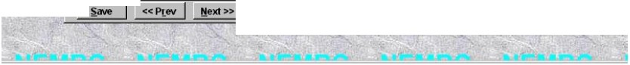
-LUDLO"' Gr and Lost Ill£1
Seqno
ype
Previous Owner
Book
10
TAYLOR JAMES JONES
110000.00
300
144
03!20!2002
y
9
T
SHUFELT JAMES LJR
110000.00
215
37-38
I
03/18!2002
y
11
SMITHCARL
110000.00 41
121
03120!2002
y
,
'
.I


Parcel Maintenance
Total MAIN: 108VllL1
OST01005-l
.JOHNSON JASTOll TEST
Puctl wt upci>ted on: I I
District Differential
'MAIN El C
In:MAIN Only

Misc/Acres Fees and Notes Payment/Tax Data
l Awaislll Change/Contract ms L ..!..!'.....
-

Price IllSale
'
I
\
Page .I )ale 'Valid

..
lr;I r
i111Cel I ctose I! e.r-=1 Qelete

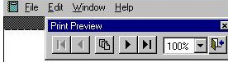
-Repo1t Designer ·37250160 fr•· Page 1 · Grand 1st-NEMRC lllr;lD
B) From the 'Reports' menu select the 'Transfen Report'. The sequence number is located onthe upper left comer of each

03/20/2002
10 :20 am

LWLOW Gi:U\d List
Pi:opei:ty Tl:ansf'cu R.epo:i:t
Poi: Tu1ns£us Between 03/18/2002 and 03/20/2002

/18/2002 Gi:antoi: OSTOlOOS-1 P:i:ice : 110,000. 00
.. .,,...

Pe l 0£ 2

chi:is

HPn ClNS I CON''IPACTS

SHU!'n.T KIClmU: H
2506 CMJ:NDl\P. BR.OOK RD "«OCID
CROP
LYNDONVILU: VT 05851-9t02 PAST
32 .5 AC Alm HOUSJ:/GI: MID B ona

Book: 215 Pe:
30.50
0.00
0.00
0.00

134,600

P.IGHT SIDI: OPPOSIT? PATOlllm Sim

OSTOl005-l
2.00 GR.llND LIST l,3t6 .00

32.50 95,100

Seq. ft : 9 03/18/2002 G.:antee OSTOl005-1 'D\'iLOP. JiUmS JONl:S
...,..

P:i:iee: 110,000.00
Book: 215
Pe: 31-38
30.50 .....
0.00
0.00
0.00
2.00 GR.Mm LIST 1,346 | .00
32.50 | 95,100

NORreFir:LD V'T 05555
32 .5 AC AND HOUSE/12 B
P.l GHT SIDI: OPPOSITJ: PATOillm OSTOl005-l
CROP PAST

SI'll:
·=

""""'

Seq. ft : 10 03 /20/2002 G:i:anto:i: OSTOl005- l P:i:iee: 110,000. 00

Change of Appraisal Process and Tracking your changes. Begin by printing your 411 report before making any changes for a given year. Below is a sample 411. Notice there is no values in the Homestead Column. Do you know why?

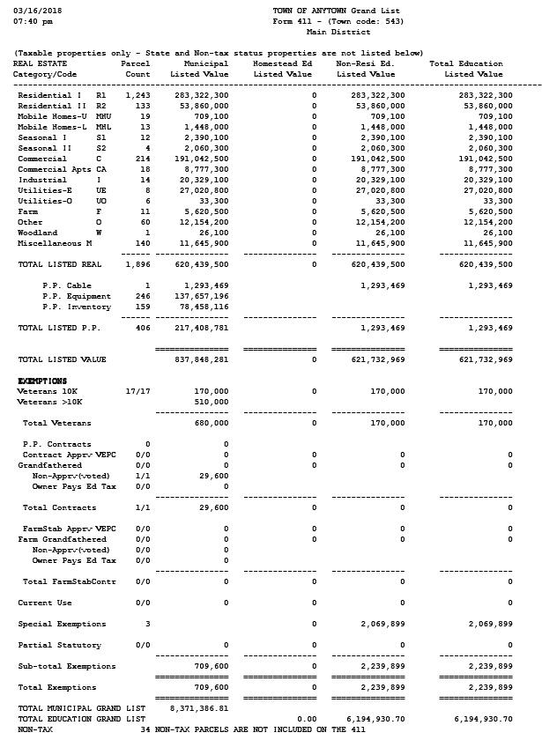

Next change a value on a parcel on the Parcel Maintenance screen as seen below. You will be prompted to flag the parcel for a Change of Appraisal notice at this time. If you are using the MSOL CAMA program then all value changes will be automatically updated and the Change of Appraisal flag will be turned on as well.
Original Parcel Value

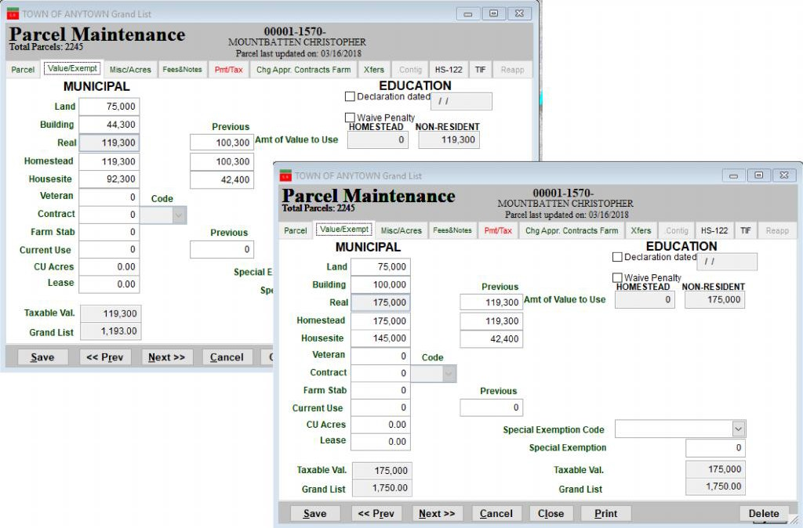

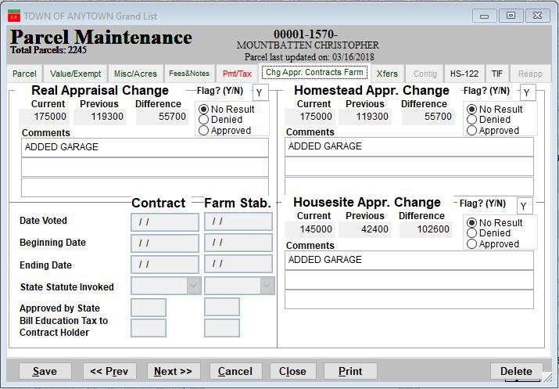
Move to the ‘Chng Appr/Contracts Farm’ Tab and Add a comment as seen here.

Run a new 411 report after you change. You will notice when you compare the new 411 to the original 411 on page one of this document that the ‘R2’ Category has increased by 55,700. The reason for the change is the parcel that was edited on page two.

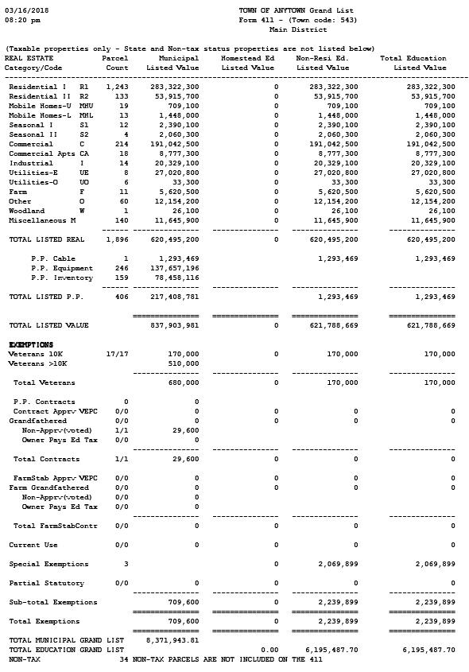

Moving to the Reports menu of the Grand List program there are 2 reports we can use to identify changes that we have made throughout the year. The first one is ‘O Comparison Reports’ the other is the ‘7 Grievance Processes’.

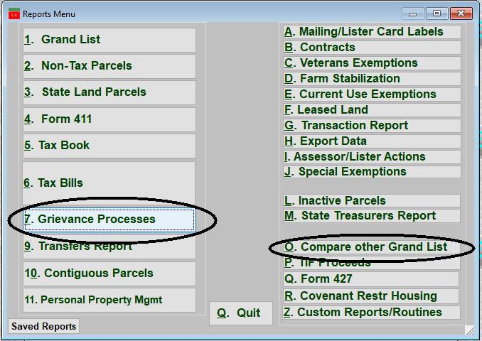

‘O COMPARISON REPORTS’: Comparison Reports compare the grand list you are working in to any other grand list you have listed on your ‘Entity Maintenance’ screen.

Or select another grand list entity you wish to compare your data with.
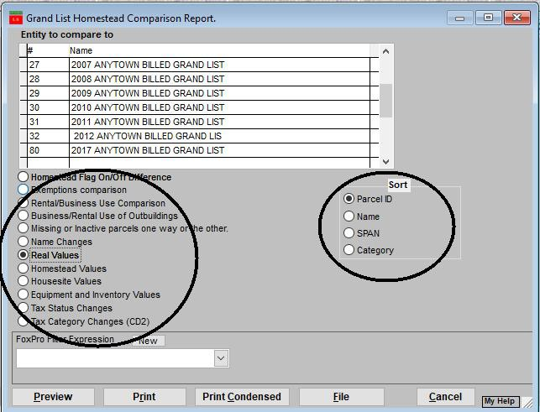

Simply highlight the Entity number by clicking on it as seen here. Entity 80 is the entity selected in the example below.

Select what comparison report you would like to see. In this example we selected the ‘Real Values’.

Below is what the Real value comparison report looks like. This is showing us the 1 parcel that we made a value change to on page two of this document. If a parcel appears on this report then we should also see it when we run the ‘7 Grievance Processes’ Reports.

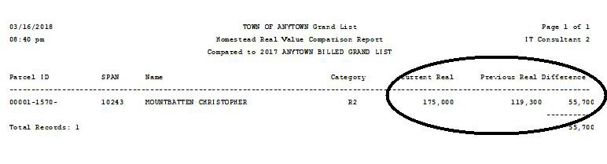

‘7 Grievance Processes: This option allows you to see all parcels that have been flagged for a ‘Change of Appraisal Notice’ or ‘Result of Grievance Notice’

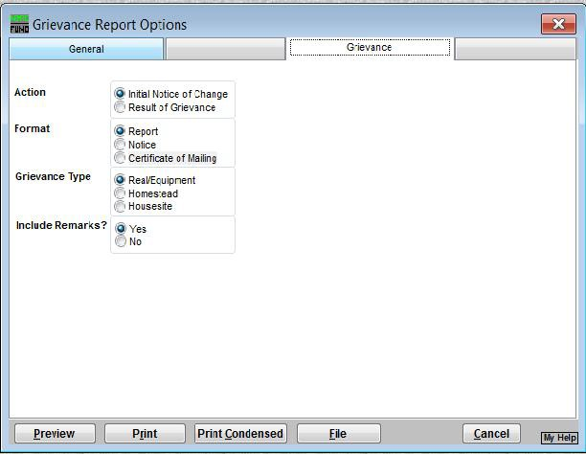
Action – you select here will dictate what reports and notices will print or display. For instance currently ‘Initial Notice of Change’ is selected therefore when you select an item under ‘Format’ it will print a Grievance Report, Grievance Notice, or Certificate of mailing.
Action - If you choose Result of Grievance then when you make a selection under ‘Format’ they will relate to the Results of grievance report, Result of grievance notice, and Result of grievance cert of mailing.

Here is what the ‘Report’ for the Action ‘Initial Notice of Change’ would look like. Itshows use the same parcel that we saw on our comparison report on the previous page.

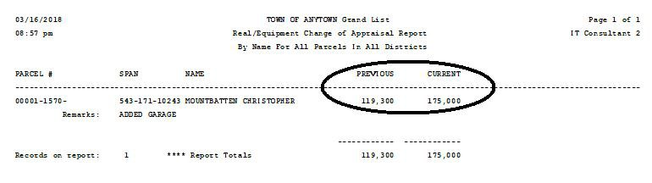

Change of Appraisal Notice – Select the Format type to ‘Notice’ then click on the ‘Edit Selected Notice’ button to the right. The software allows you to save multiple notices. As you can see here there is a ‘Change in Appraisal’ notice and a ‘Personal Property Notice Style’

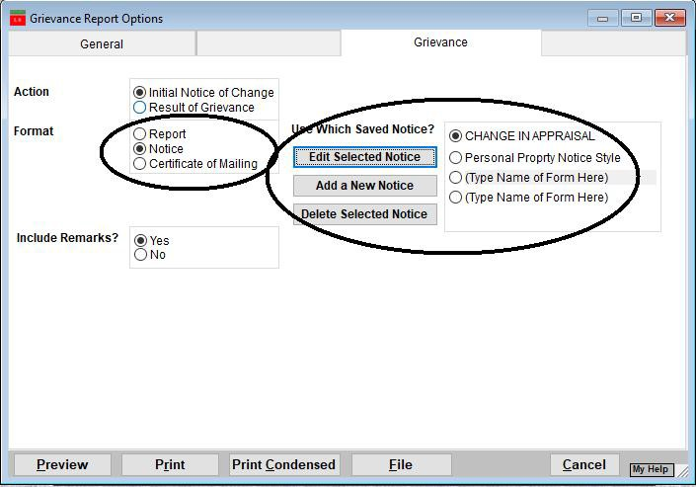

When you click on the ‘Edit Selected Notice’ button the window appears below. It allows you to edit various pieces of your notice. The Section 1 tab is the top portion of the notice, Section 2 is the middle section, and Section 3 is the bottom portion of the form.

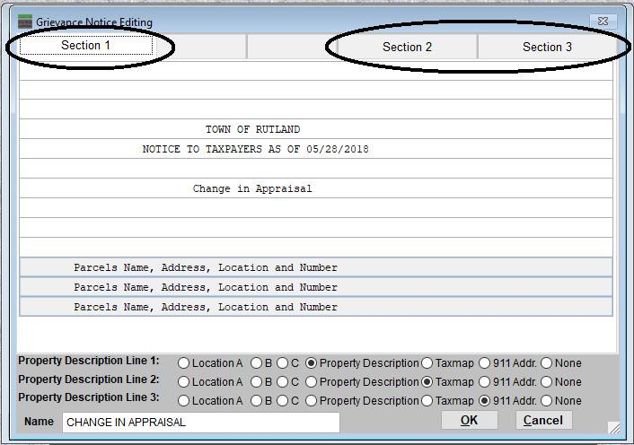

This is what the Change of Appraisal Notice looks like. It is designed so the Name and Address will fold and appear in a standard # 10 window envelope. You can see how the areas you edited on the Section 1,2, & 3 tabs on the previous page will appear on 1 page.

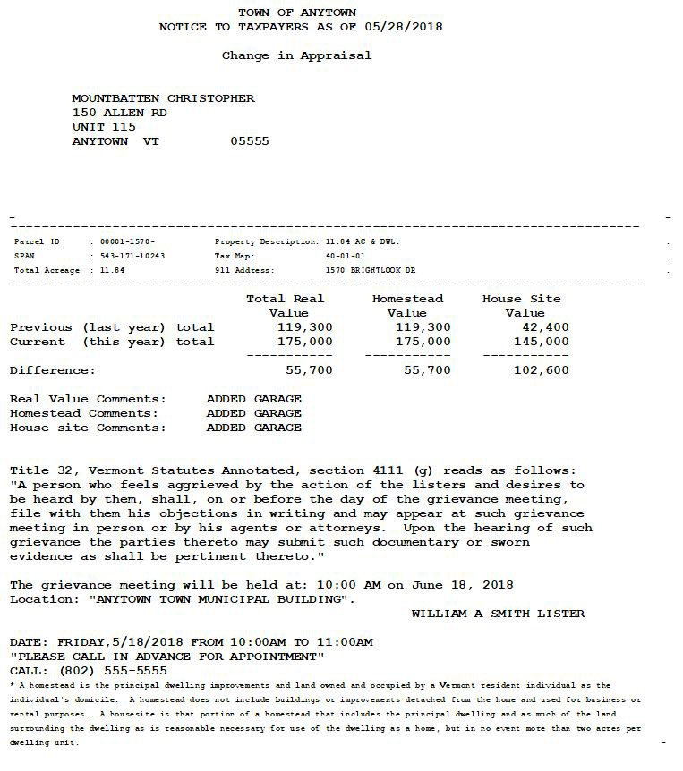

Result of Grievance

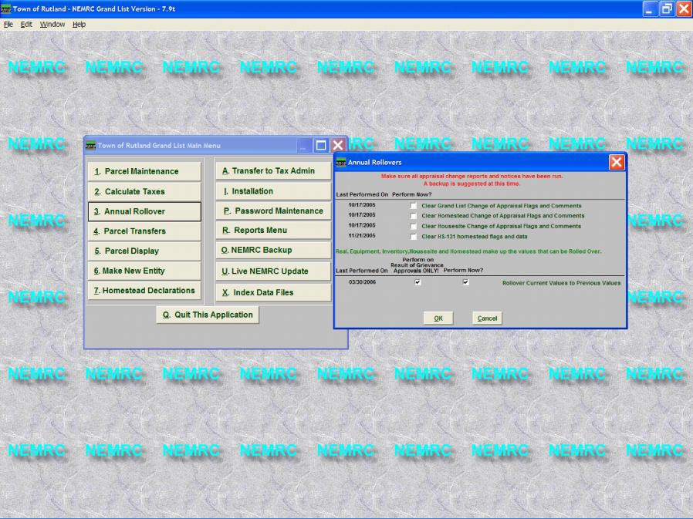
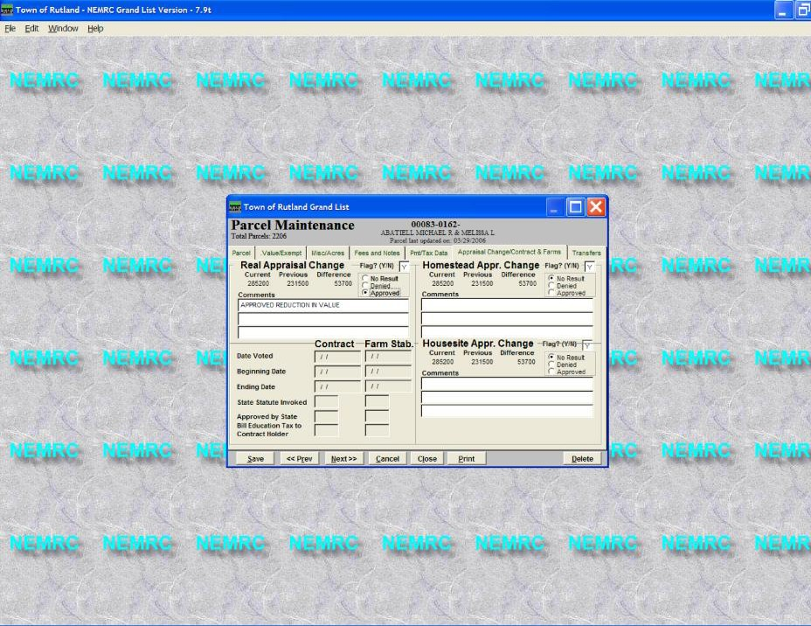
Once the Change of Appraisal hearings are over you may print a 'Result of Grievance' letter for the appropriate parcels. This is done on the ‘Parcel Maintenance’ ‘Appraisal Change / Contracts and Farms’ tab. As seen in the picture below.

.

1. You will notice that there are 3 separate Grievance flags and 3 separate Results of Grievance radio buttons. They are circled below. 1 for Real value changes, 1 for Homestead changes, and 1 for Housesite changes. You must make a selection in each area in order for that value to be present on the result of grievance notice.
2. DO NOT REMOVE your original grievance flag….

3. Enter your remarks in the corresponding comment areas.
In this example we only approved the Real value changes and only have a remark in the Real value comments section.

- Only do this step if you are linked to the Microsolve Cama software. This routine will move all of your current values to the previous value fields for those records that were flagged as ‘Approved’ for a result of grievance. Now you can import your revised cama values for the appropriate parcels.
  - On the main menu select the ‘Annual Rollover’ button
  - Check the box under ‘Perform on Results of Grievance Approved ONLY’
  - Check the box under ‘Perform Now’
LEAVE ALL OTHER CHECK BOXES BLANK AT THIS TIME.
- Press the ‘Ok’ button

5 Now go to the 'Grievance Process' report option on the 'Reports' menu and click on the 'Grievance' tab. Select the 'Result of Grievance' option next to Action and ‘Notice’ next to Format as seen below. Then begin printing your Result of Grievance notices.

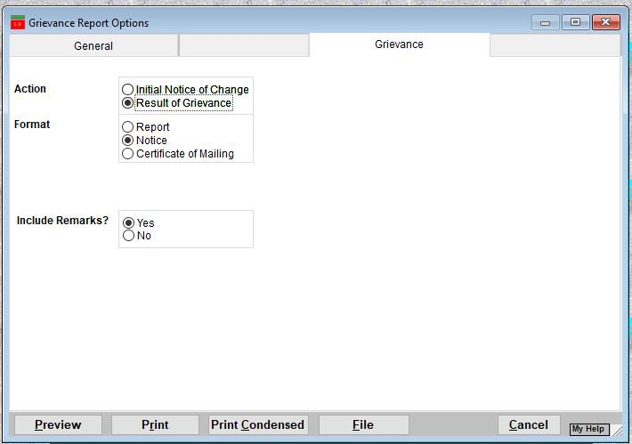

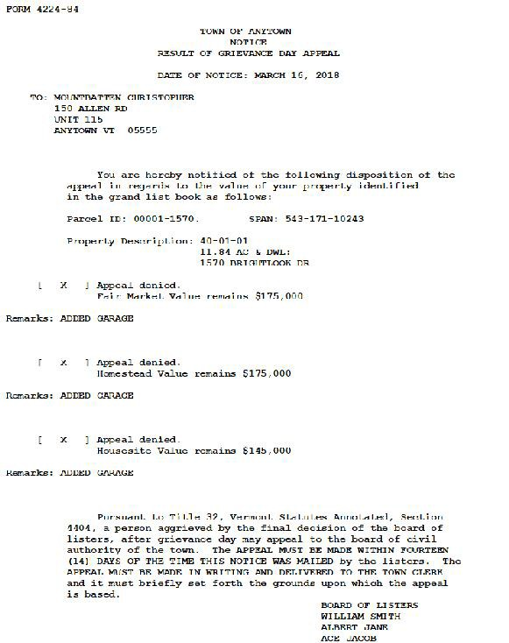
6. Below is a sample of the ‘Result of Grievance’ letter. When folded properly the name and address will fit in a
standard number 10 envelope.

