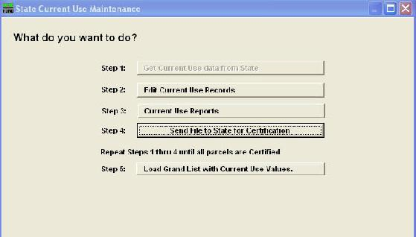

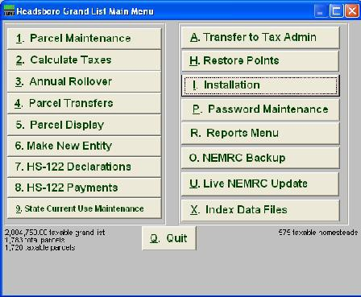
Starting from the Main Menu select ‘9. State Current Use Maintenance’. This option will highlight green in color when there are files to be

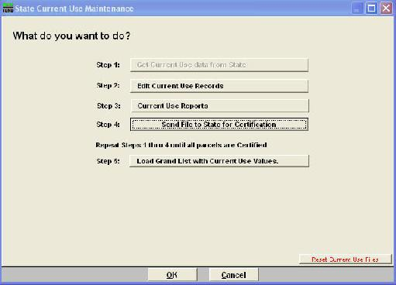
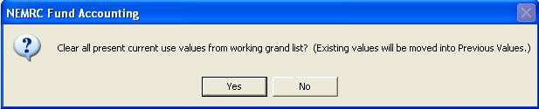
1. Click this button to download your Current Use
files from the State Current Use Program.

This procedure requires you to be connected to the
NOTE: The first time you download, the program will
prompt you to move the current use values in your working grand list to the previous current use

2. Click here to begin editing the list of parcels currently enrolled, including new parcels that met the September 1st deadline for enrollment.

Columns to pay attention to:

Certified – Record was Certified by CU Dept, CU Dept Change – Did CU Dept Make changes to record, In Sync – Are values in sync with ‘Parcel Maintenance’, Validated – Have the Listers reviewed a record. Status – Shows current status of record.
Note: Validated by the Listers. Uncertified or not validated parcels need to be reviewed further.

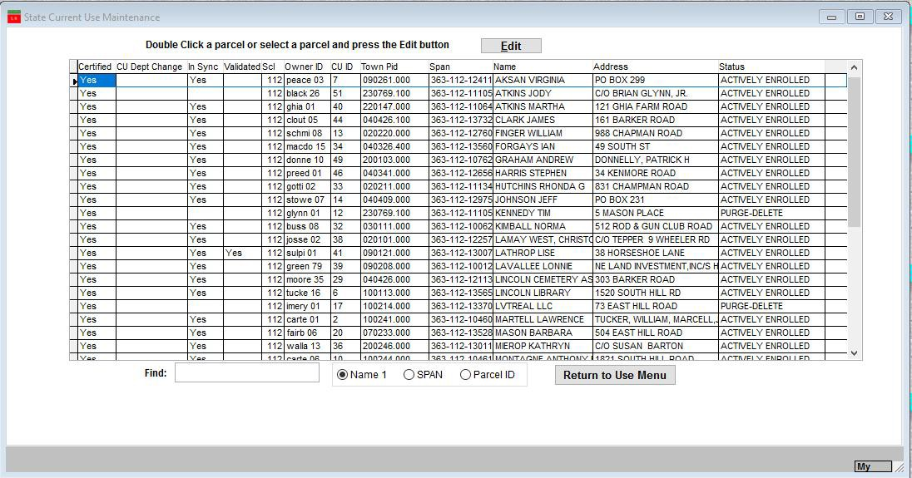
CURRENT USE TIPS
www.nemrc.com

This document will consist of some helpful tips on using the ‘9 State Current Use Maintenance’ in conjunction with your ‘1 Parcel Maintenance’. These 2 parts of the program are totally separate so you must keep this point in mind at all times.

- ‘9 State Current Use Maintenance’ – was once done via mail.
  - Listers would receive CU applications in the Mail.
  - They would manually edit the information on each record then mail the information back to the State CU department.
  - Manually update the Current use exemption on the ‘Value / Exempt tab’ of ‘1 Parcel Maintenance’ in their grand list.
- Now this process is done electronically so the process is much faster but you still have to check your
data. Below is a screen of the ‘9 State Current Use Maintenance’

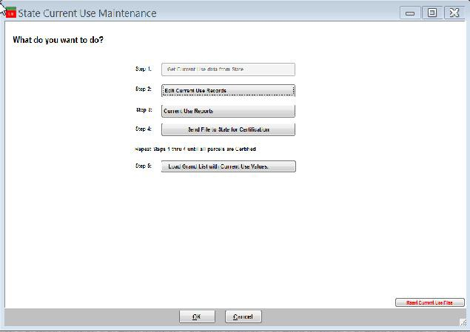
1. Download CU file from the State

Edit Each record accordingly. Each record must be ‘Validated’ by the listers before the file can be sent back to the State CU Dept.

Review any reports necessary
4. Send the file back to State CU Dept. Once the file is
sent back to them you can not edit any data until they send you the file back.
5. Load Grand List with Current Use values. This
is the process that moves the Current Use Reduction values into.

Current Use Process.

Download from State CU Dept

Edit accordingly

Send back to State CU Dept

Load CU exemptions into Grand List

You confirm your ‘411 report’ to the CU ‘All Parcels report’

Once loaded into ‘1 Parcel Maintenance’ go to the ‘R Reports’ menu and run ‘4 Form 411’ Make sure the Current Use row. Matches the totals on the ‘All Parcels Report’ from ‘9 Current Use Maintenance’. This is your manual check to make sure what you are reporting to the State CU Dept matches what you are reporting on your Grand List in ‘1 Parcel Maintenance’.

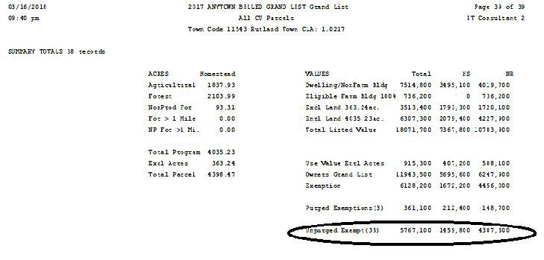

To the right is a copy of the last page of the ‘All Current Use Report’ compare the TOTAL, HS, and NR to the corresponding 411 columns.

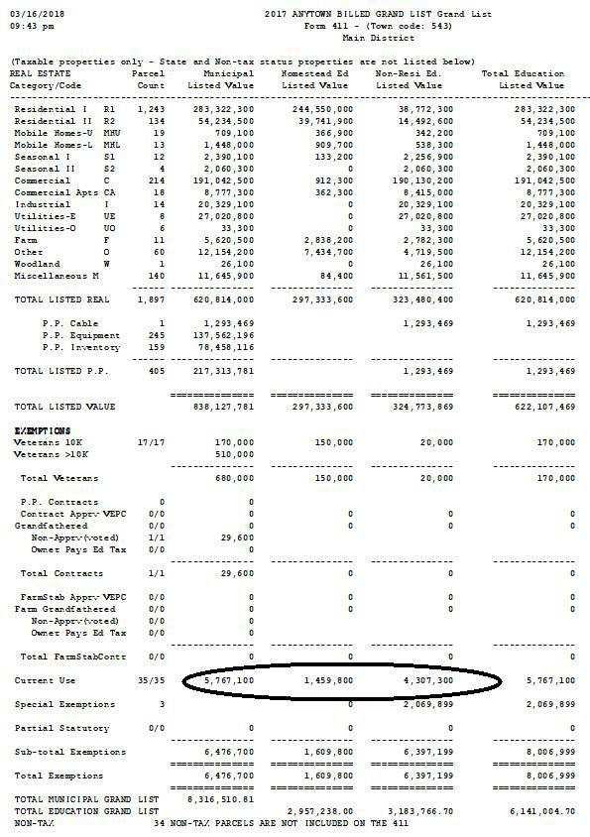
To the right is a copy of the 411 Report.
Compare the ‘Current Use’ row to the ‘All Parcels Report’ above.

Start with the 1st columns on each report. Both should match as seen below

All Parcels Total = 5,767,100 Form 411 Muni = 5,767,100
If they do not match you must uncover why they
are different. This may require you to print the entire ‘All Parcels’ report in Current Use and compare it to the Current Use Values in Parcel Maintenance. You can also use the ‘Act 68 Warning report’ to find the issues as well. This report appears when you try to run the 411 report.

Once you have reconciled the first column move onto the Homestead and Non Residential columns.
Editing CU parcels.

When editing CU parcels pay special attention to the data entry fields.
- Any item that appears red in color means that the information showing up in ‘9 State Current Use Maintenance’ does not match ‘1 Parcel Maintenance’. Correct any issue you discover.
- When you place your mouse over certain areas of this screen such as; Names & address, Acres, and Values a window will appear in the upper right corner of the screen. This window reflects the same type of information on the ‘1 Parcel Maintenance’ screen. This saves you from closing out of this screen and going to look up information on the ‘1 Parcel Maintenance’ screen.

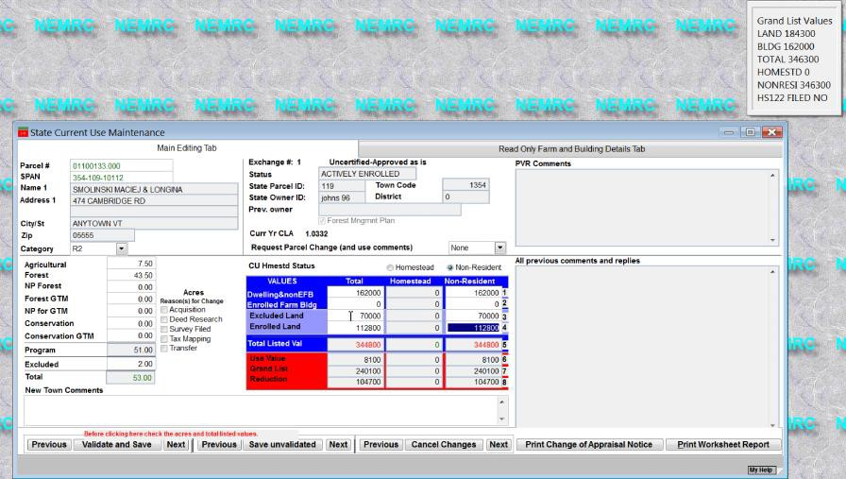

- Status – pay special attention to this field. This will tell you what is happening to this record. Below are a couple of status settings you should be aware of.

    - You can no longer edit a parcel that has a status of ‘Pending’ or ‘Purge’
    - ‘Town changes not applied’ The parcel will be reverted back to it’s previous
information.

Questions:

- What 2 reports must you compare to insure all of your Current use exemptions were loaded into ‘1 Parcel Maintenance’?

- When Editing CU parcels what does it mean when an item is highlighted in ‘Red’?

- After you send data back to the State CU Dept can you edit your Current Use records? Yes / No

- When is your 1st current use file available for download? Circle one below February – March – April

- If a parcel is flagged with a ‘Status’ of ‘Pending’ in ‘9 Current Use Maintenance’ can you edit that
record? Yes / No

Ok this is a quick guide on how to keep your Current Use in sync with Parcel Maintenance. It is important to understand that ‘1 Parcel Maintenance’ and ‘9 State Current Use Maintenance’ are totally separate so if you make a change in one you MUST make sure that change gets duplicated in the other.
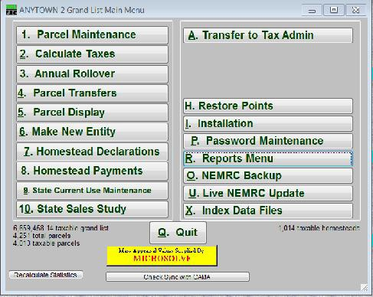
Values get loaded into ‘1 Parcel Maintenance’ from ‘9 State Current Use Maintenance’ by using the ‘Load Grand List with Current Use Values’ button. It is important that you examine each record in ‘9 State Current Use Maintenance’ and make sure all the information is correct. Any item that is Red on the Current Use edit screen needs to be fixed accordingly. Refer to the Current Use document at www.nemrc.com for more details.

Reports that can help you keep data in sync.
  - Under ‘9 Current Use Maintenance’ Make sure you compare the 'All Parcels Report’ Totals on the last page seen on the left. To your ‘411’ report or ‘Current Use Exemption’ report seen on the right. If the Totals do not match then you must figure out why and make the appropriate corrections.
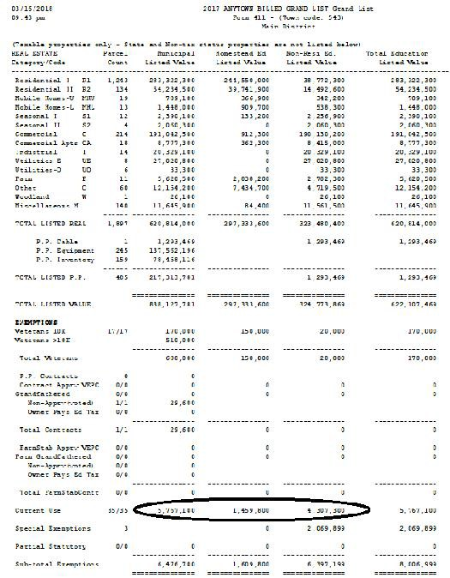

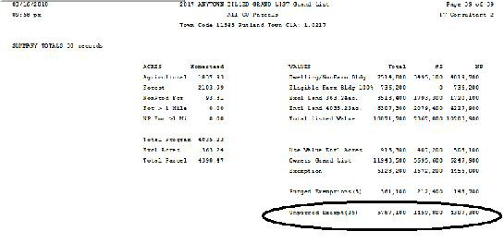

  - Other Report to assist you. ‘Act 68 Data Test Report’ Below is an example of that report. It appears any time you try to run a Grand List or 411 report and there are issues that need to be reviewed. Here are 3 different examples of Current use issues being identified that warrant your attention.
    - The 1st one is telling you this parcel has a CU exemption in Parcel Maintenance but that parcel does not exist in the ‘9 State Current Use’ file. This should not happen. All Parcels enrolled in CU should be in both Parcel Maintenance and the Current use file from the State.
    - 2nd Current use exemptions are applied to the Municipal, Homestead, and Non Residential Grand List. This message is telling you that the CU Exemption is not being applied properly to this parcel. Check both Parcel Maintenance and 9 Current Use Maint.
    - 3rd The CU exemption in Parcel Maintenance does not Match 9 State Current use maintenance. If they do not match then your reports mentioned in step 1 on the previous page will not match either and they must.

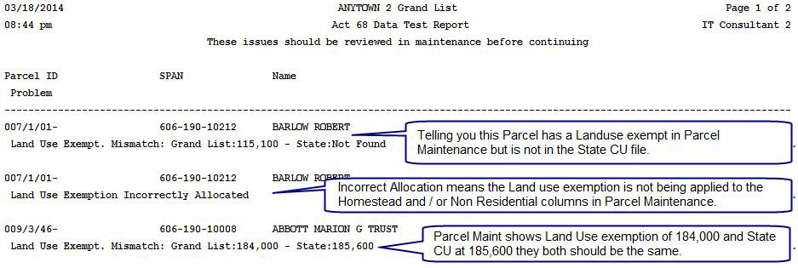

  - Changes that will definitely affect Current use and will need to be double checked in
‘9 Current Use Maintenance’
    - Homestead Declaration Change
    - Assessment change
    - Names and Address changes
    - Transfer of ownership or subdivisions
    - Combining of parcels
    - Inactivating or Deleting parcels.

This document will give you some ideas on how to use PDF files to track and organize your grand list data throughout the year. This is not a replacement of your paper files…

The first step is to create a folder on your computer that you easily find. Then you can place various Grand List reports in PDF format into that folder that will help you track changes. Below you can see I created a folder labeled ‘Grand List Reports’ and inside that folder I created a folder for 411 Reports, Change of Appraisal Reports, Current Use Reports, and Grand List reports.

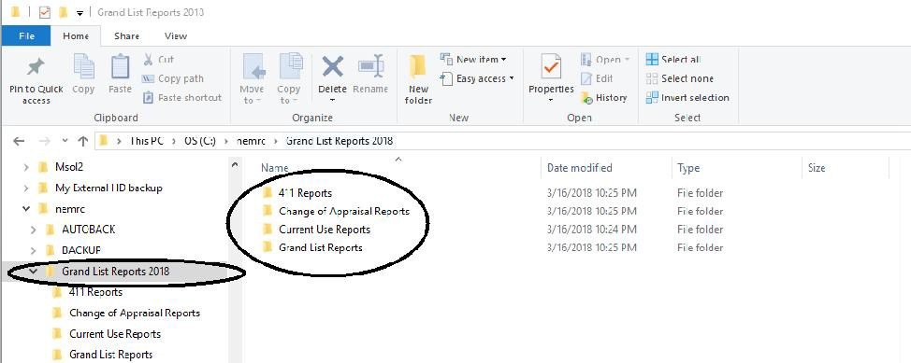

If we look inside the Current Use folder we see the Current Use ‘All Parcels report’ for each Exchange that has been Downloaded and the same report after the Listers had Edited the file.

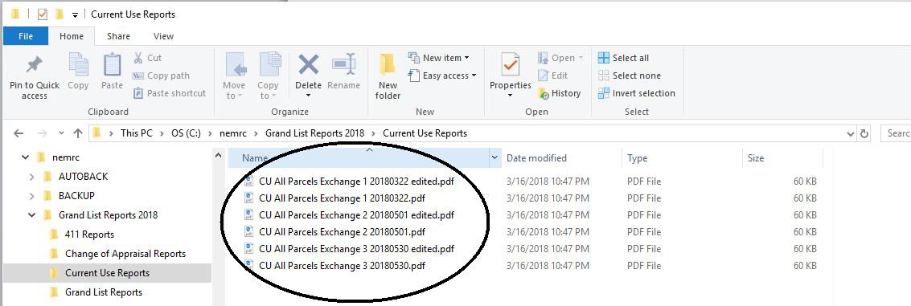

When you print your report choose your PDF printer. If you do not have one to select then have your IT person assist with installing one for you.

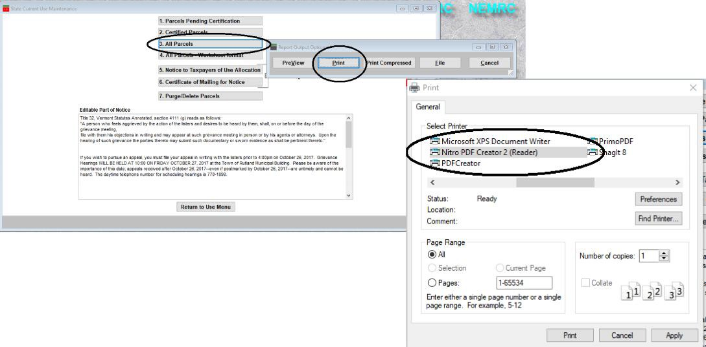
Simply select the folder where you want to save your pdf file as seen to the right. Then click the ‘Create’ button.
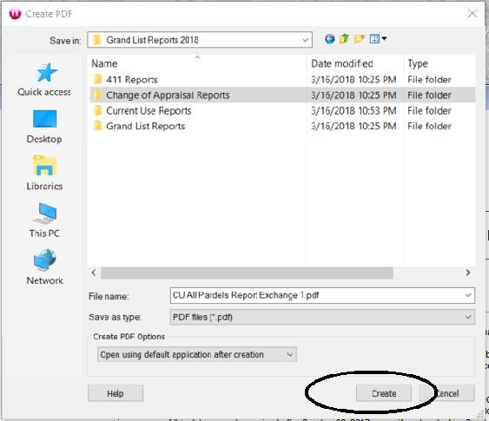

Note your PDF software my not have the same exact screen options seen here.

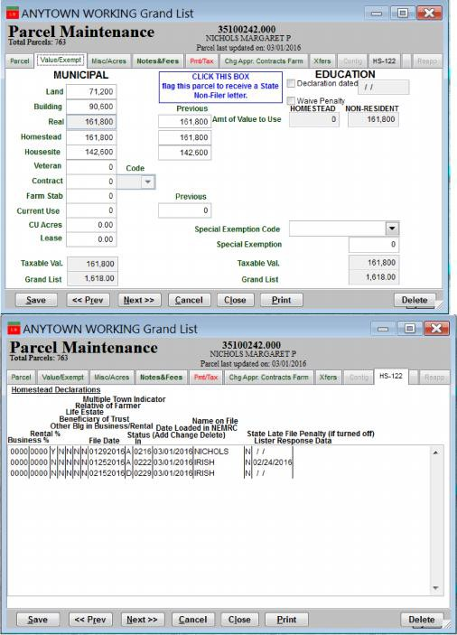
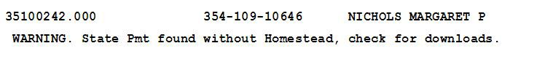
What to do when you get an ‘Act 68 Warning’ stating a parcel has a State Payment on but does not have a homestead declaration. You need to make sure these are resolved as the tax payer may not be getting taxed correctly in these situations. All issues must be resolved by December 30 of a given tax year.

Solution: This person is getting a State payment but does
not have a homestead declaration. This can happen when there is a change in ownership but you have
to research these situations. If you look at the ‘HS 122’
tab you can see what happened in this example. There are 3 homestead declarations that have been downloaded.
- The owner ‘Nichols’ declared her Homestead dec.
- Then someone named ‘Irish’ declared too. Which the Listers responded to Taxpayer Services that this was incorrect.
- Next the removal of the ‘Irish’ declaration which removed the homestead declaration from the parcel entirely. So at this point the Listers need to inform Taxpayer Services of the situation
so ‘Nichols’ Homestead declaration is turned back on again. This needs to be resolved before December 30 of a given year.

To report this issue to Tax Payer Services simply go to ‘7 Homestead Declarations’ on the Main Menu for detailed instructions go to http://www.nemrc.com/support/grandList/ and find the ‘Listers Response’ help document.

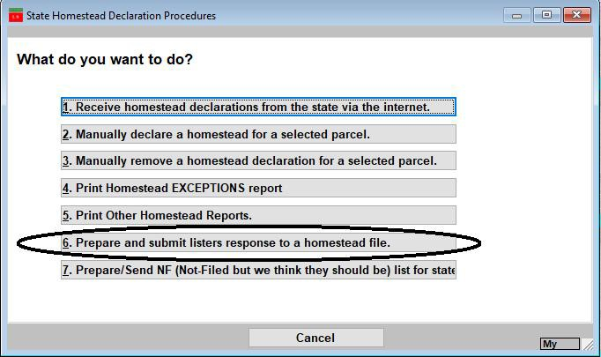
NEMRC
New England Municipal Resource Center, Ltd

SEMINAR EVALUATION FORM

We appreciate you taking a moment to supply us with your honest and objective input
about today’s seminar. This will allow us to better prepare for future seminars.

Seminar Title Date

Name & Title Organization

1. Please tell us what you thought about this seminar.

