Agenda

9:00 – 9:30 Registration and Coffee

9:30 – 10:30 Current Use alerts and tips

10:30 – 10:45 Quick Break

10:45 – 11:00 Sending 411 Reports and new alerts

11:00 – 12:00 Security related topics presented by Brian Curtis DominionTech

12:00 – 1:00 Lunch

1:00 – 1:15 Grand List passwords

1:15 –1:30 Change of Appraisal flag updates

1:30 – 2:00 Changing Parcel IDs

2:00 – 2:30 Using Comparison Reports More comparisons added

3:00 – 3:00 Tax bill layout changes 2019 prototype

3:00 – 3:30 Question and Answer

1

Current Use Filing
Using the NEMRC Grand List Software 2019

Critical Dates for Current Use

March 15: Current Use files sent to towns
July 5: Final date for return of Current Use files from the towns

Overview of Using NEMRC

Property Valuation and Review (PVR) has established an electronic procedure for sharing Current Use data with towns—exchanges of data that will include a minimum of two file imports. The first file imported from PVR will constitute the first exchange. Within the NEMRC system, towns will review all current use parcels and make necessary changes. When finished, the file is exported back to PVR for review and approval of changes.

After review, a second exchange begins when PVR electronically returns the file, indicating that parcels have been certified by the Current Use Program. Towns will import the second exchange and check for any parcels not yet certified. Further changes can be made by the town at this point before sending the reviewed second file back to PVR. This process of exchanging files will continue until all parcels are certified for the current tax year.
The automated system sends these confirmation emails to whatever email address your town has provided for the purpose of Current Use processing. Usually, this will be the address of the person who downloads and reviews Current Use data. If this person’s email address has changed recently, or if you want to confirm the address being used, please email Tax.currentuse@vermont.gov.
If your email system automatically blocks messages from unknown senders, please add the State’s email domain “@state.vt.us” to your list of trusted domains list.

Instructions

- Do you have a current backup of your data? If not, run a backup of data before attempting this or any other critical process. Follow your usual procedure for backups or call our IT staff at 828-0428 or NEMRC 800-387-1110.

- You must be connected to the internet to download the Current Use files.

- Open the NEMRC program and click on the current working grand list. At the ‘Main Menu’ if ‘U. Live NEMRC Update’ is green then you need to update to the most current version of the program first.
2

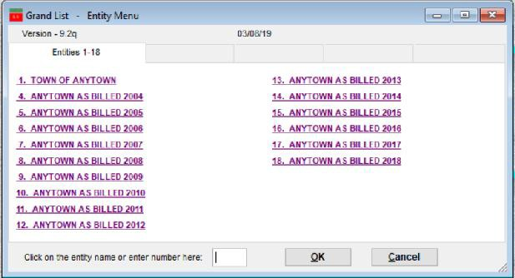
You will download your 1st current use file in your Working Grand List. This is usually Entity # 1 on your Entity Menu as seen here.

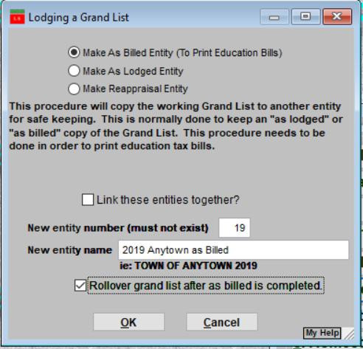
Making a New Entity
Once you are ready to create an As Billed Grand List (which is usually not before July if you are unsure contact NEMRC support or Tax IT for assistance) you will not be able to edit current use in the working grand list until the next year.
This feature was added in 2010 to help prevent end users from sending files from or downloading files to the wrong grand list entity. Make sure you check the box “Rollover grand list after as billed is completed” This moves all of your values in the Parcel Maintenance to the Previous Value fields.

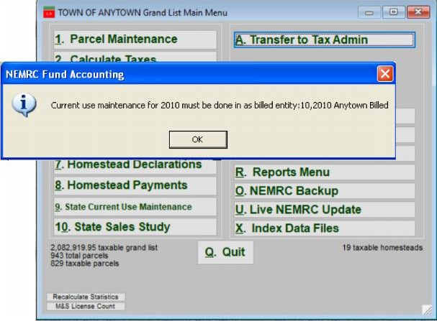
After you create your new As Billed Grand List and you click on the button ‘9. State Current Use Maintenance’ in your Working grandlist, you will receive a message that informs you any adjustments to Current Use must be done in the appropriate As Billed Grand List.

To edit the Current Use files, simply exit the Working grand list and log into the As Billed Grand List for the current grand list year.
Current use maintenance for 2019 Must be done in as billed entity: 19 2019 Anytown as Billed
3

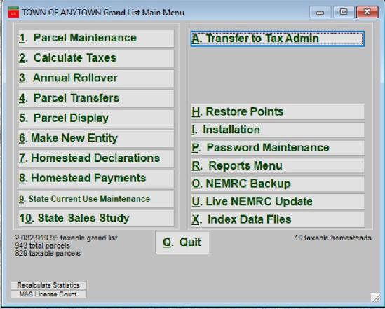
Starting from the Main Menu select ‘9. State Current Use Maintenance’. This option will highlight green in color when there are files to be downloaded. However, in some circumstances this button may not highlight as it is dependent on your virus protection and or firewall settings on your computer or network.

Warnings / Alerts: If you receive either of these 2 messages “Current use acres not defined” or “Updown.txt” file not found/available.
These are files that reside on the State server. The Current Use IT person places them on their server in March when the initial CU file is ready to be downloaded.
Typically if you receive either of these messages it is generally caused by no internet connection, your Virus protection software, or Firewall software on your computer or server. You will need to contact your IT person to assist you and possibly edit your virus/firewall settings before you can download CU files.
Note: Your virus protection and firewall software updates periodically so do not be surprised if you were able to receive and send a number of CU files then later in the year receive this message. It is most likely due to an update to the virus protection or firewall software.

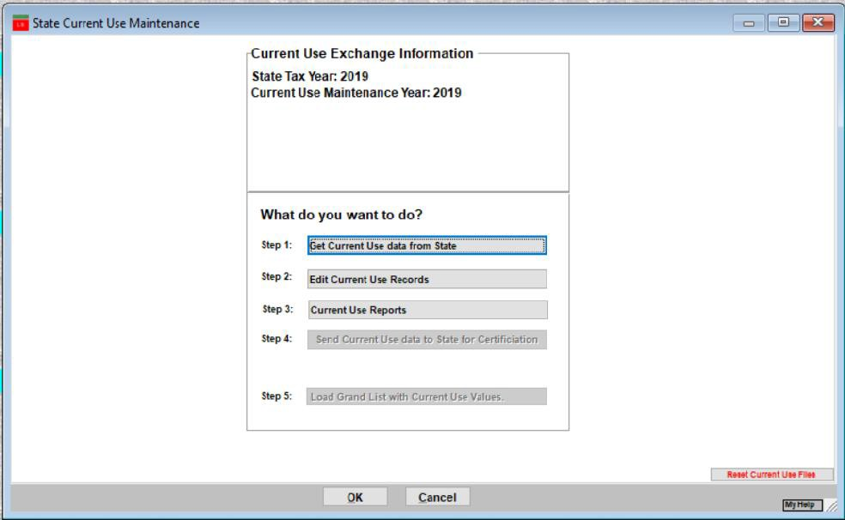
New 2019– Current Use Exchange
Information window will show you various data that will help you keep track of the following information:
Year, When you downloaded CU files, Sent CU file back, CLA being used, Exchange # you are currently editing, and status of your parcels.
1. Click this button to download your
Current Use files from the State Current Use Program.
Thisprocedurerequiresyoutobe connected to the internet.
4

NOTE: You may be asked if you want to move the current use values in Parcel Maintenance to the previous current use exemption field. Normally this is done when you create your ‘New Entity’ mentioned on page 2 of this document. If you are unsure how to answer this question simply open a couple parcels in Parcel Maintenance that had a CU exemption last year. Go to the ‘Value Exempt’ tab look at the ‘Current Use’ field as circled below. If the Current use field is 0 and the Previous CU field is filled in then your Current use values have been moved already. Select ‘No’ on the warning.
If the Current Use field does have a value in it which reflects ‘Last year’s CU exemptions select ‘Yes’ and the
program will move the CU exemptions to the Previous CU exemption field.

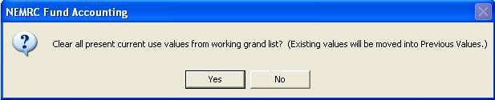

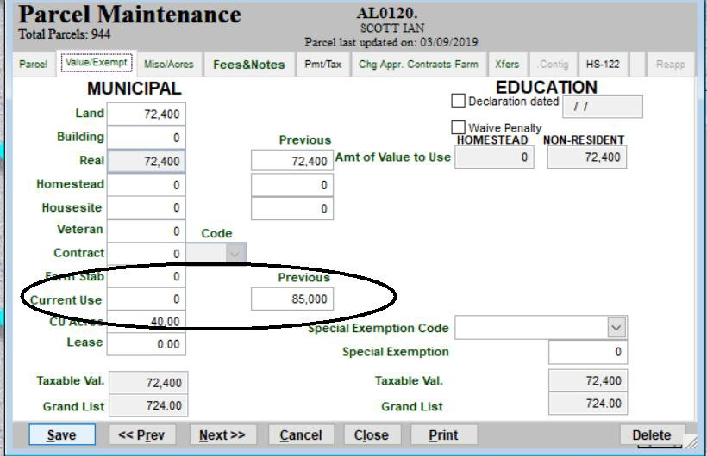
5

Current Use Exchange Information: As mentioned on page 3 of this document in 2019 this information was added so the Listers/Assessors could better track the status of their Current Use files that get sent back and forth to the CU department. With this information you will be able to see when your last download was, when you sent it back along with a brief status of your current use parcels. IE: All certified or pending etc. Once all parcels are Certified by the CU Department then you do not have to send the file back to the CU Department. Unless you make a change to a parcel or a request by the CU Department is made.

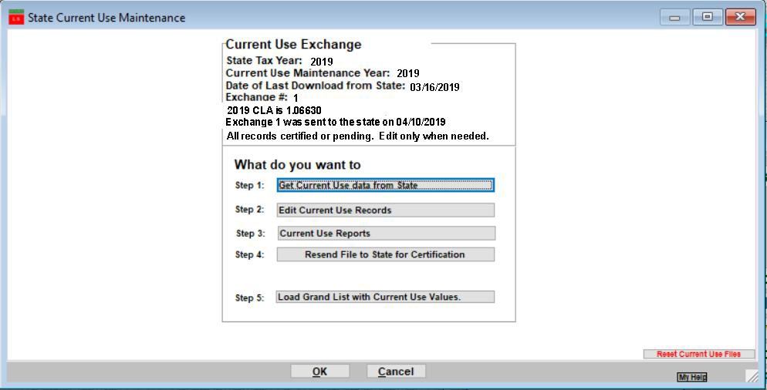
6

Current Data Exchange Alert: This message will appear anytime these conditions are met:
You have had your current CU file and not sent it back to the CU Department in over 30 days.
Or all of your parcels are ‘Certified’ however, you edited a parcel. Which would mean you need to send your file back to the CU Department, so their information matches your information at your office. NOTE: this message is triggered by looking at a parcel using ‘Step 2 Edit Current Use Records’. Then clicking on the ‘Validate and Save’ button. If you are not changing anything on the parcel then click the ‘Save un validated’ or ‘Cancel changes’ button on that screen to exit.
Clearing the message:
The message will go away once you finish working on the current file and send it back using ‘Step 4 Send file to State for Certification’.
If all your parcels are Certified and you looked at some and clicked on ‘Validate and Save’ as mentioned above, but did not make a change. Then simply open any records that have the ‘Validated’ flag set to ‘Yes’ using ‘Step 2 Edit Current Use Records’. Then click on the ‘Save un validated’. Once all of the ‘Validated’ flags are set to ‘No’ or ‘Blank’ the message will be cleared.

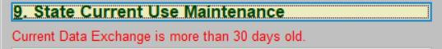
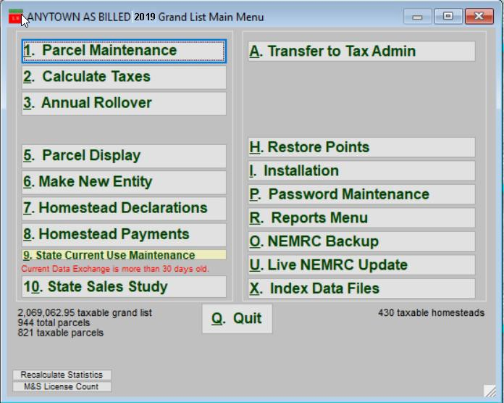
7
You can search for a parcel on this screen as well.

2. Click here to begin editing the list of parcels currently enrolled, including new parcels that met the September 1st deadline for enrollment.

Columns to pay attention to:
Certified – Record was Certified by CU Dept, CU Dept Change – Did CU Dept Make changes to record, In Sync – Are values in sync with ‘Parcel Maintenance’, Validated – Have the Listers reviewed a record. Status – Shows current status of record.
Note: Validated by the Listers. Uncertified or not validated parcels need to be reviewed further.

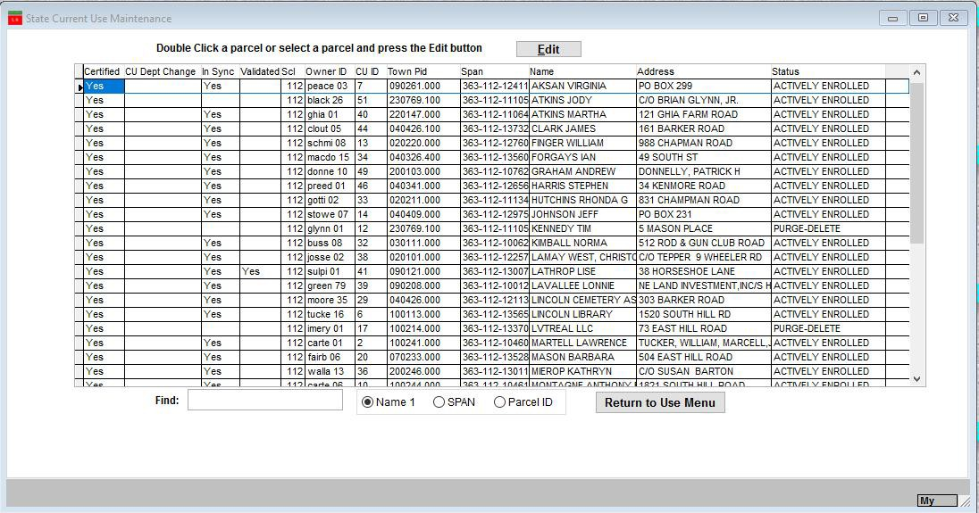
8

4. You are now ready to review this parcel and make necessary changes.
NOTE: Fields that are grey cannot be edited by the end user. Please review and edit the following fields:
Span #, Homestead Declaration Status, Owner Information, Category, Acres, Values, and other general information.

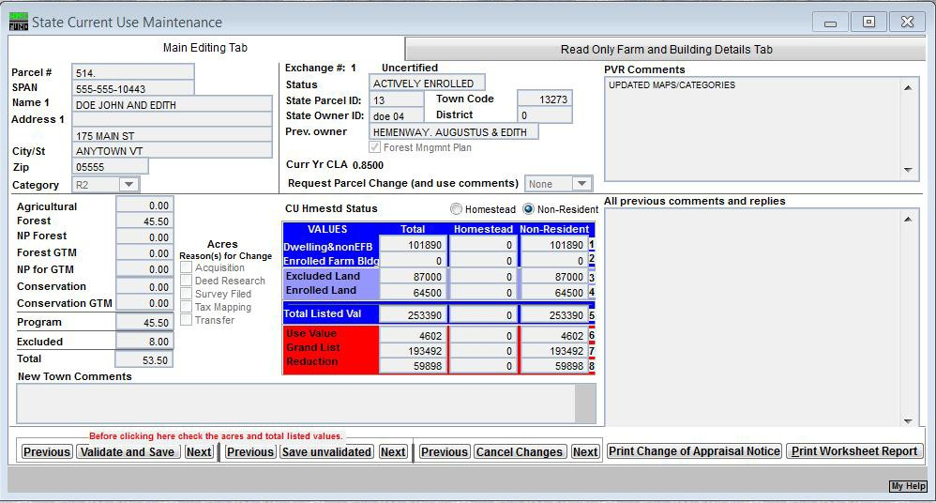
4A. If a parcel has been transferred, combined, split, or deleted from current use the ‘Request Parcel Change’ dropdown to identify the type and explain using the ‘Town Comment’ field.
If you notice any information that needs to be changed that is not available for you to edit directly, select
‘Other’ from the ‘Request Parcel Change’ dropdown and enter a ‘Town Comment’.

4B. Automatically Calculated Fields - when acreage or values have changed.
Use value
Owner Grand List
Exempt Reduction
4C. Comment field. This area will display all comments that have been entered by the Listers and the responses by the Current Use Program.
9

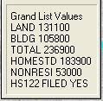
Values that are red font color means that this value does not match your data in the working grand list.
Values that are green font color means that value does match your data in the working grand list.
Span #, Parcel ID, Acreage, Total Listed Value are the only fields where the font will change colors.
NOTE: Place your cursor on Owner, Acres or value field and the program will display a box in the upper right corner of the screen showing you what value that field contains in you current working grand list. As seen here.

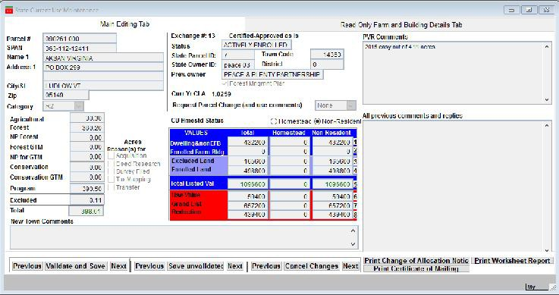
4D. Remember your values must be in either the Homestead or Non-Resident column depending on the property’s HS 122 status. Also, properties enrolled in the farm program must have enrolled farm buildings in the non-residential column. Values for un-enrolled buildings and for values of farm crop processing facilities in excess of $100,000 belong on the Dwelling & non EFB line. HS 122 flags will be tied in with the actual HS 122 files you download.

NOTE: If you make an acreage change then you must select a reason for the change. As well as entering a comment to help explain the acreage change.
Definitions:
Acquisitions and transfers - any conveyance by deed which should not be included in tax mapping.

4E. Once you are finished editing a parcel click the ‘Validate and Return to Parcel Selection’ button.
This will show you if any of the values on this screen do not match your working grand list so you can correct them as needed. If all matches then you will be returned to the screen showing you all of your enrolled parcels. From there you can select another record and repeat the editing process for that parcel.

4F.‘Save Unvalidated’ –This will save your changes but not validate the information. This allows you to leave this screen so you may do more research on this parcel without losing your changes.

4G. ‘Previous & Next’ buttons located on this screen are grouped together with a specific execution button. When pressed they will perform that task before advancing to another record. This eliminates the need to return to the previous window and select the next record on the list.
10
Change – Building Detail Tab

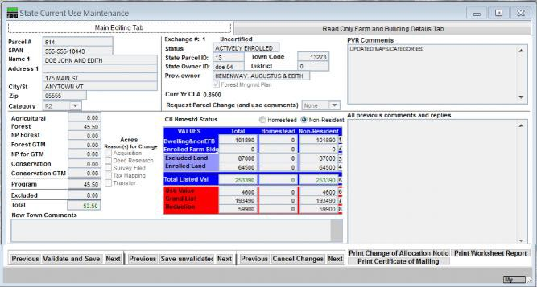

The edit screen is now has 2 tabs
‘Main Editing Tab’
‘Read Only Farm and Building Details Tab’

6. Once you have edited the appropriate data on the ‘Main Editing Tab’ you must review the data on the ‘Read Only Farm and Building Details Tab’ before you can ‘Validate and Save’ a parcel.

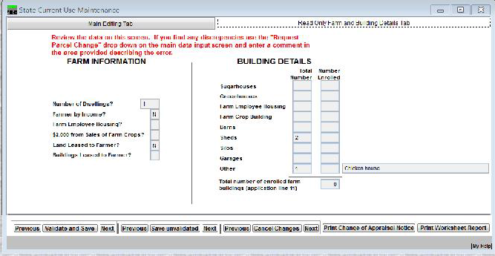

7. Once you are on the new tab Review the two ‘Building Detail’ columns on the Right. If there is an error in the either of the 2 columns then please alert the Current Use Department following the instructions below.

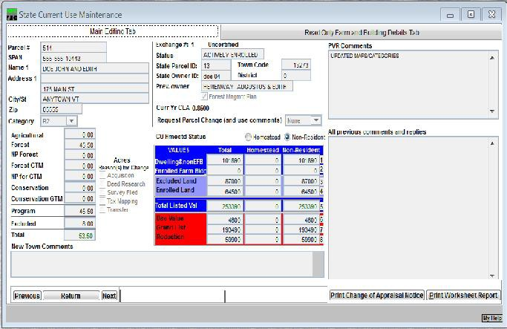
7a. Go back to the ‘Main Editing Tab’
7b. Click the Drop Down labeled
‘Request Parcel Change’
7c. Select ‘Other’ from the drop down list.
7d. Then enter a comment explaining the error you
discovered on the ‘Read Only Farm and Building Details Tab’ in the ‘New Town Comments’ space at the bottom of the screen.
7e. Click the ‘Validate and Save’ button once you
are finished.
1
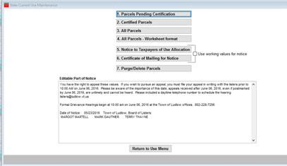
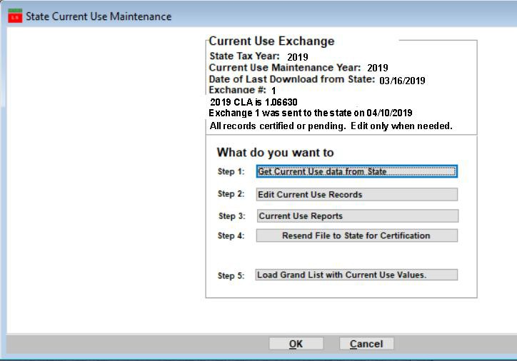
11
9A Next select one of the following
reports for your files.

9B Make sure totals on the last page of this report match the totals on the ‘Current Use Report’ or ‘411’ on the Reports Menu of the grand list. If the reports do not match identify the parcels that are different and make the proper adjustments.

9C Edit the ‘Notice to Taxpayers of Use Allocation’ in the space provided. Change verbiage, dates, and names as needed. This notice will fold so the Name and address will fit in a standard # 10 envelope.
These are records that have not been
certified yet. Sometimes you need to use the CU reduction values before they are certified. In this case place a check in the check box and the non certified values will be printed on your Notices.
9D Click the ‘Return to Use Menu’

8. Next select ‘Run Reports or Change of Value Notices’

when you are finished printing these reports.
12

  - ‘Send File to State for Certification’ After “Validating’ all parcels, printing your notices, and reports you can transfer the data to the Current Use Department for Certification.
This process requires an internet connection
When you send data to the sate you will be sending all of your land use parcels and will not be able to edit any until a response is received from the state. Make sure you have edited all of your parcels before doing this process.

  - ‘Load Grand List with Land Use Values’ This will transfer your Current Use Exemption values into Parcel Maintenance of your grand list. This should be done every time you send the file to the state. You will see the new values on the ‘Value/Exempt’ screen on ‘Parcel Maint’.
NOTE: You must do this step and make sure your current use values are in place before you can use your Grand List values to set your tax rates.

This option is only used when the CU department needs to reset your values. They will instruct you when this option is to be used.
13

Values submitted electronically will be reviewed by the Current Use staff and any changes will receive additional attention. If our files do not agree with town data we may write a letter to the property owner. This will take time and delay the final certification of all the parcels and is the reason we would like to have the data completed early. The final certification process depends on the number of changes made to the data when you submit as well as the number of discrepancies in the valuation.

Once you submit the data the file is closed and will be available to you as “read only”. It remains “read only” until you receive and import the next exchange file from PVR.
    - When Current Use has completed its review of your data, you will receive an email notifying you that a new file is available for import. You will then go to ‘Main Menu’ of the grand list program and select ‘9 State Current Use Maintenance’ and run through the process, editing those parcels that have not yet been certified (if any). After review of uncertified parcels and after making any additional changes, return the file to the Tax Department by selecting the button mentioned in step 4 from above.
    - Once the file has been sent to the state, select Step 5 to load the current use data into the grand list.

After you create an As Billed grand list, the As Billed entity must be used if, or when, you send additional current use changes to PVR - and when downloading any new file from PV & R. In other words, after you have done the annual rollover in the working grand list it is no longer used for processing of current use files until you start the next grand list season. Use the As Billed grand list once it is created.

NOTE: If your town completed a town – wide reappraisal your current CLA will be 100.00. You will need to provide the new values for each parcel. If for any reason you are not reappraising but have received a current CLA of 100%, contact the Current Use Program at (802) 828 – 5860 for instructions on resetting the electronic exchange system and for receiving a new file containing the correct CLA.

CURRENT USE TIPS
www.nemrc.com

CU - 1

This document will consist of some helpful tips on using the ‘9 State Current Use Maintenance’ in conjunction with your ‘1 Parcel Maintenance’. These 2 parts of the program are totally separate so you must keep this point in mind at all times. Go to http://www.nemrc.com/support/grandList/ for full Current Use instructions.
It is important to understand that ‘1 Parcel Maintenance’ and ‘9 State Current Use Maintenance’ are totally separate so if you make a change in one you MUST make sure that change gets duplicated in the other.

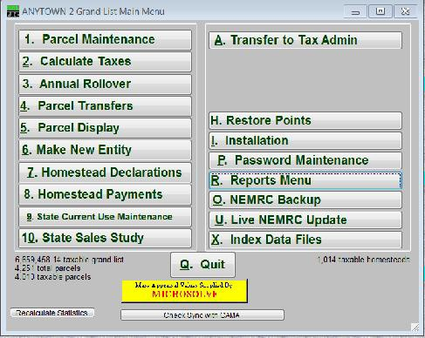

Values get loaded into ‘1 Parcel Maintenance’ from ‘9 State Current Use Maintenance’ by using the ‘Load Grand List with Current Use Values’ button. It is important that you examine each record in ‘9 State Current Use Maintenance’ and make sure all the information is correct. Any item that is Red on the Current Use edit screen needs to be fixed accordingly

- ‘9 State Current Use Maintenance’ – was once done via mail.
- Listers would receive CU applications in the Mail.
CU -2

- They would manually edit the information on each record then mail the information back to the State CU department.
- Manually update the Current use exemption on the ‘Value / Exempt tab’ of ‘1 Parcel Maintenance’ in their grand list.
- Now this process is done electronically so the process is much faster but you still have to check your data. Below is a screen of the ‘9 State Current Use Maintenance’

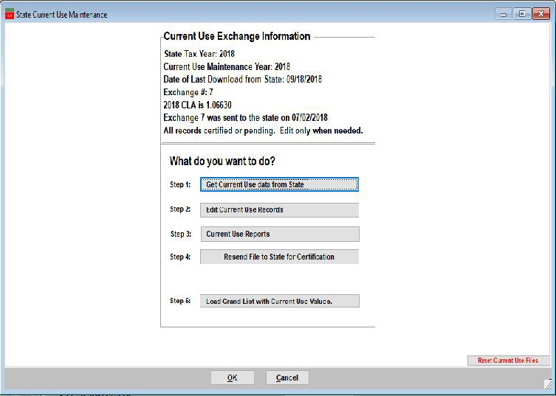
1. Download CU file from the State

- Edit each record accordingly. Print worksheet for each parcel for your records. Each record must be ‘Validated’ by the listers before the file can be sent back to the State CU Dept.

- Review any reports necessary – (# 3 ‘All Parcels
report must match your 411 report in the grand list)

- Send the file back to State CU Dept. Once the file is sent back to them you can not edit any data until they send you the file back.

5. Load Grand List with Current Use values. This is the process that moves the Current Use Reduction values into.

Current Use Process.

Download from State CU Dept

Edit accordingly

Send back to State CU Dept

Load CU exemptions into Grand List

You confirm your ‘411 report’ to the CU ‘All Parcels report’

Best Practices for this Procedure

  - Backup your data before downloading CU files.

  - Edit all Parcels in ‘9 State Current Use Maintenance

  - Print – Reports before sending data back to CU Dept. That includes ‘Worksheets’ for each record, ‘Pending’ parcel report, and ‘Purged’ parcel report, ‘All Parcels’ report and ‘411 report’ at all times. This way you will have an audit trail between Current Use downloads and you will be able to identify what changed between downloads. Make sure you are aware and can explain all items that have changed before moving forward. Create a folder on your computer and store each report as a PDF file for future reference.

  - Backup your data before Sending CU files back.

  - Send file to State for Certification

  - Load Grand List with Current Use Values (Every time you send a file back to the State otherwise you may not be able to run a 411 report).

  - Compare totals on the ‘All Parcels’ report to your 411 report to make sure they match.
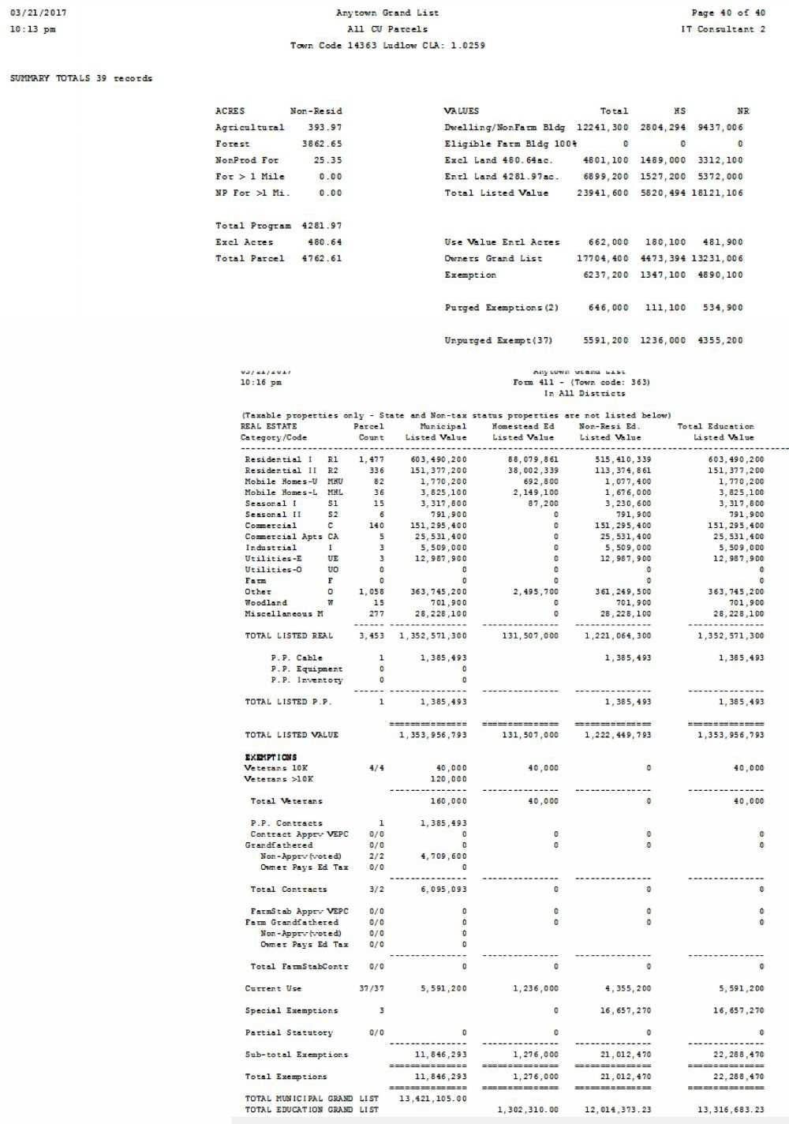
CU - 3
Once loaded into ‘1 Parcel Maintenance’ go to the ‘R Reports’ menu and run ‘4 Form 411’ Make sure the Current Use row. Match the totals on the ‘All Parcels Report’ from ‘9 Current Use Maintenance’. This is your manual check to make sure what you are reporting to the State CU Dept matches what you are reporting on your Grand List in ‘1 Parcel Maintenance’.

To the right is a copy of the last page of the ‘All Current Use Report’ compare the Last Row ‘Unpurged Exempt’ TOTAL, HS, and NR to the corresponding 411 columns.

To the right is a copy of the 411 Report. Compare the ‘Current Use’ row to the ‘All Parcels Report’ above.
Start with the 1st columns on each report. All Parcels Total = 5,591,200
Form 411 Muni = 5,591,200
0 Balance

Once you have reconciled the first column move onto the Homestead and Non Residential columns.

If there is any discrepancy you must review your Parcels in ‘#9 Current Use Maintenance’ vs ‘1 Parcel Maintenance.

Below is a warning that will appear when you try to run your ‘1. Grand List’ or ‘4. Form 411’ report. This is just reminding you have not loaded any Current Use exemptions into ‘1 Parcel
CU - 5

Maintenance’ yet. You can proceed with the production of the reports just know that they will not include any Current Use exemptions at this time. If you are one of the few City/Towns that do not have any current use records then you can ignore this message. NOTE: This will stop you once you start passing files back and
forth between the town and CU dept.

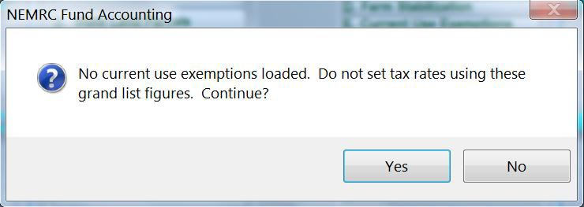

Once you have printed tax bills the program is going to check to see if your Most Current Current Use Data in ‘9 Current Use Maintenance’ have been loaded into ‘1 Parcel Maintenance’. The alert is there so everyone knows that the Most Current Use Data has not been loaded so a Tax bill or 411 report may not be accurate. It Does not mean you have never loaded Current use files in the past or they are missing in ‘1 Parcel Maintenance”.

- To clear this message Best Practices:
    - Previous 411 Report. Compare the Current Use row as to the All Parcels report as described on page 3 of this document. This will tell you right off if any Current use values are going to change when you load the Grand List with Current Use Vales.
    - Simply follow the steps on page 2 of this document to “Load Grand List with Current Use Files”.
    - Then compare the Current Use Reports to the 411 Report as seen on page 3 of this document.

This message will appear when you try to run the following reports:
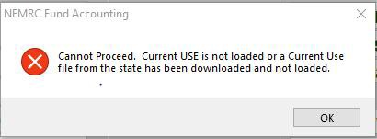

- Grand List report
- 411 Report
- Print Tax bills (Copy of or Revised)

CU - 6

  - Other Report to assist you. ‘Act 68 Data Test Report’ Below is an example of that report. It appears any time you try to run a Grand List or 411 report and there are issues that need to be reviewed. Here are 3 different examples of Current use issues being identified that warrant your attention.
    - The 1st one is telling you this parcel has a CU exemption in Parcel Maintenance but that parcel does not exist in the ‘9 State Current Use’ file. This should not happen. All Parcels enrolled in CU should be in both Parcel Maintenance and the Current use file from the State.
    - 2nd Current use exemptions are applied to the Municipal, Homestead, and Non Residential Grand List. This message is telling you that the CU Exemption is not being applied properly to this parcel. Check both Parcel Maintenance and 9 Current Use Maint.
    - 3rd The CU exemption in Parcel Maintenance does not Match 9 State Current use maintenance. If they do not match then your reports mentioned in step 1 on the previous page will not match either and they must.
    - 4th The Parcel has a CU exemption in ‘Parcel Maintenance’ but is flagged in 9 Current Use Maint. As ‘Purged’. Research and determine whether or not this parcel should have a Current Use exemption.

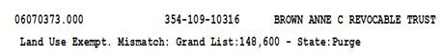
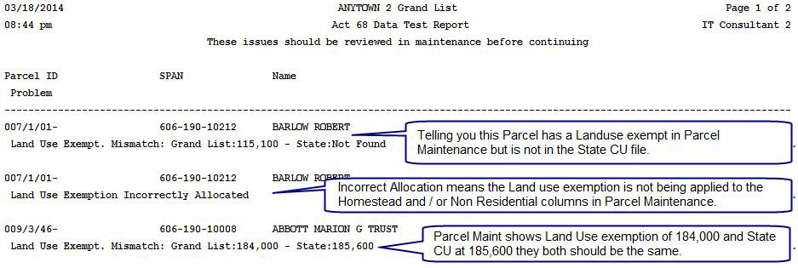
Parcel Maint Shows Land Use exemption of 148,600 and State CU
has parcel flagged as ‘Purged’

  - Changes that will definitely affect Current use and will need to be double checked in ‘9 Current
Use Maintenance’
    - Homestead Declaration Change
    - Assessment change
    - Names and Address changes
    - Transfer of ownership or subdivisions
    - Combining of parcels
    - Inactivating or Deleting parcels.
Using your 411 Cont.

Sending files to PVR

During certain times of the year you need to send your 411 and Grand List file to PVR. Generally August 15th and again before January 15 of a given grand list year. (PVR may request that you send your files more often but as a general rule DO NOT SEND these files every time you view a 411 report.) Refer to http://www.nemrc.com/support/grandList/ and select the help document labeled ‘Electronically Filing of Grand List/411’ document.

- If you have not sent a 411 for your as billed grand list after August 15th you will receive the following alert when you log into the As Billed Grand List. In this example the program is telling us the preliminary 411 for the “Town of Anytown 2018 As Billed Grand list” has not been sent to the State. To submit a 411 to the state simply print or preview the 411 report and follow the prompts for sending your files to the State.

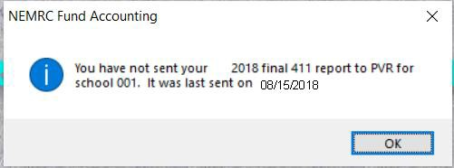
/ /

- If you have not sent a 411 for your As Billed Grand List to the state between January 1st and January 15th you will receive the following alert when you log into the As Billed grand List. In this example the program is telling us the Final 411 for the “Town of Anytown 2018 As Billed Grand list” has not been sent to the State. To submit a 411 to the state simply print or preview the 411 report and follow the prompts for sending your files to the State.

- When submitting 411 files to the State you will be prompted to verify that the “Personal Property” information is correct. Please take time to insure that this information correctly indicates how personal property is being tracked in your town.

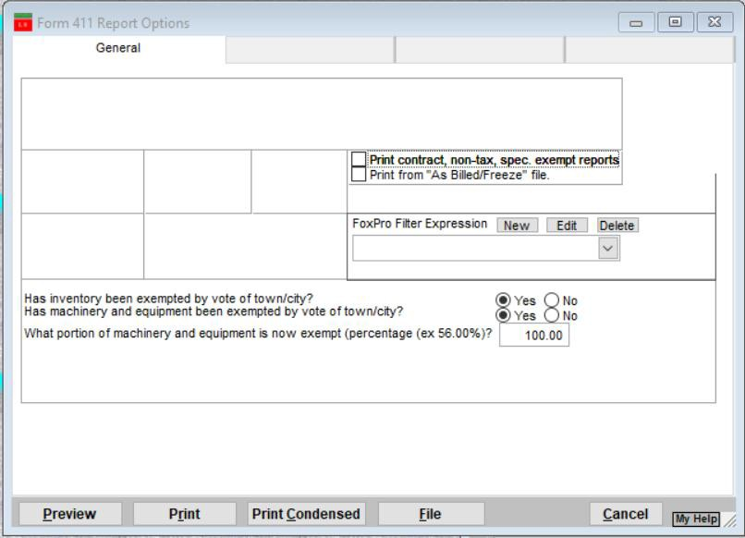

- After Previewing or Printing the 411 Report a window will appear asking if you would like to send a file to the State as seen on the left. Once you press the ‘Ok’ button, you will receive a message confirming you have answered the ‘Personal Property’ questions correctly. Seen below on the right. Press ‘Yes’ if you have already confirmed this information to be accurate. Press ‘No’ to abort sending a file to the state and return to the ‘411 report options’ screen. Once you send the files to the State the date you sent the files will appear in the lower left corner of the ‘411 Report option’ screen.

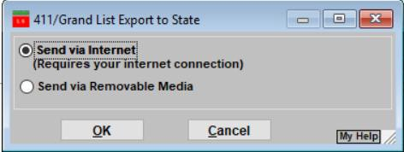

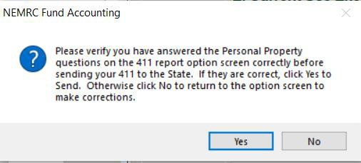

Below is a list of files that you are sending to PVR. These files will be processed at the tax department then passed along to the Education department. So it is important to verify the Grand list figures they send in the mail back to your town office. For more details about this letter go to page 4 of the following document on the NEMRC website. http://www.nemrc.com/support/grandList/LS_2015handouts/Cash%20flow%20process.pdf

The files created and sent are stored in your NEMRC Directory and they are as follows:

  - VTANYT_##.abc – This is a backup of your Grand List data is created and sent to PVR. This will match the 411 reports that you are sending as well. In the past the District Advisers asked for a backup of your data when they were on site or requested that you provide them with a backup via email or some other medium.
  - 411EXP##.CSV – List of Totals of Exemptions in your Grand List. IE: Veterans, Contract, Farm Stabilization, Current Use, and Special Exemptions.

  - 411LST##.CSV – List of all your parcels where Tax Status is Non Taxable and State Owned Land

  - 411TFP##.CSV – Shows all parcels within your TIF District regardless of Parcel Status or Tax Status.

  - 411TFS##.CSV – TIF Summary File, This shows the information displayed on the
‘Installation’ ‘TIF Tab’ (This file only appears if you have a TIF District)

  - 411TOT##.CSV –TIF district showing the information displayed on the ‘Installation’ ‘TIF Tab’ (This file only appears if you have a TIF District)

- 411_GL##.CSV – All parcels on your Grand List report.

