Passwords

Passwords – This software allows the users to:
- establish as many passwords as needed
- each password can have different privileges
- create passwords that consist of Upper/Lower case letters, Numbers, and Special characters.
- Grand List software should have different passwords for each As Billed Grand List as well.
P - 1

Viewing / Editing – Simply open the program and select ‘Password Maintenance’ on the ‘Main Menu’ seen below. If you get a message stating ‘Access Denied’ that means you do not have privileges to access this area of the program.

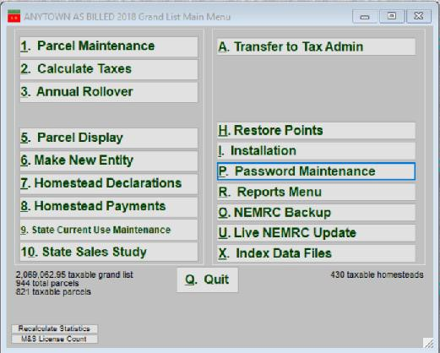
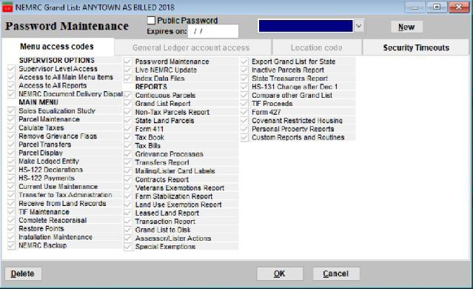

Click the drop down on the right side to see a list of all passwords currently in the system along with their corresponding privileges. Once a password from the list is selected you may add and remove privileges simply by clicking on the check boxes on this screen.

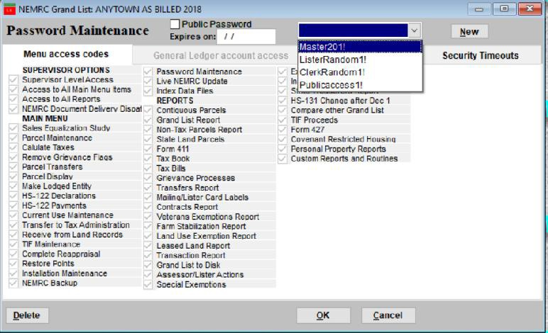

Adding a new password - Click the New button on the right and follow the prompts on the screen. Once your new password is created you may select the appropriate privileges for this user by placing a check in each of the boxes on this screen.

Public Password Checkbox – If this password is going to be used by users that should not see confidential information then check this box. This will automatically remove access to sensitive areas or data within the software.

Deleting a password – To delete a password simply select the password from the drop down list and click on the ‘Delete’ button in the lower left corner of the screen. Then select ‘Yes’ to confirm this action. You should periodically review your passwords and remove passwords that are no longer being used.

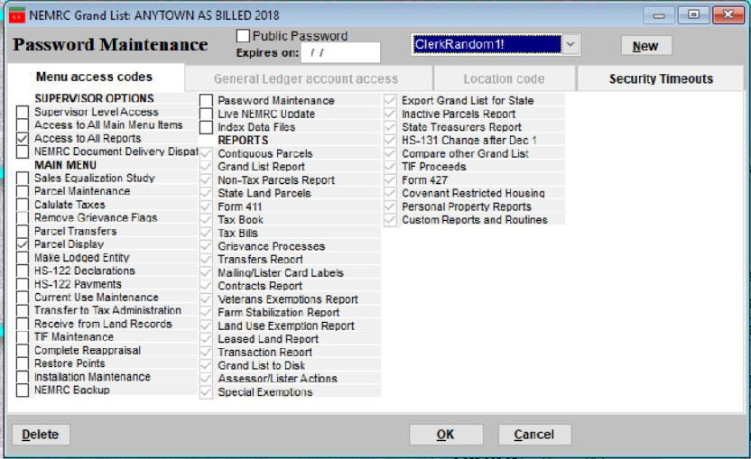

Changing existing passwords – This will allow you and other users to update passwords and retain existing privileges.

- Simply launch the software and when you are prompted to enter your current password simply check the box labeled ‘Change my password on the next screen?’.
- Then enter your existing password.
- Press the ‘Ok’ button to continue.
- Now follow the instructions on the next window that appears. You will be asked to enter your new password and then confirm your new password by typing it again.

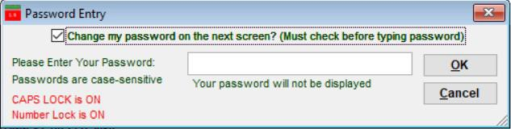

Due to end user feedback we have modified the process that is used to flag parcels for a Change of Appraisal Notice. In prior years when you changed a parcels Real Value, Homestead, or House site value the program would automatically turn on a Change of Appraisal flag for the value you changed. For example. If you changed the ‘Housesite’ value on a parcel as seen in the example below. We changed it from 235,900 to 200,000 and we were prompted to turn on the Change of Appraisal flag. Then enter a comment as to why we changed the value.

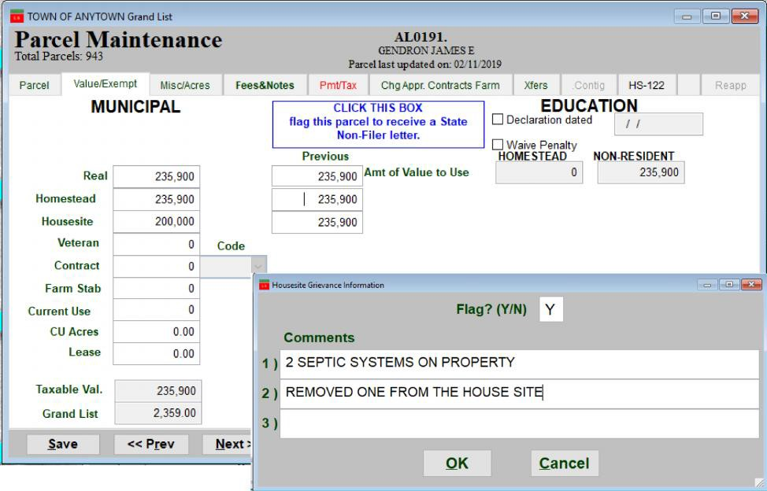

When you reviewed the ‘Chg/Appr Contracts Farm’ Tab you would find that only the ‘Housesite Appr. Change filed was set to ‘Yes’ and the ‘Real Appraisal’ and Homestead Appr. Change flag remained ‘N’ as those values did not change.

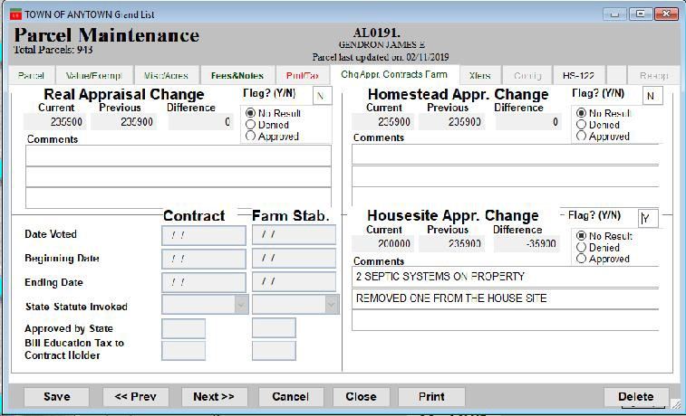

From this point forward when you just change a Real Value, Homestead, or Housesite value the program will automatically flag all 3 for Change of Appraisal flags. See illustration below. When you print your Change of Appraisal notice for this parcel the property owner will see that the Real value and the Homestead value did not change. However the Housesite value did and it is noted why it was changed.

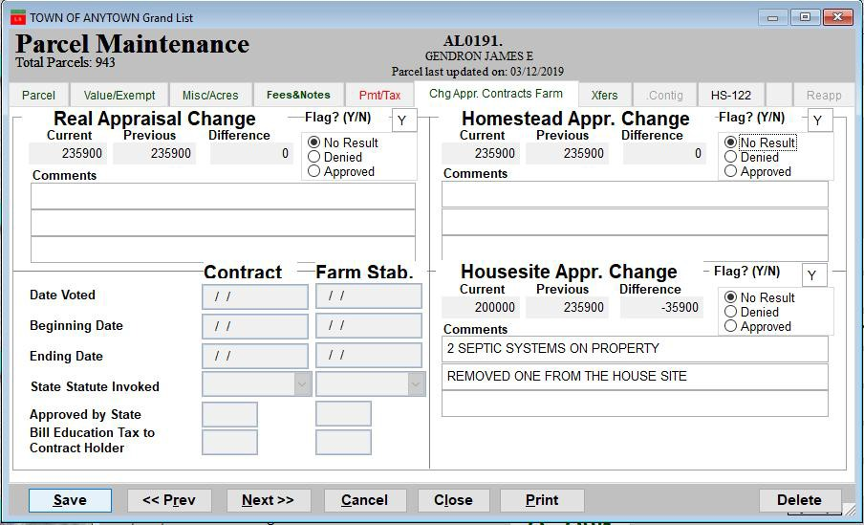
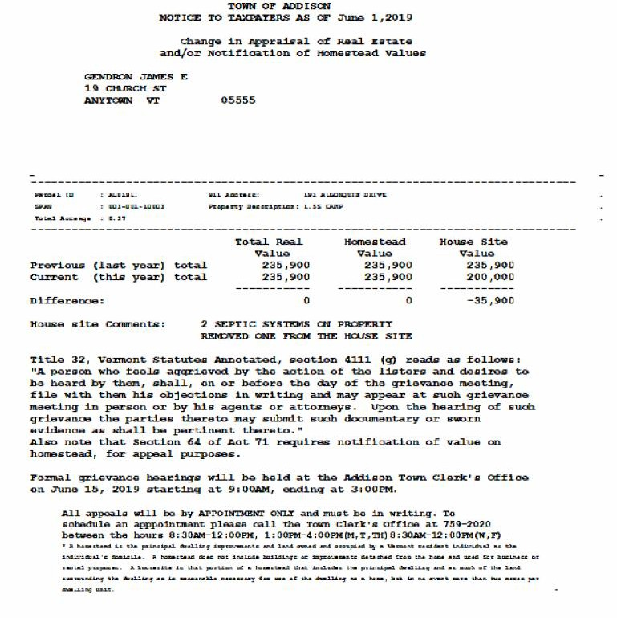
3. The Change Notice has updated as
well. The owner name still fits in a window envelope.
4. Parcel ID, Span #, Total Acreage,
Property descry, Tax map, & 911 fields print in the middle as seen here.

5. The Previous values and Current Values are all grouped together. Showing the difference below each column.
6. All comments will show in this area if
selected to print

Now go to‘7 Grievance Process’ screen on the ‘Reports Menu’ and look at the actual Change of Appraisal Notice for our sample parcel on the previous pages. Below is the Grievance Process screen.
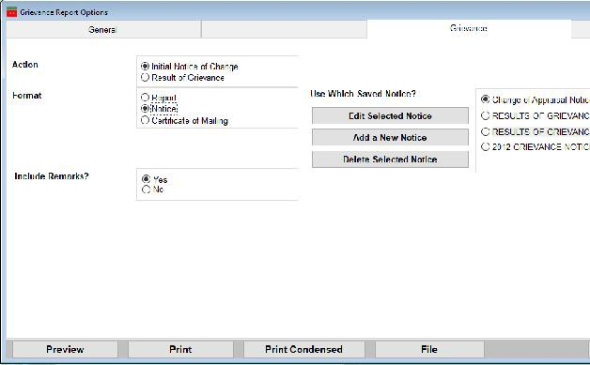

Action – you select here will dictate what reports and notices will print or display. For instance currently ‘Initial Notice of Change’ is selected therefore when you select an item under ‘Format’ it will print a Grievance Report, Grievance Notice, or Certificate of mailing.
Action - If you choose Result of Grievance then when you make a selection under ‘Format’ they will relate to the Results of grievance report, Result of grievance notice, and Result of grievance cert of mailing.
Changing parcel ids

History of parcels ids – In the past some Municipalities renumbered their Grand List every year, some created parcel ids that would inform the Listers and other Municipal officers where a parcel was located, While others used tax map numbers as their parcel identifiers. When all this work was done on paper it made sense that you would want a parcel id scheme that would let you know what street the parcel was located and if it was on the left side or right side. These IDs were a way for Listers to set up their files in the filing cabinet as well.

Once Act 68 was put in place and computers were being used to track all of your grand list data it was asked that Listers not change parcel ids every year, and try not to change them at all if possible. That is why a password is needed before you are able to change parcel ids. However, there is no perfect number system where a parcel id would not change at some point. Other than just using a random numberings scheme.

Changing parcel ids seems to be a topic Listers approach NEMRC about often throughout the year. Therefore, we are creating this document to give you some things to think about for the future. We would recommend preserving your current parcel ids in a field that you can edit on your own, Still show that field on reports, and be able to find parcels based on your current parcel ids. Then change your “Parcel ID” field to a random numbering scheme or the last 5 digits of the span number. (However, span numbers change when a Unlanded Mobile Home gets replaced with a newer mobile home).

Changing parcel ids is a simple task until you have to think how the change may affect others in your office and outside your office. For instance, If you change a parcel id on the grand list it immediately affects that parcel in all of your previous grand lists.
As the parcel you just changed has always been identified on the prior grand list under ID 03-01-001 and now in 2019 it is renumbered to 08-01-001. Now let’s expand that out to the other offices in your town like the Treasurer’s office, Planning and Zoning, Town Clerks (Land Records, Animal Licensing etc) Code Enforcement Department (Apartment Buildings), Outside Escrow companies. When you change that parcel Id these other departments and outside companies need to update that parcel id as well.
Otherwise you have a situation where 1 department has the new parcel id and 5 others have the old parcel id.
Other things to think about. Confidentiality. If your parcel id is based your 911 address do you change the ID when someone submits a 911 confidentiality form with the town. Many people do not realize these forms exist. Below is a sample of the form. The property owner must fill it out and submit it to the Town Clerk where they own property. Once this document is filed then it is up to the Municipality to make sure their locatable address is removed from public records.

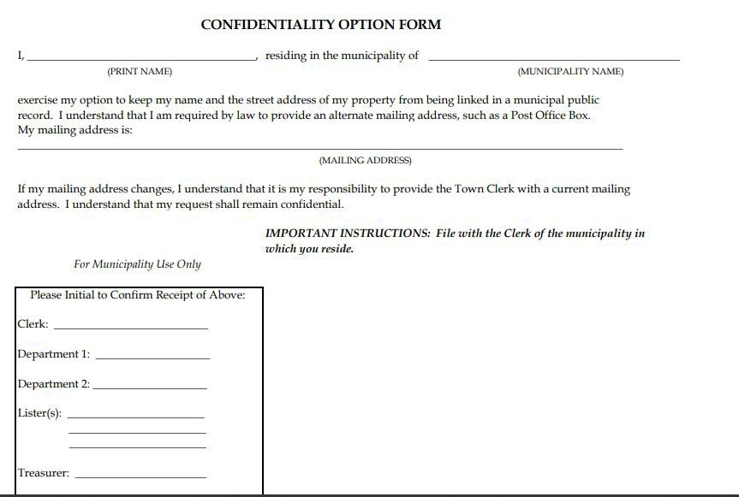

What you have to do if a Parcel ID needs to change:

Open your Grand List program and go to ‘1 Parcel Maintenance’ bring up the parcel that needs to have the Parcel ID changed. Then click the button labeled ‘Change Parcel ID’

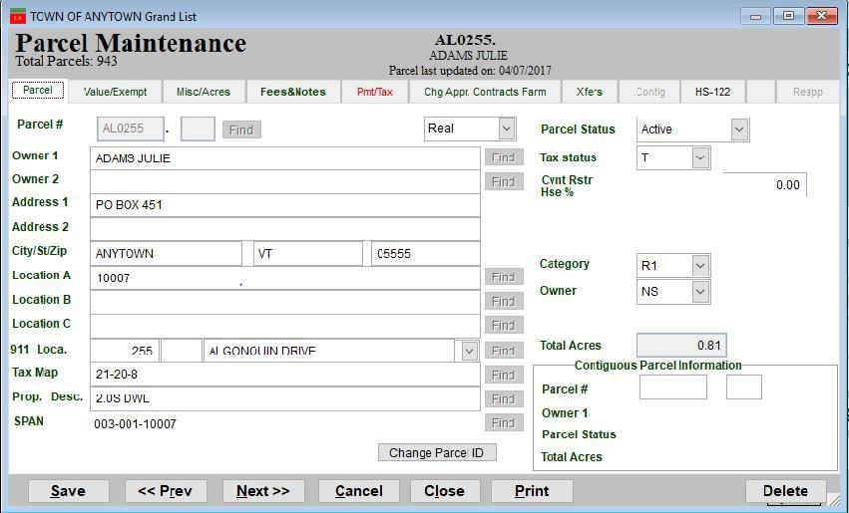

Next you will be prompted to contact NEMRC support to obtain an access code. Once the access code is entered you can enter you new parcel id. However, you are going to have to keep track of what the old parcel id was and what the new id is on this parcel.
Because you are going to probably have to have the Treasurer update their tax receivable software. It is not uncommon for Treasurers to get requests for 10 years of history on a specific parcel. If they do not update the prior years of tax history with the new parcel id they will not get all the information that is being requested of them.

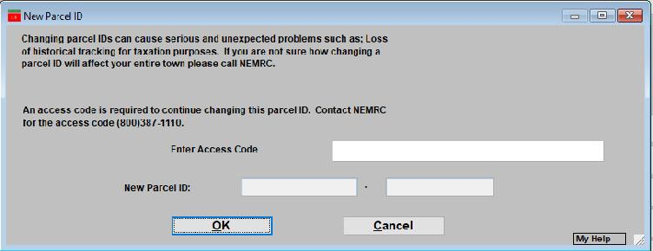
ID - 4

What would it look like if you changed your parcel ids from their current format to a random number or the last 5 digits of the span number? In the example below the parcel # field is a random number 924. The original id is now in the Location A field.
You are able to change this field as needed because and you can still look up parcels by that ID and print it on various reports.

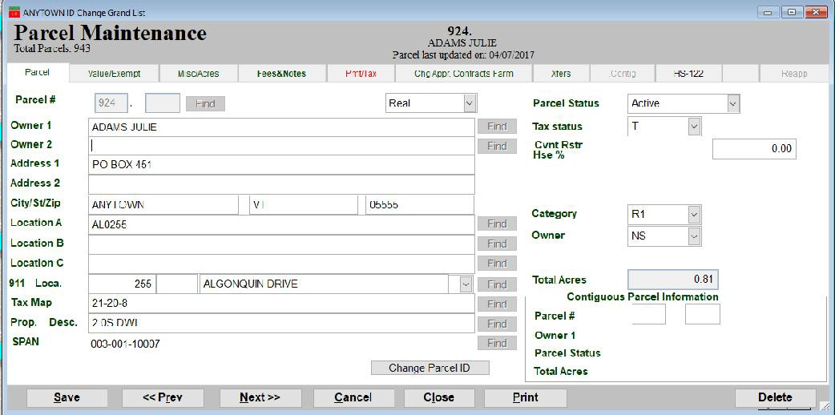

Here is an example of a Grand List report. The Location A field can be printed on this report and others if needed.

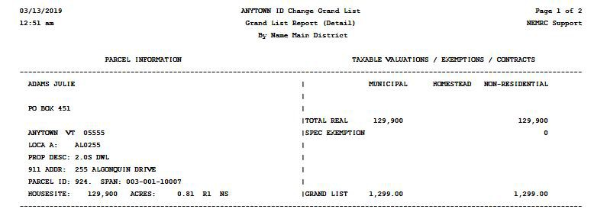

COMPARISON REPORTS:
Comparison Reports compare the grand list you are working in to any other grand list you have listed on your ‘Entity Maintenance’ screen. These reports can be run from the Reports Menu option ‘O Compare other Grand List’ or from the Main Menu option ‘7 Homestead Declarations’ next click the ‘Print other homestead reports’ then click the button labeled ‘Compare last years HS – 122 data’.
1. You can run reports against “Frozen” Grand List by placing a check mark in the box available. A Freeze file is automatically created when you print your tax bills. This file can not be changed. This option is only available when you are logged into an “As Billed Grand List”
2 Or select another grand list entity you wish to compare your data with. Simply highlight the Entity number by clicking on it as seen here. Entity 18 is the entity selected in the example below.

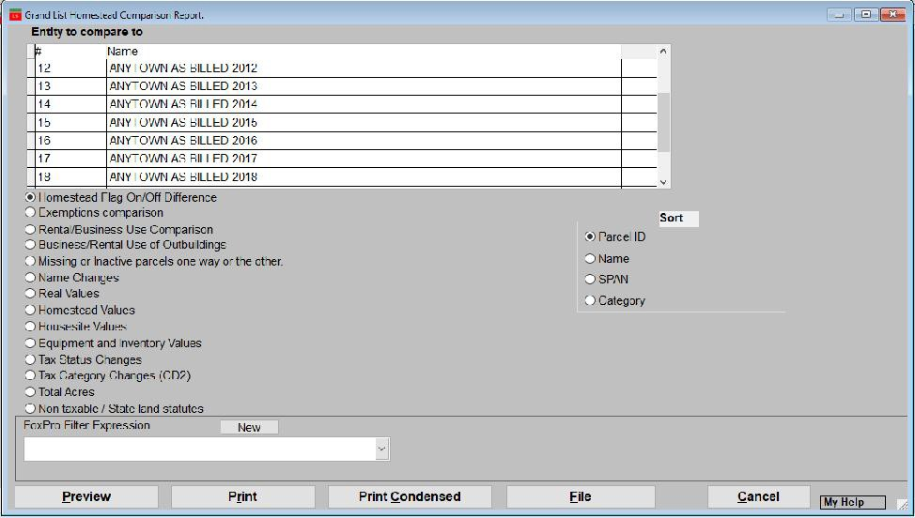

3. Select a comparison report you would like to run. The next page has is a description of each report.

Comparison Report descriptions

- Homestead Flag On/Off Difference – Provides you with a list of parcels that were flagged last year but
not this year.

- Exemption Comparison – Displays parcels that had a change in any exemption value.
Veterans, Current Use, Contracts, Farm Stabilization, and Special Exemptions.

- Rental/Business Use Comparison – Lists any parcel with a change to the Rental / Business use
percentage of their HS 122 (Homestead Declaration).

- Business/Rental Use of Outbuilding - Lists any parcel with a change to the Business/Rental use of
Outbuilding based on their HS 122 (Homestead Declaration).

- Missing or Inactive parcels one way or the other – This report shows all parcels that have been added,
removed or if their ‘Active/Inactive’ status had been changed. Remember you should not ‘Delete’ parcels from your grand list use the ‘Inactive’ status and note why and when they are inactivated.

- Name Changes - Shows all parcels that the first owners name has changed. This can include spelling errors that have been corrected, valid transfers, or simply adding punctuation to the name field.

- Real, Homestead, Housesite Value – These 3 reports list any parcel the real, homestead, or housesite
value of one grand list does not match the real, homestead, or housesite value of the grand list you are comparing it too.

- Equipment and Inventory Values - Lists any personal property accounts where the Equipment or
Inventory value has changed.

- Tax Status Changes - Lists any parcel where the taxable status ‘Taxable, Non Taxable,
or State Owned’ changed.

- Tax Category Changes (CD2) – List any parcel where the category changed IE: R1, R2, MHU,
MHL etc

- Total Acres – Lists any parcel where the acreage has changed.

- Non Taxable / State Land Statutes – Lists any parcel where the ‘Statute’ changed on ‘Non Taxable’,
‘State owned’, or ‘Voted’ contract / Farm Stabilization. These should not change from one year to the next unless something specific happened to a parcel.

Tracking Business and Rental percentages from one year to the next.

Below is an example of the Business/Rental use comparison report. As mentioned on the previous page it compares the amount of Rental/Business use declared on the current year’s HS 122 to a previous year’s Homestead Declaration. This report is very important to run and make adjustments as needed. It is the one of the easiest ways to see who is not declaring business and rental use from one year to the next. If a person closes their business or stops renting then you need to make sure you run this report and adjust the homestead and house site values accordingly. Otherwise you will be including them on the Non Resdential grand list and they will get taxed with the Non Residential tax rate.

Example 1: Person is declaring Rental use of 30% this year and declared 0.00% last year. In short they are declaring rental use for the first time this year. Research this property the best you can and adjust the homestead and house site values by 30% so they get included on both Homestead Ed and Non Residential Ed Grand list.
Example 2: Person is declaring Rental use of 0% this year and declared 29.00% last year. If you believe they are not renting any longer then you must change their Homestead and House site values so they are not included on the Non Residential Grand List. Note: You may find out that they are on this list simply because they have not filed their Homestead Declaration yet.
Example 3: Person is declaring Rental use of 13% this year and declared 14.00% last year. Adjust Homestead and house site values accordingly to parcels that are declaring more or less of a percent. If you feel this is simply a typo you can report it back to Tax payer services by using the Listers response. Go to https://www.nemrc.com/support/grandList/ and select Listers Response for more details.

Example 4: Person is declaring Rental Use of 51% this year and declared Business Use of 51.00% last year. This is most likely a mistake made when filling out the HS 122 form. The Homestead and House site values still need to be adjusted for 51% either way. If you research and find it should be under Business Use then report it back to Tax payer services by using the Listers response. Go to https://www.nemrc.com/support/grandList/ and select Listers Response for more details.

Example 1
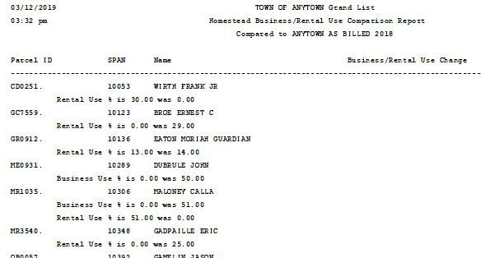

Example 2

Example 3

Example 4

Next run the “Business / Rental Use of Outbuilding” comparison report. This is the only place you are going to catch parcels that are no longer using an outbuilding for Business / Rental Use. So you want to pay special attention to any parcel on this report that states Business Use of outbuilding is now off. This is the only report that is going to tell you that a parcel is no longer using an outbuilding for business/rental use. You must research why they are not declaring business / rental use on the outbuilding. If they no longer run the business out of the outbuilding then you must make sure you adjust the Homestead and House site accordingly. Or the parcel will be included on the wrong grand list and taxed on the Non Residential tax rate. A person may end up on this report if they have not filed a homestead declaration yet.

Example 1: As mentioned above research this parcel and adjust homestead and house site values.

Example 2: Notice ME0931 DUBRULE is declaring an out building for Business and Rental Use this year however looking at the comparison report on the previous page he declared 50% business use last year. You must research this parcel deeper and figure out if he is using part of his house for business use?
  - If so then you must do a lister response and make sure his homestead and house site values are adjusted by 50%.
  - If they moved the business out of the home to an Outbuilding on the property then you must subtract the amount of the outbuilding from the Homestead and house site value of the
Either way in this example he should be subject to being on the Non Residential grand list. The question that needs to be answered is How Much of his parcels value should be on the Non Residential grand list? 50% of his house or the entire value of the outbuilding.

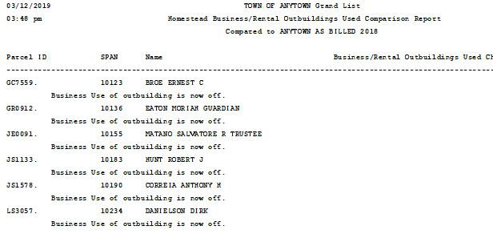
Example 1
ME0931
10289DUBRULE JOHN.
Business Use of Outbuilding is now ON

Example 2:

Another way to compare Business / Rental percentages and Outbuildings used for Business / Rental use is to simply print these reports from each grand list. Print one from the Working Grand list and one from the 2018 As Billed grand list. Then you can manually compare them. Below is how to run the reports.

- Go to the Main Menu and select ‘7 Homestead Declarations’

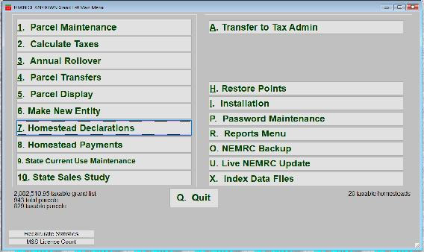
- Next select ‘5 Print Other Homestead Reports’

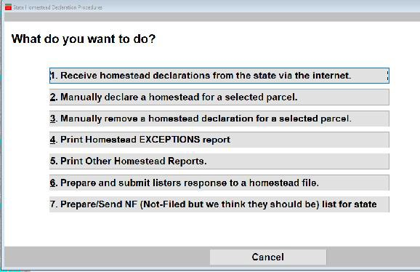

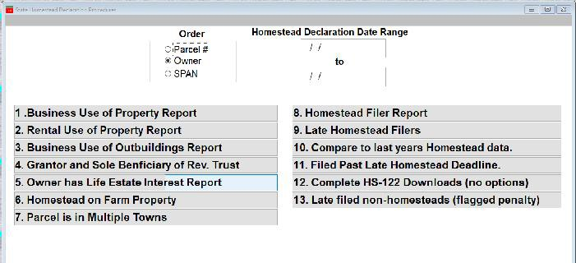
- Run each of these reports
“1 Business Use of Property” “2 Rental Use of Property”
“3 Business Use of Outbuilding”

Here is a sample of the Rental use of property. The top report is from the Working Grand List and shows 3 parcels have declared rental use this year. Whereas, the bottom report shows Rental Use of property declared in the Anytown As Billed 2018 Grand List and there are 4 parcels on that report. Simply compare the 2 reports manually and research any differences accordlingly.

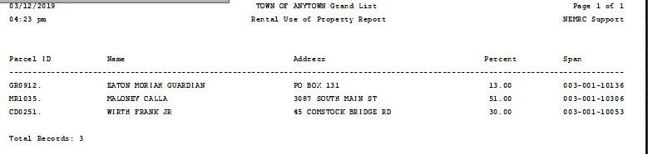

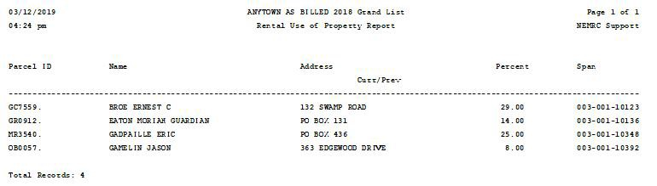

Tax Bill Prototype 2019
TB - 1

DO NOT ORDER PRE - PRINTED TAX BILLS UNTIL LAYOUT IS FINALIZED
Below is a prototype of what the 2019 Property tax bill Layout may look like. At the end of the 2018 Legislative session a law was passed that stated the Municipal taxes should be shown separately from the Education taxes. Along with the State Payments must be shown as Municipal State Payments and Education State Payments. Tax Payer Services will provide State Payment files with each state payment broken down between Municipal vs Education. The software will apply the payments accordingly.
On the next page is the current tax bill layout. Comparing the 2 you can see the middle sections where the Tax rate names, rates, and taxes section is changing to display Municipal vs Education tax side by side rather than vertically as seen on the current layout. The taxes due and installments will still calculate the same

Proposed Prototype Tax bill

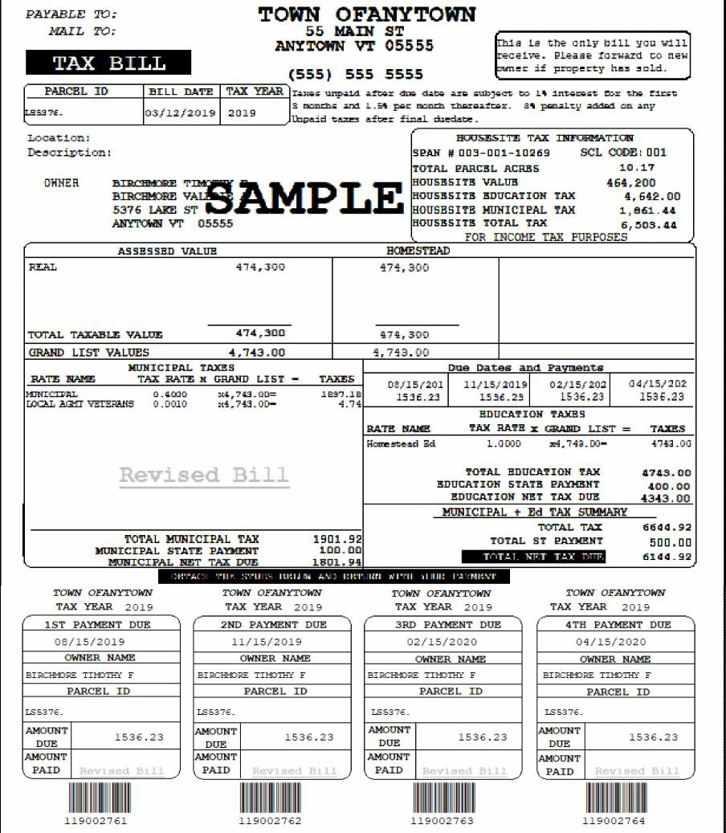

Current 4 installment tax bill

P.AYABLE .'I'D:
Z.!. AI.L TO:
Jl1s ls me only b1.ll you 1o1t11
w-c_iue:_ Pl!!.2!1. e f,onnt c:d to n
ll'!Ulcr if prtyoold.
AHYTORN VT [)5555
TAX BILL
------- ---- ----
U.'!5316.
(SSS) SSS 5SS5

TOWN OFANYTOWN
SS MAIN S'I'
TB - 2

r:.oc.a c1on : Deec:r1JJ·t1on :
HOUSESill n.lC INl!'ORMltTION
PAN • 003-001-10269 SL corns :001
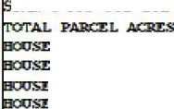

10.17
::==, AMPLE

LlUl'.B ;;-c I
SITE V.A.UD:
SITE EDUCA:TIClll TAX
464,200
...6..2 .00

0316
SITE
- nvICIPAL TAX 1,861.44

ANYTOlffl VT 00000
Srr:E 'I'OT.A.L TAX 6,503.44

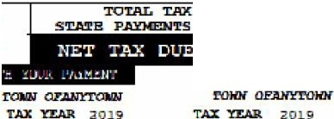
FOR :rnt ct!! 'JAX PIJRPOSES
ASSESSED VA.LOE
'17'1,300
i'H,300
TOTAL TAXAB.U: VA.I.DE
ORAHD LIST WJ.UBS
474,300
4,743.00
fli,300
i,1i3.00
For a:>tre infanat:ilm l!lb:ntt. b:tw e<Lcal::ilm -1-L"""'.....,cu....._."""..,...T'-A." X._B,, ATl: _x,,'-I"G' RAJID' _,L,,_X,,S,,,-T"-'=- -
t.oa ......mo. .,_.,.. <!labiorn1nad, ·!JO> ·<>nl.in.. t»;il!IJNic:IPAL
htl:.p:l/t.l!llt....,i::mml:. 917T}.-tyn1WAQIT
0.40JO
0 .0010
m,? l!l.00-
l'4, 74.il .0()::
-=-.\:&.:Y=R s-1
1.891' L<
4 .7
1.0000
itt ? l!l.00- •
!'143.0(
RevisP-Bill
1.St B<lyme:nt2r.c1 Pa.yment
08/lb/2019
1.536 .23
11115(201!1
1536 .;;J 3
3rd Pa.yment
02115/2020
l.53·6 .2:3
4 eh Pa¥Jtene
04/15/2020
s36 .23
EE 1U.9:J
soo.oo
614 _ g2
I
2ND PAYMENT DUE
31ID PAD!EN'l' DUE
4'l'B PAYMER'l' DUE

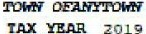

ll/15/Z019
OlfHBR MA.MB
m ntcJH:r r
E'ARCR L ID
l51>31ii .
AlC)OllT  DOE | 15!16.2!1
AI«XJH'J'
PUD

02/ 15/ 2020
QlllllER lltAllE
m TJ:tC'l'lir r
PARCEL ID
LS'6i!l'6.
DUB | 1536.23
AMOUNT
£>AID

 |  | "'
04/15/2020
01lf1ilKR NANR
B.I=n:l23! 'nlDlE! i'
PARCl:l. m
LSiii!?e.
AlC)l!JH'1  E)l!JB | 15913.29
AMDO!l'1'  PAlD | -

mlDllllllUIJ
r S'l' PAYMER'l' DUE
08/15/201
R>.H.:
BiilCIH:l23! 'Hlf:>lm! i'
PARCEL ID
u;,;ar;;.
Abl'.lml'r DOE | 1536.23
AM'.l(]H'P  \. PUD | H
I | DUlllll!llll

1rnrn111111u
llllm l IJll

ll'900276J.
J.J.'9002763 119002764

NEMRC
New England Municipal Resource Center, Ltd

SEMINAR EVALUATION FORM

We appreciate you taking a moment to supply us with your honest and objective input
about today’s seminar. This will allow us to better prepare for future seminars.

Seminar Title Date

Name & Title Organization

- Please tell us what you thought about this seminar.

