This feature is used -
A: Renewal - Remind animal owners that it is time to register their animals
B: Late Notice - Inform animal owners that they did not register their animals on time and they are now late.
From the Animal Licensing ‘Main Menu’ select ‘I – Installation’.

Click on the drop down button next to ‘Renewal Form’ and change it to ‘05’. This is the newly designed form that prints 3 animals per page.
NOTE: You may select the any form from this list that you would like to print.

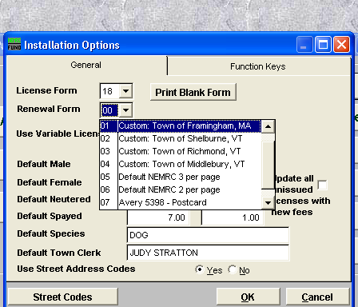

Press the ‘Ok’ button to save your Selection.

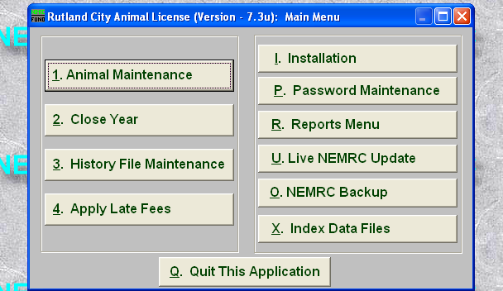
Next go to the ‘Reports’ menu and select either
‘5 Print animal Renewal forms’ or
‘7 Print Late Notices’.
These 2 options use the same layout that you selected on the ‘Installation’ menu.

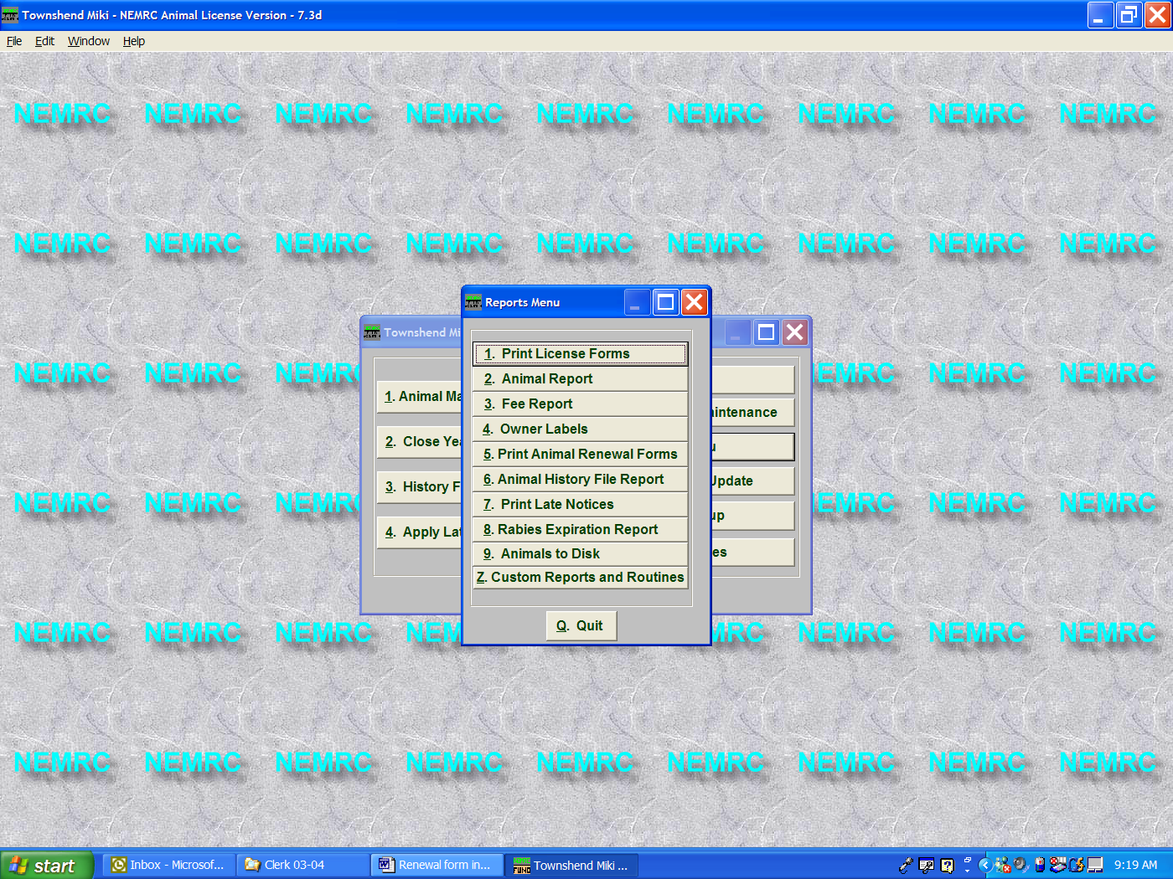

Enter the License expiration date of the animals you want to issue a renewal form. In this example we used an expiration date of 3/31/03. If an animal does not have a current tag number and the expiration date is 3/31/03 then a renewal for will print for that animal.

Select to print a range of animals or all animals that do not have a current tag number and the expiration date is 03/31/03.

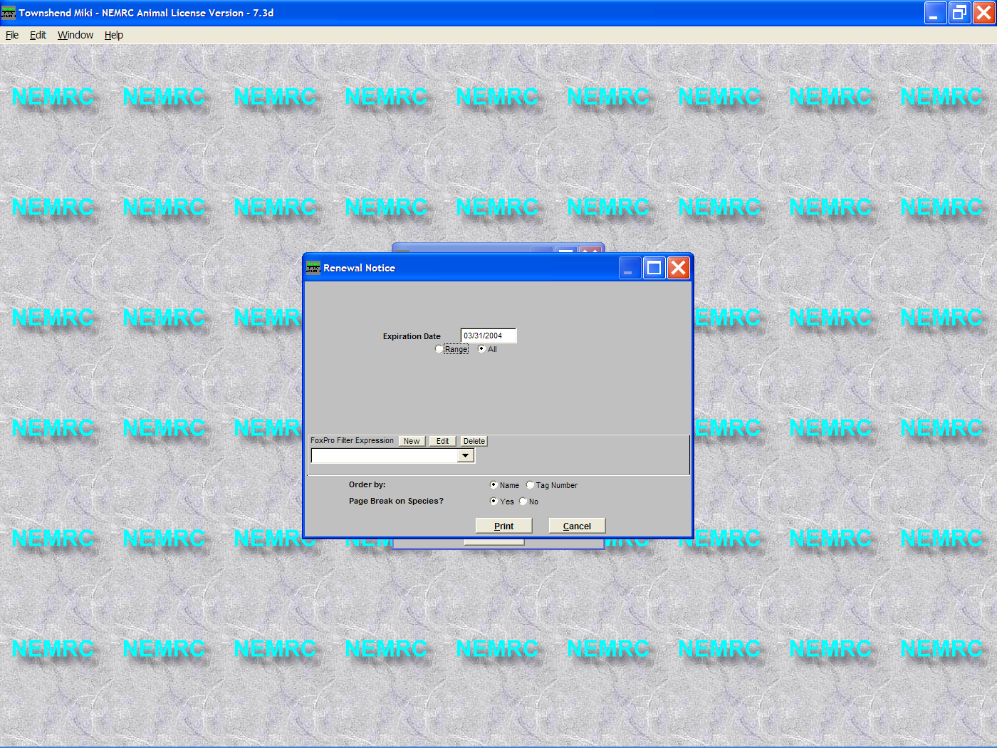

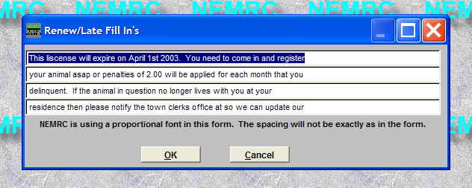
Choose the order that you want the forms to print. Press the ‘Print’ button to begin printing your renewal forms.

The window that appears below allows you to type up to 4 lines of customizable text.

Press the ‘Ok’ button to save your changes and begin printing your renewal forms.

