Animal Licensing Fee Report

The fee report shows all fees collected for a specific date range.

- Groups animals by species
- Includes animals that have been moved to history file.
- Displays all current, late, state, kennel fees.
- Reports the number of neutered and spayed animals.

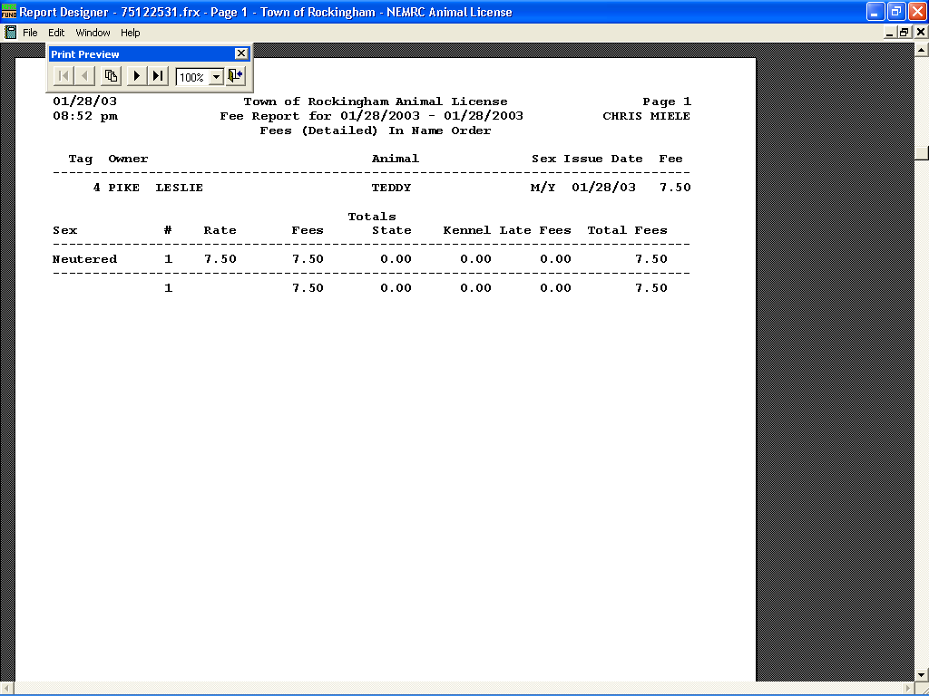

This page displays all animals without a defined species. Then displays the fee totals

Page 2 shows all animals where Canine is the species.

