Animal Licensing

Closing the Animal Year

When you close Animal Licensing for the year there are a couple of important rules to remember.

- Back up your data before you close the year! This will allow you to restore the data if a mistake is made when the year is closed.
- When you close the year you have the option to move all untagged animals to the history file. Moving the untagged animals to history will help you keep your current animal file clean and up to date. You can always move an animal from the history file back to the current animal file.
- This process can not be run more than one time per year due to a new feature that has been added. At the year close the 'Current Tag’ number will automatically be moved to the ‘Last Years Tag’ number leaving the ‘Current Tag’ number blank. If you close the year twice, and click the ‘Y’es radio button next to the question ‘Untagged animals exist, move animals to history?’ all of your animals will be moved to the history file, because the ‘Current Tag’ number is blank. If you feel that you need to close the year again call NEMRC Support first 800 387 1110.
- Once the ‘Close Year’ routine has finished you can print all of your animal license forms and start distributing the new animal tags and licenses.

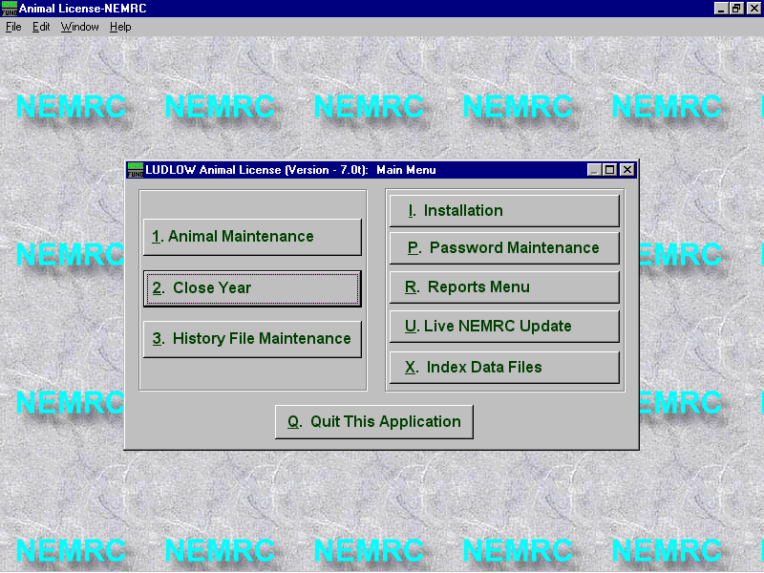
The following Pages illustrate step by step how to close the Animal Year.
1. From the ‘Main Menu’ select ‘2’ ‘Close Year’

2. The ‘Close Year’ window will appear. Please read this screen carefully.
- First, look at the date this procedure was performed and compare it to the current date. If that date is close to the current date that means the year has been closed once already and closing it again will cause problems as mentioned previously.
Note: if this is the first year you have ever used the animal licensing program this date will be blank, because you have never closed the animal year before. You will close the year after you have entered all of your animals into the program for one year. Then you will run this process when it is time to issue the new animal licenses

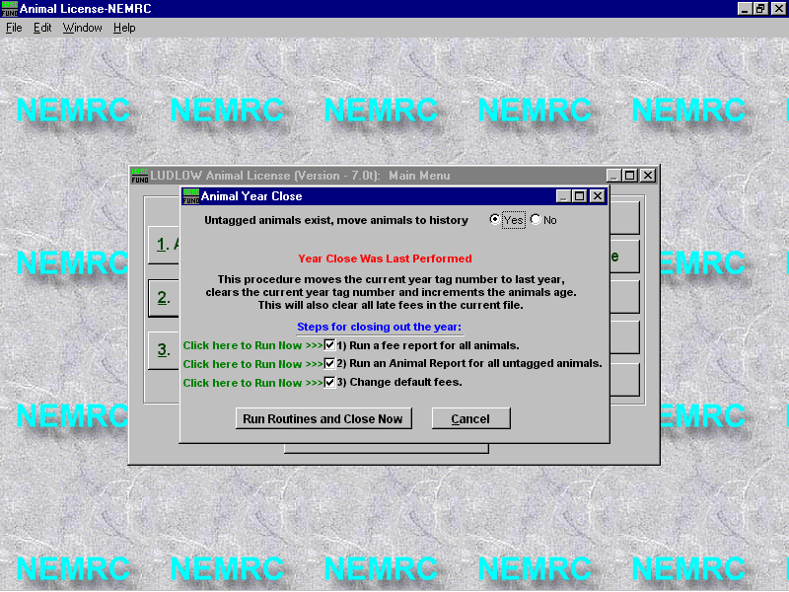
- Next you have the opportunity to print out a ‘Fee Report’, and ‘Untagged Animal Report’. Most of our clients run these reports at this time; therefore, leave these two items checked. If you have already printed these reports from the ‘Reports Menu’ simply uncheck these two items.
- ‘Change Default Fees’ before the closing of the year is performed. Usually the animal fees do not change very often. If you do not want to change the default fees now just uncheck that box. You can also change the default fees by going to ‘Installation Maintenance’ on the ‘Main Menu’.
- If you have finished making your selections click on the ‘Run Routines and Close Now’ button.
A. If you chose to print out either of these reports then the ‘Fee Report’ and ‘Animal Report’ options screens will appear. Make your selections on these screens and print or display your reports.
12/31/01

7. Once this process has finished the ‘Close Complete’ windows appears. Press ‘Ok’ to return to the ‘Main Menu’

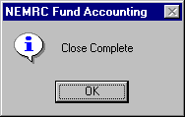
- When the Closing process is complete you will return to the ‘Main Menu’. Select ‘1 Animal Maintenance’. Now all of the ‘Current Tag’ numbers are blank. If you want to retrieve a record you must use ‘Last Years Tag’ number or ‘Owner’s Last Name’.
- Once you have retrieved a record you will notice the following fields have changed.
- ‘Current Tag’ number is blank waiting for you to enter in the new tag number.
- ‘Issue Date’ is now empty. You will have to type in the date that the animal was registered.
- ‘Age Year’ has been increased by one year automatically for you.

