Breed and Color drop down lists have been added to the NEMRC Animal Licensing program. The drop down lists will be populated using your existing data. You can clean up the drop down list as you begin to use them. Meaning that you can remove a breed or color that are misspelled or could be better abbreviated. However, you must add the new breed or color first. Then update all of the records that contain the old spelling with the newly created spelling. Once that is done the old spelling item will be removed from the list. For instance, let’s say you have a breed typed in as ‘G Retrieve’ and you would like to update the breed drop down list to show ‘Golden Retriever’. Simply add the new spelling of ‘Golden Retriever’ to the drop down list as shown in the instructions below. Then update all records with the ‘G Retrieve’ with ‘Golden Retriever’.

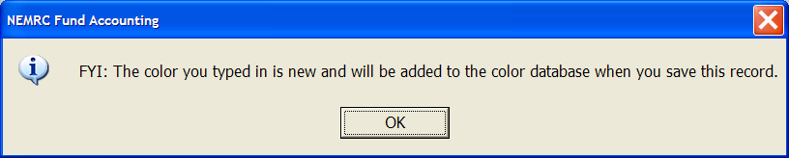
- When you type in a new breed or color the window below will appear letting you know that you are about to add a new breed or color.
- Press the ‘Ok’ button to continue entering data on the current record.

3. The new Breed or Color you added will not be saved until you press the ‘Ok’ on the Animal Maintenance screen.

